Safeguards Science and Technology Group

Nuclear Engineering and Nonproliferation Division
Radiation Review
User Manual

January 23, 2013

Author(s):
S. Klosterbuer, H. Nordquist
J. Longo,J. Montoya
Maintaining Author:
J. Longo

Software Version:
This document applies to Version 3.2.0.9 and earlier 3.2.0 versions of Radiation Review software.
Sponsorship:
This work was supported by the United States Member State Support Program to IAEA Safeguards; the U.S. Department of Energy, Office of Nonproliferation and National Security, International Safeguards Division and the U.S. Department of Energy, Office of Safeguards and Security.
Authored by the Safeguards Science and Technology Group (NEN-1) of Los Alamos National Laboratory.
This material was prepared by Los Alamos National Security, LLC (LANS), under Contract DE-AC52-06NA25396 with the U.S. Department of Energy (DOE). All rights in the material are reserved by DOE on behalf of the Government and LANS pursuant to the contract. You are authorized to use the material for Government purposes but it is not to be released or distributed to the public. NEITHER THE UNITED STATES NOR THE UNITED STATES DEPARTMENT OF ENERGY, NOR LOS ALAMOS NATIONAL SECURITY, LLC, NOR ANY OF THEIR EMPLOYEES, MAKES ANY WARRANTY, EXPRESS OR IMPLIED, OR ASSUMES ANY LEGAL LIABILITY OR RESPONSIBILITY FOR THE ACCURACY, COMPLETENESS, OR USEFULNESS OF ANY INFORMATION, APPARATUS, PRODUCT, OR PROCESS DISCLOSED, OR REPRESENTS THAT ITS USE WOULD NOT INFRINGE PRIVATELY OWNED RIGHTS.

History of Revisions

Revision No. | Effective Date | Pages Revised | Reason for Action
003.000 | January 8, 2004 | All | First version that has revision tracking. Major upgrade of September 20, 1999 user manual.
003.001 | February 13, 2004 | All | Added detail not covered in Jan 8, 2004 version due to time constraints
003.002 | November 19, 2004 | All | Updated to reflect menu options for 3.1.0 0
003.002 | December 1,2004 | Fac Mgr Section | Update with latest dialog box
003.003 | December 15, 2004 |  | Updated Tools | Export Data section to handle exporting MiniGRAND data for FDMS. Updated files written in Appendix A.
003.004 | December 9, 2005 | All | Updated all sections to reflect changes for Radiation Review 3.2.0.0
003.005 | January 25, 2006 |  | Updated Determine Measurements section to include information about the new “minutes before” parameter (also Fig 2.4-25). Added new MG status bits to Fig. 2.6-5.
003.006 | December 13, 2007 |  | Changes for B2R1. DRAFT  Page 2: New copyright information.  Added EOSS information.
003.006 | March 23, 2008 |  | Changes to add EOSS instrument and document other changes for B2R1
003.006 | March 26, 2008 |  | Changed Data Integrity Check section to reflect removal of “Update Conditions” button.
003.007 | Feb. 8, 2010 |  | B2R1 issues for RAD 3.2.0.7 and the User Guide are summarized in Appendix § C.1
003.008 | Aug. 2, 2010 |  | The 3.2.0.8 release issues for RAD are summarized in Appendix § C.2
003.009 | Jan. 23, 2013 |  | TimeAlign mote on graph documented. The 3.2.0.9 release issues for RAD are summarized in Appendix § C.3
Table of Contents
1. Introduction 11
1.1. Purpose 11
1.2. Scope 11
1.3. Background 11
1.4. Acronyms 12
1.5. References 13
1.6. Overview of Document 13
2. Operations Reference 14
2.1. Main Menu Bar 14
2.2. File Menu 15
2.2.1. Printer Setup 15
2.2.2. Backup All Data 15
2.2.3. Restore All Data 17
2.2.4. Backup Configuration 18
2.2.5. Restore Configuration 18
2.2.6. Copy Logs 20
2.2.7. Exit 20
2.3. Import Menu 21
2.3.1. Import All Dialog Box 21
2.3.2. Common Data Import Process 23
2.3.3. Text Window Results 24
2.3.4. Import Selected Files Dialog Box 26
2.3.5. Import Most Recent Files Dialog Box 29
2.4. Tools Menu 31
2.4.1. Select Facility 31
2.4.2. Select Review Period 33
2.4.3. Data Integrity Checks 34
2.4.4. Find Channel Events 40
2.4.5. Direction Analysis 45
2.4.6. Adjust Station Timestamp 50
2.4.7. Graph 52
2.4.8. Determine Measurements 60
2.4.9. Export Data 66
2.4.10. Facility Manager 71
2.5. Summaries Menu 74
2.5.1. Marks 74
2.5.2. Channel Events 77
2.5.3. Direction Events 83
2.5.4. Days in Database 86
2.5.5. Measurements in Database 88
2.6. Diagnostics Menu 91
2.6.1. Raw Data 91
2.7. Window Menu 100
2.8. Help Menu 101
2.8.1. Contents 101
2.8.2. Search 101
2.8.3. Product Support 102
2.8.4. About Radiation Review 103
2.9. Alternate Startup 104
2.9.1. REVIEW Startup Mode 104
2.9.2. IMPORT Startup Mode 104
2.9.3. REANALYZE Startup Mode 104
2.9.4. SETUP Startup Mode 104
2.9.5. TITLE, INSPECTION or SKIP_RUNNING_MSG Startup Mode 104
2.9.6. Inspection Information Dialog Box 106
3. Installation Information 108
Appendix A. Files 109
A.1. Input Files 109
A.1.1. Binary Raw Data Files (*.BID, *.ISR, *.BSR, *.MCA, *.JSR,*.ESS) 109
A.1.2. Database Files 109
A.1.3. Text Raw Data Files 111
A.1.4. Configuration Files 111
A.2. Output Files 116
A.2.1. Files from text window results 116
A.2.2. Files for import to INCC 116
A.2.3. Events XML File for Reading by FDMS or other review tools 117
A.2.4. Find Events Log File 119
A.2.5. Find Events Data File for Reading by Integrated Review 119
A.2.6. Direction Analysis Log File 120
A.2.7. Direction Analysis Data File for Reading by Integrated Review 120
A.2.8. Export Analysis Data File for Reading by Integrated Review 121
Appendix B. Troubleshooting 123
B.1. Warning/Error Messages 123
B.2. Database becomes corrupt 127
B.3. Program locks up 127
B.4. Undefined facility on startup 127
Appendix C. Technical Support, Change Summary 129
C.1. Radiation Review 3.2.0.7 Resolved Issues and Change Summary 129
C.2. Radiation Review 3.2.0.8 Resolved Issues and Change Summary 130
C.3. Radiation Review 3.2.0.9 Resolved Issues and Change Summary 130
Appendix D. Setting Facility Specific Parameters 131
D.1. Channel Event Parameters 131
D.2. Direction Analysis Parameters 134
Appendix E. Shift Register Specific Information 135
E.1. Shift Register Analysis 135
E.1.1 SR Measurement Analysis 135
E.1.2 Run Type Determination (Doubles Assay) 138
E.1.3 Run Type Determination (Singles Assay) 139
E.1.4 A/T Test 140

Figure 2.1-1 Main Menu 14
Figure 2.2-1 File Submenu 15
Figure 2.2-2 File | Backup All Data Dialog Box 15
Figure 2.2-3 Create path question 16
Figure 2.2-4 Overwrite database question 16
Figure 2.2-5 Database copy complete 16
Figure 2.2-6 File | Restore All Data Dialog Box 17
Figure 2.2-7 File | Restore All Data Complete Message 17
Figure 2.2-8 File | Backup Configuration Dialog Box 18
Figure 2.2-9 Configuration copy complete 18
Figure 2.2-10 File | Restore Configuration Dialog Box 19
Figure 2.2-11 File | Restore All Data Complete Message 19
Figure 2.2-12 File | Copy Logs Dialog Box 20
Figure 2.2-13 Logs copy complete 20
Figure 2.3-1 Import Pull-down Menu 21
Figure 2.3-2 Import | Import All Dialog Box 21
Figure 2.3-3 Clear Database Question 23
Figure 2.3-4 Import Progress Bar 23
Figure 2.3-5 Cancel Import Question 23
Figure 2.3-6 Import | Import All Log Results Window 24
Figure 2.3-7 Text Window Actions Pull-down Menu 25
Figure 2.3-8 Import | Import Selected Files Dialog Box 26
Figure 2.3-9 Import | Import Most Recent File(s) Dialog Box 29
Figure 2.4-1 Tools Pull-down Menu 31
Figure 2.4-2 Tools | Select Facility Dialog Box 31
Figure 2.4-3 Different Facility Selected 32
Figure 2.4-4 Same Facility Selected 32
Figure 2.4-5 Tools | Review Period 33
Figure 2.4-6 Tools | Data Integrity Checks Dialog Box 34
Figure 2.4-7 Tools | Data Integrity MiniGRAND/GRAND Text Window Results 36
Figure 2.4-8 Tools | Data Integrity MiniADC Text Window Results 37
Figure 2.4-9 Tools | Data Integrity SR Text Window Results 38
Figure 2.4-10 Tools | Find Channel Events Dialog Box 40
Figure 2.4-11 Event Search Progress Bar 42
Figure 2.4-12 Tools | Find Channel Events Text Window Results 43
Figure 2.4-13 Tools | Direction Analysis Dialog Box 45
Figure 2.4-14 Tools | Direction Analysis Text Window Results 48
Figure 2.4-15 Tools | Adjust Station Timestamp Dialog Box 50
Figure 2.4-16 Tools | Graph Dialog Box and Display 52
Figure 2.4-17 Graph Event Details Dialog Box of Existing Event 55
Figure 2.4-18 Graph Event Details Dialog Box of New Event 55
Figure 2.4-19 Graph Delete Event Question 56
Figure 2.4-20 Graph Edit Event Dialog Box 56
Figure 2.4-21 Graph Showing Event Being Edited 57
Figure 2.4-22 Graph Help Information 58
Figure 2.4-23 Graph Options Dialog Box 59
Figure 2.4-24 Tools | Determine Measurements Dialog Box 60
Figure 2.4-25 Advanced Measurement Parameters Dialog Box 62
Figure 2.4-26 Determine Measurements Text Windows Results 64
Figure 2.4-27 Tools | Export Data Dialog Box 66
Figure 2.4-28 Tools | Export Data – Measurements to Export Dialog Box 68
Figure 2.4-29 Tools | Export Data Text Window Results 69
Figure 2.4-30 Tools | Facility Configuration Dialog Box 71
Figure 2.4-31 Tools | Facility Manager Exit Warning Message 72
Figure 2.4-31 Tools | Instrument Manager Dialog Box 72
Figure 2.4-32 Tools | Units Manager Box 73
Figure 2.5-1 Summaries Pull-down Menu Examples 74
Figure 2.5-2 Summaries | Marks Dialog Box 74
Figure 2.5-3 All Marks Summaries Text Window Results 75
Figure 2.5-4 Daily Mark Summaries Text Window Results 76
Figure 2.5-5 Summaries | Channel Events Dialog Box 77
Figure 2.5-6 Summaries | Channel Events - All Events Sorted by Channel 79
Figure 2.5-7 Summaries | Channel Events - All Events Sorted by Time 80
Figure 2.5-8 Summaries | Channel Events – Daily Summaries Sorted by Channel 81
Figure 2.5-9 Summaries | Channel Events – Daily Summaries Sorted by Time 82
Figure 2.5-10 Summaries | Direction Events Dialog Box 83
Figure 2.5-11 Summaries | Direction Events - All Events Text Window Results 84
Figure 2.5-12 Summaries | Direction Events - Daily Summaries Text Window Results 85
Figure 2.5-13 Summaries | Days in Database Dialog Box 86
Figure 2.5-14 Summaries | Days in Database Text Window Results 87
Figure 2.5-15 Summaries | Measurements Dialog Box 88
Figure 2.5-16 Summaries | Measurements Text Window Results 89
Figure 2.6-1 Diagnostics Pull-down Menu 91
Figure 2.6-2 Diagnostics | Raw Data Dialog Box 92
Figure 2.6-3 Shift Register Status Bit Definitions 93
Figure 2.6-4 Binary Status Bit Definitions 93
Figure 2.6-5 GRAND Status Bit Definitions 94
Figure 2.6-6 MiniADC Status Bit Definitions 95
Figure 2.6-7 Diagnostics | Raw Data Results Text Window for GRAND data 95
Figure 2.6-8 Diagnostics | Raw Data Results Text Window for Binary data 96
Figure 2.6-9 Diagnostics | Raw Data Results Text Window for SR data 97
Figure 2.6-10 Diagnostics | Raw Data Results Text Window for MiniADC data 98
Figure 2.7-1 Windows Pull-down Menu 100
Figure 2.8-1 Help Pull-down Menu 101
Figure 2.8-2 Help | Product Support Screen 102
Figure 2.8-3 Help | About Screen 103
Figure 2.9-1 Inspection Startup Dialog Box 105
Figure 2.9-2 Inspector Information Dialog Box 106

Radiation Review
User Manual

Introduction

Purpose
This User Manual is intended to be a reference for users of the Radiation Review program. This manual provides instructions to use the Radiation Review program to display data collected from GRAND (either GRAND-3 or MiniGRAND), shift register (either JSR, AMSR or ISR), MiniADC, Binary Logger, VIFM, or EOSS instruments running in unattended mode with step-by-step instructions for each menu option. Descriptions of any files that are either input to or output from Radiation Review are part of this manual as well as instructions for setting parameter values for some analysis options.

Scope
This manual provides instructions for using the Radiation Review program. It details how to use each of the menu options in the program. These instructions are intended to be a reference for the general user.
In addition, the appendices contain information on the file formats, databases used, etc. that may be of interest to maintenance staff.

Background
In general, a collect program runs on a computer connected to either one or many instruments. The collect program runs in unattended mode during the inspection period. The collect program downloads data from its instrument(s) and stores them in data files, one file per day. In the case of the legacy DOS collect programs, SR Collect (Ref. 1) and GRAND Collect (Ref. 2), the collect program runs on a computer located in the same cabinet with the instruments. The current data collection program, Multi-Instrument Collect (MIC) Ref. 3, can run on a local computer or more typically, on a central computer running Windows connected to several instruments. Radiation Review is also capable of reading data files produced by the VIFM Collect application (Ref. 11).
The Radiation Review program is used to read data files from several instruments and import them into its database, search for events (peaks) in specified channels using various algorithms, determine the direction of motion if applicable, provide options for the user to display the data graphically or to display subsets of the data in the database and to select measurement runs for export to other analysis programs.
Radiation Review is one of the programs that make up the Integrated Review Software (IRS) suite. Other programs in the IRS are Operator Review (Ref. 6), IAEA Neutron Coincidence Counting code (INCC) Ref. 4, Digital Video Review (DVR) Ref. 5, Isotopic Review (ISO) which uses SFRAM Refs. 8-9, and Integrated Review (IR) Ref. 7. Radiation Review can be run standalone or as a member of an IRS installation.

Acronyms
AMSR | Advanced Multiplicity Shift Register
A/T | Accidentals/Totals test
COM | Component Object Model
DVR | Digital Video Review
EOSS | Dr. Neumann Electronic GmbH. Electro-Optical Sealing System
FDMS | Fork Detector Measurement System
GRAND-3 | Gamma Ray And Neutron Detector electronics package
IAEA | International Atomic Energy Agency
ID | Identifier
ILON | Intelligent Local Node
INCC | IAEA Neutron Coincidence Counting software
INI | Initialization file
IR | Integrated Review
IRS | Integrated Review Software
ISO | Isotopic Review
ISR | Intelligent Shift Register
JSR | Jomar Shift Register
LANL | Los Alamos National Laboratory
LA-UR | Los Alamos Unclassified Report
MIC | Multi-Instrument Collect
MII | Measurement Interval of Interest
MiniADC | Miniature Analog to Digital Converter electronics package
MiniGRAND | Miniature Gamma Ray And Neutron Detector electronics package
N | Nuclear Nonproliferation Division
N-4 | Safeguards & Security Systems Group
NCC | Neutron Coincidence Counter
PC | Personal Computer
RAD | Radiation Review
SFRAM | Standalone Fixed energy Response function Analysis with Multiple efficiencies
SR | Shift Register
UNARM | Unattended and Remote Monitoring
VIFM | VXI Integrated Fuel Monitoring System

References
- W. J. Hansen, J. A. Painter, R. Auguston, “SR (Shift Register) Collect Users Manual Version 2.00l”, Ron, December 19, 1994, LA-UR-95-1393
- W. C. Harker, “GRAND Collect Users Manual”, Bill, October 13, 1995, GCOL-UM-001.001S.
- D. G. Pelowitz, P.J. Moore and T. R. Wenz, “Multi-Instrument Collect User’s Manual”, Feb. 8, 2010, LA-UR-02-2371 (Rev), MIC-UM-002.0.0.5
- W. C. Harker, M. S. Krick, “INCC Software Users Manual, Mar. 29, 2009, LA-UR-01-6761
- S. E. Buck, “Digital Video Review User Manual”, January 25, 2000, LA-UR-99-2206 (Rev 3), UM-DVR-016.004
- S. E. Buck, C. M Schneider, “Operator Review User Manual”, August 2003, LA-UR-99-2205 (Rev)
- S. E. Buck, M. E. Abhold, S. F. Klosterbuer, “Integrated Review User Manual, Version 1.32”, May 1999, LA-UR-99-1290
- C. M Schneider, H. A. Nordquist, “Isotopic Review User Manual, Version 0.1”, February 2003, LA-UR-03-1517
- T. E. Sampson, T. A. Kelley, “PC/FRAM, Version 4.2 User Manual”, March 2003, LA-UR-02-5268
- S. F. Klosterbuer, “Radiation Review Release Notes”, January 8, 2004, LA-UR-99-1602 (Rev. 6), RAD-RN-003.001
- Bot Engineering Ltd., “VIFM Collect Application Version 5.0.8 Functional Specification” June 21, 2004

Overview of Document
Section 2 of the document contains the step-by-step instructions for how to use the various menu options.
Section 3 contains information on installing the software.
Appendix A documents the files used by Radiation Review. It discusses the input files (raw data, configuration, databases, etc.) and output files (INCC exports, text files produced for user by IR, etc.).
Appendix B provides troubleshooting information.
Appendix C gives Technical Support contact information and a list of recently fixed issues.
Appendix D provides procedures for determining how to set parameters for some menu options.
Appendix E describes the analysis performed on shift register data.

Operations Reference
Step-by-step instructions to the menu options are provided. The application conforms to standard windows conventions. All clicks are assumed to be left-mouse clicks unless otherwise stated.

Main Menu Bar

The Radiation Review program is started by double-clicking on the Radiation Review icon.
When the program starts, the Main Menu shown in Figure 2.1-1 appears:
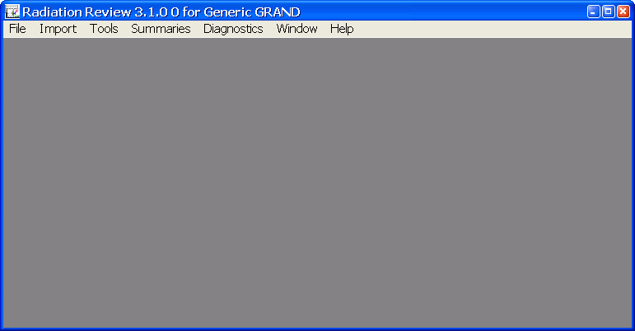
Figure 2.1-1 Main Menu
Select one of the column headings from the Main Menu Bar (File, Import, Tools, Summaries, Diagnostics, Window, or Help) by using the mouse to select the desired topic. Or you can press the Alt key plus the underlined letter indicated by the underlined character. For example, to display the File submenu you could either use the mouse to left-click on the File heading or use the keyboard to type Alt-F.

File Menu
If you select File from the Main Menu Bar, the menu in Figure 2.2-2 is displayed.
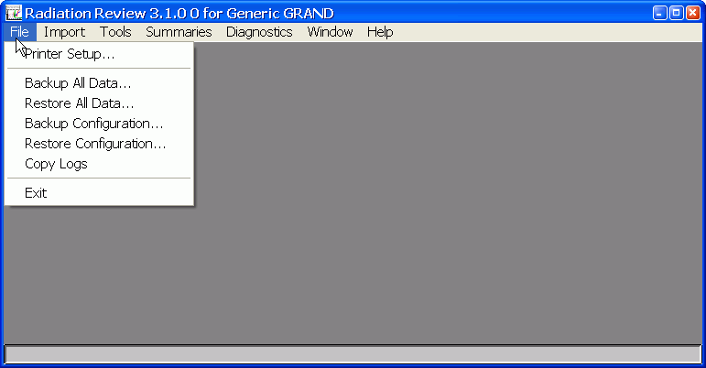
Figure 2.2-2 File Submenu

Printer Setup
The Printer Setup connects you to the standard Windows printer setup options for the default printer connected to the computer running Radiation Review.

Backup All Data
The File | Backup All Data option can be used to copy all Radiation Review data associated with the current facility. When this option is chosen, the Figure 2.2-3 dialog box is displayed.
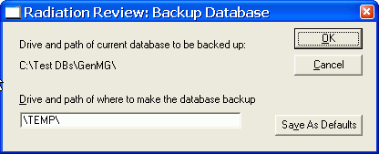
Figure 2.2-3 File | Backup All Data Dialog Box
The current facility’s database is displayed at the top of the dialog box in the Drive and path of current database to be backed up field.
To copy all Radiation Review data associated with the current facility, fill in the drive and path in the Drive and path of where to make the database backup field.
Click on Save As Defaults to save these parameters to be the defaults the next time the program is started.
Clicking on the Cancel button aborts the option and all changes you have made to the parameters are discarded.
Clicking on the OK button starts the backup process.
If a path does not exist at the specified backup directory, you are asked if you are sure you want to create the path with the question box shown in Figure 2.2-4.
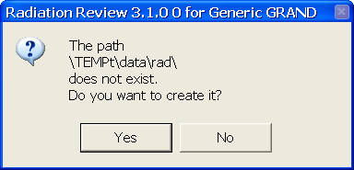
Figure 2.2-4 Create path question
If a database already exists at the specified backup directory, you are asked if you are sure you want to overwrite the database with the question box shown in Figure 2.2-5.
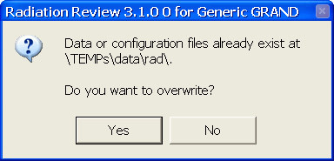
Figure 2.2-5 Overwrite database question
If you answer yes to the question, then all Radiation Review data associated with the current facility is copied to the specified directory. If the database is large this may take some time. You are updated of the progress of the copy with a dialog box. When the copy is finished, the message in Figure 2.2-6 is shown.
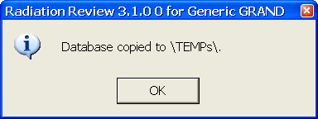
Figure 2.2-6 Database copy complete

Restore All Data
The File | Restore All Data option allows you to copy Radiation Review data from a backed-up database to the current facility database. When this option is chosen, the Figure 2.2-7 dialog box is displayed.
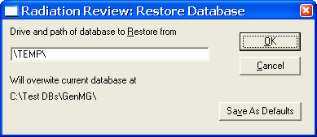
Figure 2.2-7 File | Restore All Data Dialog Box
The drive and path of the database to copy are in the Drive and path of the database to Restore from field.
The Will overwrite current database at field gives the location to which the database will be copied. This is always the database associated with the currently selected facility.
Click on Save As Defaults to save these parameters to be the defaults the next time the program is started.
Clicking on the Cancel button aborts the option and all changes you have made to the parameters are discarded.
Clicking on the OK button starts the backup (copy) process.
If a path does not exist at the specified restore directory, you are asked if you are sure you want to create the path with the question box in question Figure 2.2-4 Create path question .
If a database already exists at the specified restore directory, you are asked if you are sure you want to overwrite the database with the question box in Figure 2.2-5 Overwrite database question.
If you answer yes to either question, then all the Radiation data at the backup database are copied to the current facility’s database. If the database is large this may take some time. You are updated of the progress of the copy with a dialog box. When the copy is finished, the database specified as the restore database is opened. You are informed of this by the information in Figure 2.2-8
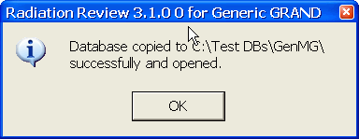
Figure 2.2-8 File | Restore All Data Complete Message

Backup Configuration
The File | Backup Configuration option can be used to copy all Radiation Review configuration information associated with the current facility. When this option is chosen, the Figure 2.2-9 dialog box is displayed.
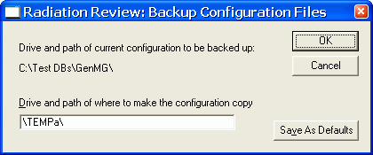
Figure 2.2-9 File | Backup Configuration Dialog Box
The location of the current facility’s configuration information is displayed at the top of the dialog box in the Drive and path of current configuration to be backed up field.
To copy all Radiation Review configuration information associated with the current facility, fill in the drive and path in the Drive and path of where to make the configuration copy field.
Click on Save As Defaults to save these parameters to be the defaults the next time the program is started.
Clicking on the Cancel button aborts the option and all changes you have made to the parameters are discarded.
Clicking on the OK button starts the backup process.
If a path does not exist at the specified backup directory, you are asked if you are sure you want to create the path with the question box shown in Figure 2.2-4.
If configuration information already exists at the specified backup directory, you are asked if you are sure you want to overwrite the database with the question box shown in Figure 2.2-5.
If you answer yes to the question, then all Radiation Review configuration information associated with the current facility is copied to the specified directory. You are updated of the progress of the copy with a dialog box. When the copy is finished, the message in Figure 2.2-10 is shown.
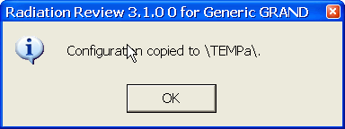
Figure 2.2-10 Configuration copy complete

Restore Configuration
The File | Restore Configuration option allows you to copy Radiation Review configuration data from a backed-up configuration. When this option is chosen, the Figure 2.2-11 dialog box is displayed.
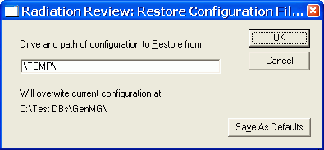
Figure 2.2-11 File | Restore Configuration Dialog Box
The drive and path of the database to copy are in the Drive and path of the configuration to Restore from field.
The Will overwrite current configuration at field gives the location to which the configuration will be copied. This is always the configuration associated with the currently selected facility.
Click on Save As Defaults to save these parameters to be the defaults the next time the program is started.
Clicking on the Cancel button aborts the option and all changes you have made to the parameters are discarded.
Clicking on the OK button starts the backup process.
If a path does not exist at the specified configuration to be written directory, you are asked if you are sure you want to create the path with the question box in question Figure 2.2-4 Create path question .
If a configuration already exists at the specified restore directory, you are asked if you are sure you want to overwrite the configuration with the question box in Figure 2.2-5 Overwrite database question.
If you answer yes to either question, then all the Radiation Review configuration data at the backup are copied to the current facility’s configuration. You are updated of the progress of the copy with a dialog box. You are informed when the configuration is copied by the message in Figure 2.2-12. It is required that you restart Radiation Review to make sure the new configuration is completely used.
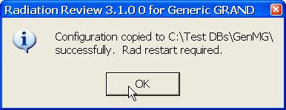
Figure 2.2-12 File | Restore All Data Complete Message

Copy Logs
The File | Copy Logs option can be used to copy all log files created by Radiation Review in the specified directory to another directory. When this option is chosen, the dialog box in Figure 2.2-13 is displayed.
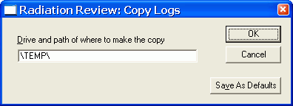
Figure 2.2-13 File | Copy Logs Dialog Box
The location of where to copy the current facility’s logs is displayed in the dialog box in the Drive and path of where to make the copy field.
Click on Save As Defaults to save these parameters to be the defaults the next time the program is started.
Clicking on the Cancel button aborts the option and all changes you have made to the parameters are discarded.
Clicking on the OK button starts the backup process.
If a path does not exist at the specified place to copy to, you are asked if you are sure you want to create the path with the question box shown in Figure 2.2-4.
All Radiation Review logs associated with the current facility are copied to the specified directory. You are updated of the progress of the copy with a dialog box. When the copy is finished, the message in Figure 2.2-14 is shown.
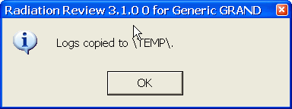
Figure 2.2-14 Logs copy complete

Exit
To exit the Radiation Review program, choose the Exit option under the File menu.

Import Menu
If you select Import from the Main Menu Bar, the menu in Figure 2.3-15 is displayed.
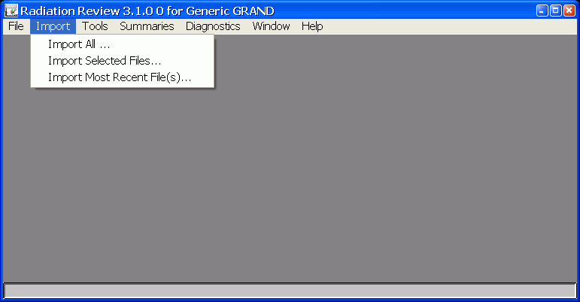
Figure 2.3-15 Import Pull-down Menu

Import All Dialog Box
The Import | Import All option allows you to import raw data from the instruments into the database. Typically, this option is used to import all data for an entire inspection period into the database. All files in the specified directory(ies) are imported. When the Import | Import All option is selected, Figure 2.3-16 appears:
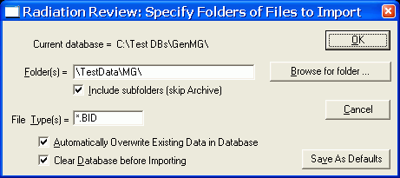
Figure 2.3-16 Import | Import All Dialog Box
The location of the database associated with the current facility is displayed in the Current database field. This is an information only parameter that cannot be changed by the user.
In the Folder(s) field, the user specifies the path or paths from which data will be imported. To specify multiple paths, separate the path names with a semicolon (;). An example would be “C:\DATA\GRAND1;C:\DATA\GRAND2”.
It is also possible to browse for the folder(s) to use for data import. If the Browse for folder button is clicked, a directory tree structure of all drives on your computer is displayed and you can select the path containing the raw data files.
If you check the Include subfolders (skip Archive) box, then the import process searches through all subfolders using the Folder(s) directory as the root. You may only have one folder as the root folder. If you have more than one path in the Folder(s) path and have the Include subfolders box checked, you are informed that only the Folder(s) paths specified will be searched (no subfolders). Any subfolders named Archive will be skipped and no data imported from those subdirectories.
In the File Type(s) field, the user specifies the extension of the files to be imported. The following types are supported:
File Extension | Instrument Data
.BID | GRAND-3 or MiniGRAND-3 data collected by DOS GRAND Collect or MIC
.BSR | JSR-11/12 data collected by DOS SR Collect
.ISR | AMSR/ISR data collected by MIC
.JSR | JSR-11/12 data collected by MIC
.MCA | MiniADC data collected by MIC
.BNY | Binary Logger data collected by MIC (Previously was *.EVT)
.ID | ID information produced by Operator Review (See Appendix A.1.3),
*sl*.* or *.vbf | VIFM data
*.ESS | EOSS binary data files produced by MIC
Note: Radiation Review 3.2.0.7 forward supports reading of signed Grand and VIFM files only. Signed, or ‘sign and forward’ .ISR data files are not processed by Radiation Review at the present time.
It is possible to specify multiple data types by separating the data types with a comma (,). For example, to import data from both GRANDs and ISRs, set the File Type(s) field to *.BID, *.ISR.
The Automatically Overwrite Existing Data in Database checkbox indicates whether to automatically overwrite a day’s information for an instrument in the database, if there is an overlap. If this box is checked, when a day’s data exists in the database and another file for the same day is imported, one of the following actions occurs:
1) if existing database data occur only after the new data, then the new data are pre-pended (added before) to the data already in the database,
2) if existing database data occur only before the new data, then the new data are appended to the data already in the database,
3) if existing database data overlap with the new data, then the existing data are deleted and the new data written to the database.
The Clear Database before Importing checkbox indicates whether to clear all data (erase) in the database before starting the import process.
If the Save As Defaults button is clicked, you have the option to save the current parameters to be the default values the next time the program starts.
To cancel the Import, select Cancel.
When you have selected your parameters, select OK to start the import.

Common Data Import Process
If the Clear Database before Importing box is checked, Figure 2.3-17 appears:
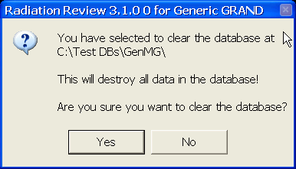
Figure 2.3-17 Clear Database Question
If you select OK to clear the database, all the data currently in the database are deleted (the parameters settings are part of the configuration information stored elsewhere and are unchanged if you clear the data). If you select to Cancel, the import process aborts.
While the data are being imported, a progress dialog box, Figure 2.3-18, showing the progress is displayed.
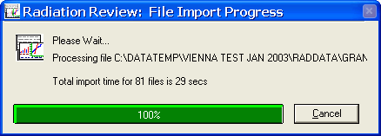
Figure 2.3-18 Import Progress Bar
A Cancel button is in the File Import Progress dialog box, Figure 2.3-18. If you select Cancel, another dialog box, Figure 2.3-19 appears asking whether you are sure you want to cancel. If you answer Yes, the import process terminates after the current file is in the database. If you answer No the import process continues.
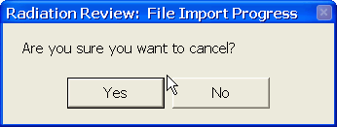
Figure 2.3-19 Cancel Import Question
When the import process is complete, a results summary is displayed in a text window similar to Figure 2.3-20, Data Import Log for All Files.
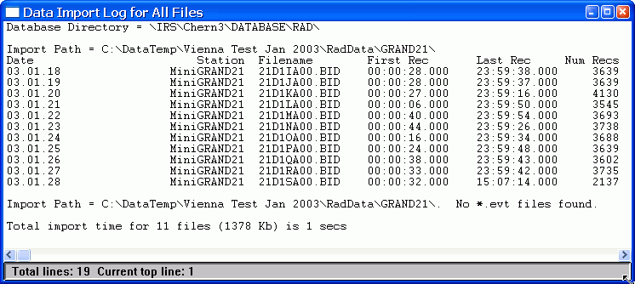
Figure 2.3-20 Import | Import All Log Results Window
The Data Import Log for All Files results window has the following sections:
Header Portion:
The first line displays the root directory path of the database(s) into which the data have been imported.
Main Results:
For each path searched a list of all the files found matching the file extension are listed. For each file the following columns of results are displayed:
Date – date for data contained in the file
Station – station associated with data in the file
Filename – name of the data file
First Rec/Last Rec – the timestamps of the first and last records in the data file (hour, minute seconds, milliseconds)
Num Recs – number of data records in the file
Optional information – any special conditions about the import such as overwriting existing data, data out of order, etc. are listed at the end of the line.
Note: The datestamps of the first and last records and number of records in the file are not displayed for the EOSS instrument type, but seal IDs found in the file are displayed instead. The EOSS data files are not day files.
Summary Portion:
In the summary at the bottom, the totals for import time, number of files and data amount in all the files imported is listed.
To get a copy of the complete results windows as shown above, you can select to copy the text window results or a portion of it to the printer or to a file or to the clipboard as described in Section 2.3.3. To access the menu that allows you to save or print results, click on the icon in the upper left corner of the text window.

Text Window Results
Anytime results are displayed in a text window in Radiation Review, you can select to copy the text window results or a portion of it to the printer or to a file or to the clipboard. To access the menu that allows you to save or print results, click on the icon in the upper left corner of the text window. Figure 2.3-21 shows the options possible for any text window.
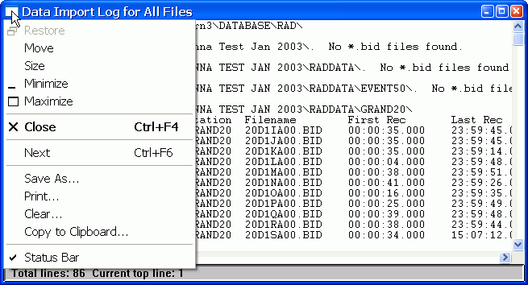
Figure 2.3-21 Text Window Actions Pull-down Menu
You can select to save or print the entire contents of the text window or only a portion (indicated by highlighting the desired portion). If you want to save only a portion of the window, just highlight the lines of interest. The following actions can be taken with either the entire text window or a portion of it:
Save As … The standard Windows File Save dialog box appears and you can select to name and save the file wherever you want to. These files can then be used to import the data into other applications, such as Microsoft Excel.
Print … You are prompted with how many lines will be printed. If you choose to print, the selected contents are printed to your default printer.
Clear … If you select this action, the contents of the text window are deleted.
Copy to Clipboard … The contents of the window are copied to the Windows Clipboard and you can paste them into any document you want.

Import Selected Files Dialog Box
The Import | Import Selected Files option allows you to import selected data files into the database. This option is used to import a subset of the possible files into the database. When the Import | Import Selected Files option is selected, the Specify Selected Files to Import dialog box, Figure 2.3-22, appears:
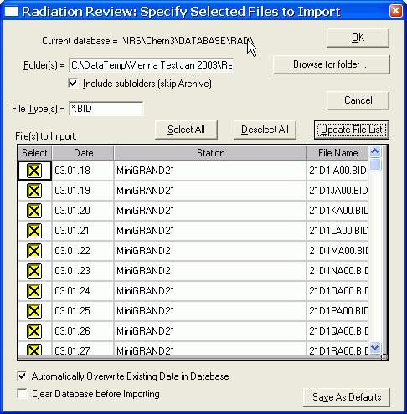
Figure 2.3-22 Import | Import Selected Files Dialog Box
The location of the database being used is displayed in the Current database field. This is an information only parameter that cannot be changed by the user.
In the Folder(s) field, the user specifies the path or paths from which data will be imported. To specify multiple paths, separate the path names with a semicolon (;). An example would be “C:\DATA\GRAND1;C:\DATA\GRAND2”.
It is also possible to browse for the folder(s) to use for data import. If the Browse for folder button is clicked, a directory tree structure of all drives on your computer is displayed and you can select the path containing the raw data files.
If you check the Include subfolders (skip Archive) box, then the import process searches through all subfolders using the Folder(s) directory as the root. You may only have one folder as the root folder. If you have more than one path in the Folder(s) path and have the Include subfolders box checked, you are informed that only the Folder(s) paths specified will be searched (no subfolders). Any subfolders named Archive will be skipped and no data imported from those subdirectories.
In the File Type(s) field, the user specifies the extension of the files to be imported. The following types are supported:
File Extension | Instrument Data
.BID | GRAND-3 or MiniGRAND-3 data collected by DOS GRAND Collect or MIC
.BSR | JSR-11/12 data collected by DOS SR Collect
.ISR | AMSR/ISR data collected by MIC
.JSR | JSR-11/12 data collected by MIC
.MCA | MiniADC data collected by MIC
.BNY | Binary Logger data collected by MIC (Previously was *.EVT)
.ID | ID information produced by Operator Review (See Appendix A.1.3),
*sl*.* or *.vbf | VIFM data
*.ESS | EOSS binary data files produced by MIC.
It is possible to specify multiple data types by separating the data types with a comma (,). For example, to import data from both GRANDs and ISRs, set the File Type(s) field to *.BID, *.ISR.
The File(s) to Import table in the dialog box displays a list of files that meet the conditions in the Folders(s) and File Type(s) fields. For each file, the date of the data in the file, the name of the station at which the data were collected, and the filename are listed. In addition there is a column labeled Select. To select a file for import, click on the Select column entry for that file. If the file is already selected indicated by an X, clicking on the X de-selects it. If there are more files in the directories than can be displayed in the dialog box, a scroll bar appears on the right side of the dialog box so that you can scroll through the files.
The Select All button can be used to select all files. When this button is clicked, an X appears in the Select column for each file.
The Deselect All button can be used to deselect every file. When this button is clicked, all X’s are removed from the Select column.
The Update File List button is used to create a new list of files based on the conditions in the Folders(s) and File Type(s) fields. It should be always clicked after you have changed the Folders(s) or File Type(s) fields.
The Automatically Overwrite Existing Data in Database checkbox indicates whether to automatically overwrite a day’s information for an instrument in the database, if there is an overlap. If this box is checked, when a day’s data exists in the database and another file for the same day is imported, one of the following actions occurs:
1) if existing database data occur only after the new data, then the new data are pre-pended (added before) to the data already in the database,
2) if existing database data occur only before the new data, then the new data are appended to the data already in the database,
3) if existing database data overlap with the new data, then the existing data are deleted and the new data written to the database.
The Clear Database before Importing checkbox indicates whether to clear all data (erase) in the database before starting the import process.
If the Save As Defaults button is clicked, you have the option to save the current parameters to be the default values the next time the program starts.
To cancel the Import, select Cancel.
When you have selected your parameters, select OK to start the import.
The same process as described in Section 2.3.2, Common Data Import Process is used to import the data.

Import Most Recent Files Dialog Box
The Import | Import Most Recent File(s) main menu option allows you to import only the most recent file in each of the specified directories. This option provides a way to quickly update the most recent data collected (typically used in real-time data review). When Import | Import Most Recent File(s) is selected, the Specify Folders of Files to Import dialog box, Figure 2.3-23, appears:
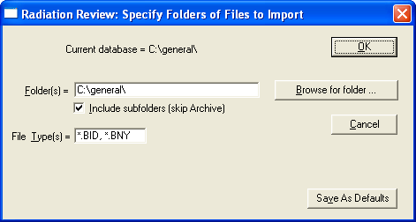
Figure 2.3-23 Import | Import Most Recent File(s) Dialog Box
The location of the database being used is displayed in the Current database field. This is an information only parameter that cannot be changed by the user.
In the Folder(s) field, the user specifies the path or paths from which data will be imported. To specify multiple paths, separate the path names with a semicolon (;). An example would be “C:\DATA\GRAND1;C:\DATA\GRAND2”.
It is also possible to browse for the folder(s) to use for data import. If the Browse for folder button is clicked, a directory tree structure of all drives on your computer is displayed and you can select the path containing the raw data files.
If you check the Include subfolders (skip Archive) box, then the import process searches through all subfolders using the Folder(s) directory as the root. You may only have one folder as the root folder. If you have more than one path in the Folder(s) path and have the Include subfolders box checked, you are informed that only the Folder(s) paths specified will be searched (no subfolders). Any subfolders named Archive will be skipped and no data imported from those subdirectories.
In the File Type(s) field, the user specifies the extension of the files to be imported. The following types are supported:
File Extension | Instrument Data
.BID | GRAND-3 or MiniGRAND-3 data collected by DOS GRAND Collect or MIC
.BSR | JSR-11/12 data collected by DOS SR Collect
.ISR | AMSR/ISR data collected by MIC
.JSR | JSR-11/12 data collected by MIC
.MCA | MiniADC data collected by MIC
.BNY | Binary Logger data collected by MIC (Previously was *.EVT)
.ID | ID information produced by Operator Review (See Appendix A.1.3),
*sl*.* or *.vbf | VIFM data
*.ESS | EOSS binary data files produced by MIC.
It is possible to specify multiple data types by separating the data types with a comma (,). For example, to import data from both GRANDs and ISRs, set the File Type(s) field to *.BID, *.ISR.
The default behavior of Import Most Recent Files is the following:
- The database is not cleared, but appended to.
- Any data found that is after the last data point in the existing database is imported.
- Data that exists in the database is not overwritten, but appended to .
If the Save As Defaults button is clicked, you have the option to save the current parameters to be the default values the next time the program starts.
To cancel the Import, select Cancel.
When you have selected your parameters, select OK to start the import.
The same process as described in Section 2.3.2, Common Data Import Process is used to import the data.

Tools Menu
If you select Tools from the Main Menu Bar, a menu similar to Figure 2.4-24 is displayed. Depending on which instruments are at the specified facility being reviewed, some of the menu options may be grayed out if they have no meaning for the specific facility.
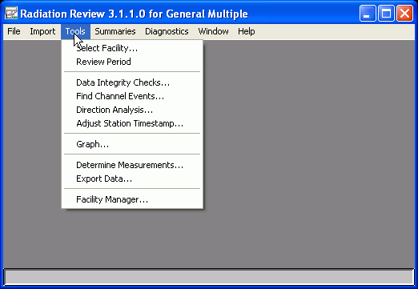
Figure 2.4-24 Tools Pull-down Menu

Select Facility
This option allows the user to select a specific facility if there is more than one facility contained in the Facility Manager database. When the Select Facility option is selected, the Figure 2.4-25 dialog box appears:
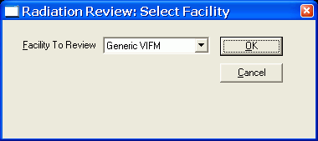
Figure 2.4-25 Tools | Select Facility Dialog Box
Clicking on the arrow in the Facility to Review field produces a list of all facilities in the current database. The user can select a different facility by clicking on the name of it in the list.
Click on Cancel to abort the option and not change the facility.
Click on the OK button to accept the current highlighted facility. Two different informational messages could appear based on whether you selected a different facility (Figure 2.4-26 ) or chose to keep the current facility (Figure 2.4-27).
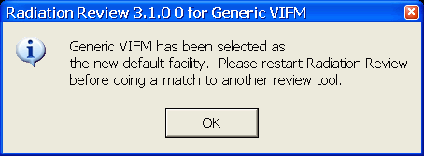
Figure 2.4-26 Different Facility Selected

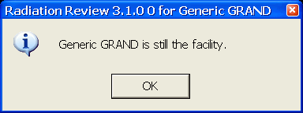
Figure 2.4-27 Same Facility Selected

Select Review Period
The Tools | Review Period main menu option allows you to specify a subset of the database as the data to be reviewed. Once a subset of the database to be reviewed is selected, then the default Search Start Date/Time and Search Time Interval values for the fields on all menu options contain this selection. When Tools | Review Period is selected Figure 2.4-28 appears:
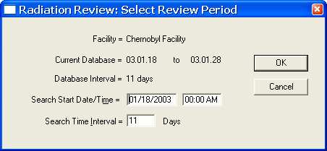
Figure 2.4-28 Tools | Review Period
The Facility name is displayed on the top line. The Current Database and Database Interval display the first and last dates of data in the database and the total number of days covered by the database. The Database Interval is expressed as days; even if a day only contains data for an hour in the day, it is counted as an entire day. Facility, Current Database and Database Interval are information only parameters and cannot be changed by the user.
The next two lines of parameters, Search Start Date/Time and Search Time Interval, allow the user to select a subset of the entire database to be used by the other review options. The Search Time Interval units can be days, hours or minutes. The default values for Search Start Date/Time and Search Time Interval vary depending on whether Radiation Review is running standalone or a part of an IRS session. In standalone mode, these parameters default to the entire database unless this Review Period menu option is executed. If this Review Period menu option is executed more than once while the program is running, then the values selected the last time OK was clicked for Select Review Period are displayed. If Radiation Review is running as part of an IRS session, then these parameters default to the time interval specified on the Inspector Information Screen or stored in the INSPEC.INI file.

Data Integrity Checks
The Tools | Data Integrity Checks option will search the data for points corresponding to the conditions specified in the parameters. This allows the user to quickly check the completeness of the data set as well as look for unexpected conditions, such as no AC power present. When the Tools | Data Integrity Checks option is selected, Figure 2.4-29 appears (various check boxes may be grayed out if they do not apply to the instrument type(s) for the facility):
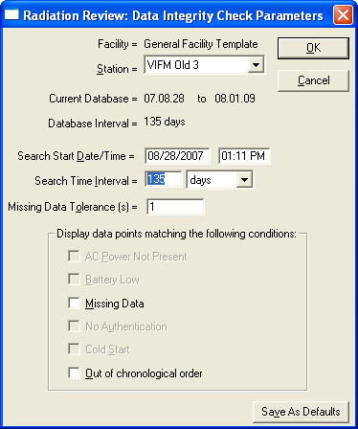
Figure 2.4-29 Tools | Data Integrity Checks Dialog Box
The Facility name is displayed on the top line. The Station field provides a dropdown list of all stations in the facility and allows the user to indicate whether to perform the search for a single station or all stations. The Current Database and Database Interval display the first and last dates of data in the database and the total number of days covered by the database. The Database Interval is expressed as days; even if a day only contains data for an hour in the day, it is counted as an entire day. Facility, Current Database and Database Interval are information only parameters and cannot be changed by the user.
The next two lines of parameters, Search Start Date/Time and Search Time Interval, allow the user to select a subset of the entire database to be used. The Search Time Interval units can be days, hours or minutes. The default values for Search Start Date/Time and Search Time Interval vary depending on whether Radiation Review is running standalone or a part of an IRS session. In standalone mode, these parameters default to the entire database or the time interval last selected using the Tools | Review Period menu option. If Radiation Review is running as part of an IRS session, then these parameters correspond to the time interval specified on the Inspector Information Screen. If you execute this menu option more than once during a program run, then on re-entry to this menu option these interval values are set to those used the last time in this menu option.
The six check boxes at the bottom of the dialog box specify the conditions for which the data can be searched. Depending on the data type of the station specified, some of the boxes may be grayed out indicating that this status does not apply to that type of data. The following data integrity checks are possible:
AC Power Not Present: the data record status is examined to see if the status indicates that AC power was not present when the record was acquired.
Battery Low: the data record status is examined to see if the status indicates that the battery was low when the record was acquired.
Missing Data: the data record is examined to see if all time is accounted for. For each data point in the interval, the expected timestamp of the next point is calculated as a function of its elapsed time and its timestamp. The next data point timestamp is expected to be a calculated number (elapsed time * 1.1 + x where x is the Missing Data Tolerance) of seconds beyond the current point’s timestamp. If the timestamp of the next point is more than this expected difference, data is said to be missing in the data set.
No Authentication: the data record status is examined to see if the status indicates that the record could not be authenticated by the data collection program. When data are transmitted between the instrument Monitor firmware and MIC, each data record is authenticated. The first records transmitted after a Cold Start are not expected to be authenticated. All other records are expected to be authenticated.
Cold Start: the data record status is examined to see if the status indicates that the data record was acquired when the Monitor program was in the cold start state. When the Monitor program in the GRAND-3 is completely reset (by doing a switch 2 reset in the hardware), it is called a cold start. All data records will indicate a cold start status until a group of records has been successfully transmitted to MIC. Since cold start records require physically changing the GRAND-3 hardware switch state, cold start records are expected only after new software has been installed or maintenance has been done on a GRAND-3.
Out of Chronological Order: each data record in the interval is checked to see if its timestamp is greater than or equal to the timestamp of the previous data point. If it is not, the data are declared out of order. The data should only be out of order when the time in the instrument is changed to be an earlier time.
Note: Checks do not apply to all instruments data. Those that don’t apply the check boxes will be grayed out for that instrument.
Since the conditions depend on the instrument type of the station, once you select a new station the station type’s applicable conditions to be enabled/disabled in the list of checkboxes.
Clicking on the Cancel button aborts the option and all changes you have made to the parameters are discarded.
Click on Save As Defaults to save these parameters to be the defaults the next time the program is started.
Clicking on the OK button starts the search.
The data in the specified station(s) is searched for the requested condition(s). Depending on the amount of data in the interval, this search may take several minutes. As each station is searched, the current status of the search is shown in a dialog box with a Cancel button at the bottom. If you select to Cancel the search process, another dialog box appears asking whether you are sure you want to Cancel. If you answer Yes, the search process stops with the current data set. If you answer No, the integrity check continues.
During the search, a results window, Data Matching Status Flag Conditions, is updated. The first part of the results window documents the search conditions and lists the status definitions for the instrument. Any records that match one of the specified conditions are displayed with a 3-character code indicating the reasons. The possibilities are (these are listed in the order the conditions are searched):
AC – No AC power present,
Low – Battery low,
CS – Cold Start,
Ath – Authentication Error
MII – In Measurement Interval of Interest
Out – Out of Order and
Gap – missing data
If a data record matches 2 or more conditions, only the last matching reason is printed. The following three text windows show sample results from three different kinds of instruments supported by Radiation Review: MiniGRAND/GRANDs, AMSR/ISRs and MiniADCs. If an instrument operated with no problems during the inspection, you would expect to find 0 conditions matching.
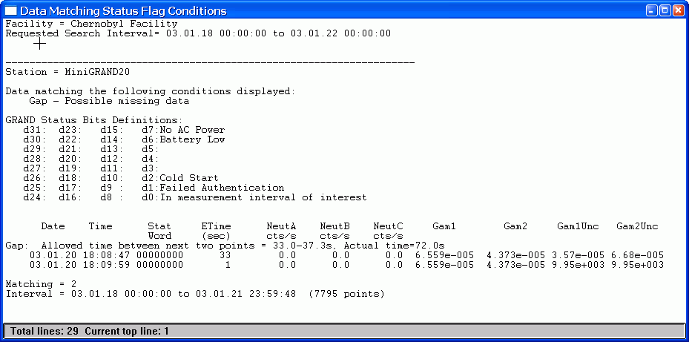
Figure 2.4-30 Tools | Data Integrity MiniGRAND/GRAND Text Window Results
The Data Matching Status Flag Conditions results window has the following sections for MiniGRAND/GRAND instruments:
Header Portion:
The first lines in the results text window display the facility specific header. The next section lists the search parameters.
Main Results:
For each station searched a list of all the data points matching the specified conditions are listed. For each data point the following columns of results are displayed:
First Column: Which condition the data point matches
Date/Time – the date/time
Stat Word – the status word associated with the data record (hexadecimal format),
Etime – the elapsed time,
Neut A – the count rate in pulse channel A,
Neut B – the count rate in pulse channel B,
Neut C – the count rate in pulse channel C,
Gam1 – the relative gammas in the first current channel,
Gam2 – the relative gammas in the second current channel,
Gam1 Unc – for GRAND-3s, the uncertainty associated with the Gam1 relative gammas; for MiniGRANDs depending on the MiniGRAND configuration this is either the Gam 1 relative gammas uncertainty or the internal temperature,
Gam2 Unc – for GRAND-3s, the uncertainty associated with the Gam2 relative gammas; for MiniGRANDs depending on the MiniGRAND configuration this is either the Gam 2 relative gammas uncertainty or the external temperature.
Summary Portion:
In the summary at the bottom, the status of the search, the number of matching data points and the search interval are displayed.

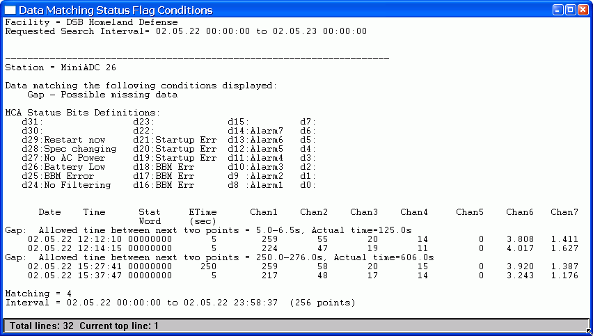
Figure 2.4-31 Tools | Data Integrity MiniADC Text Window Results
The Data Matching Status Flag Conditions results window has the following sections for MiniADC instruments:
Header Portion:
The first lines in the results text window display the facility specific header. The next section lists the search parameters.
Main Results:
For each station searched a list of all the data points matching the specified conditions are listed. For each data point the following columns of results are displayed:
First Column: Which condition the data point matches
Date/Time – the date/time
Stat Word – the status word associated with the data record (hexadecimal format),
Etime – the elapsed time,
Chan 1, Chan2, Chan3, Chan4, Chan5, Chan6, Chan7 – the counts in the channels defined in the MiniADC.
Summary Portion:
In the summary at the bottom, the status of the search, the number of matching data points and the search interval are displayed.

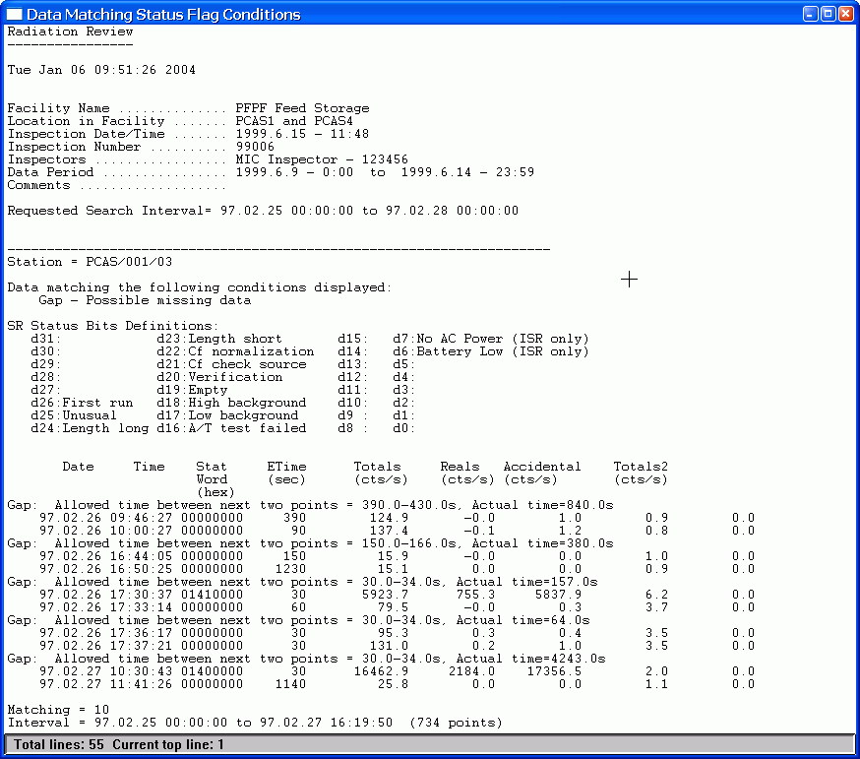
Figure 2.4-32 Tools | Data Integrity SR Text Window Results
The Data Matching Status Flag Conditions results window has the following sections for JSR/ISR/AMSR instruments:
Header Portion:
The first lines in the results text window display the facility specific header. The next section lists the search parameters.
Main Results:
For each station searched a list of all the data points matching the specified conditions are listed. For each data point the following columns of results are displayed:
First Column: Which condition the data point matches
Date/Time – the date/time
Stat Word – the status word associated with the data record (hexadecimal format),
Etime – the elapsed time,
Totals – the totals (singles) count rate,
Reals – the reals (doubles) count rate,
Accidentals – the accidentals count rate,
Totals 2 – the second totals count rate.
Summary Portion:
In the summary at the bottom, the status of the search, the number of matching data points and the search interval are displayed.
To get a copy of the complete results windows as shown above, you can select to copy the text window results or a portion of it to the printer or to a file or to the clipboard as described in Section 2.3.3. To access the menu that allows you to save or print results, click on the icon in the upper left corner of the text window.

Find Channel Events
The Tools | Find Channel Events option will search the database for peaks corresponding to the conditions specified in the parameters. The parameters must be carefully set for each facility. Typically experts such as facility officers set these parameters. See Appendix D for directions on how to determine the parameters for a given facility. When the Tools | Find Channel Events option is selected, Figure 2.4-33 appears:
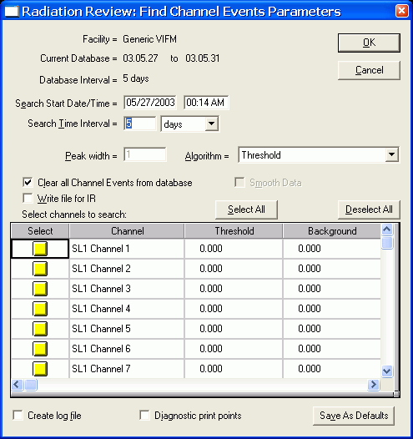
Figure 2.4-33 Tools | Find Channel Events Dialog Box
The Facility name is displayed on the top line. The Current Database and Database Interval display the first and last dates of data in the database and the total number of days covered by the database. The Database Interval is expressed as days; even if a day only contains data for an hour in the day, it is counted as an entire day. Facility, Current Database and Database Interval are information only parameters and cannot be changed by the user.
The next two lines of parameters, Search Start Date/Time and Search Time Interval, allow the user to select a subset of the entire database to be used. The Search Time Interval units can be days, hours or minutes. The default values for Search Start Date/Time and Search Time Interval vary depending on whether Radiation Review is running standalone or a part of an IRS session. In standalone mode, these parameters default to the entire database or the time interval last selected using the Tools | Review Period menu option. If Radiation Review is running as part of an IRS session, then these parameters correspond to the time interval specified on the Inspector Information Screen. If you execute this menu option more than once during a program run, then on re-entry to this menu option these interval values are set to those used the last time in this menu option.
The Peak Width, Algorithm and Smooth Data parameters should be set to facility specific values (not all values apply to all algorithms).
The Algorithm allows you to specify which search algorithm to be used. Radiation Review currently supports 3 algorithms:
Threshold - The data in each selected channel are analyzed, channel events are defined as those data points which are above the threshold value entered for that channel in the table. Each channel event is defined as starting with the first data point that is above the threshold and ends with the last consecutive data point above the threshold. This search algorithm is well-suited for facilities with a constant background whose radiation movements are easily distinguished from the background. (The background value in the table, the peak width and the smooth data parameters are not used for this algorithm.)
Sliding Window with Background - The data in each selected channel are analyzed by applying a “comb-type filter” to the data and a second data array is formed. The peak containing a channel event is located by evaluating whether the data in the second array are above the threshold. If data are found to be above the threshold in the second array, then the start and end of the event are determined by searching backwards and forwards to find the first and last consecutive data points of the original data that are above the background specified. If smoothed data have been selected, then the original data is smoothed before the calculations. The peak width is used in the Sliding Window with Background algorithm. This search algorithm is well-suited for facilities that have a constant background and whose channel events can be distinguished from the current background value specified. The threshold and background values are determined as described in Appendix D, Section D.1.
Sliding Window with Local Background - this algorithm is similar to the Sliding Window with Background. The peak containing a channel event is found by checking if the data in the second data array are above the threshold just like before. The start and end points are determined by when the second data array crosses zero. If smoothed data are selected, then the original data is smoothed before the calculations. The peak width is used in the Sliding Window with Local Background algorithm. The search algorithm is well-suited for facilities that do not have a constant background but whose channel events can be distinguished from the current local background. The threshold and background values are determined as described in Appendix D, Section D.1.
The Peak Width parameter used in the Sliding Window analyses specifies the average number of points contained in the peak; a single number must represent all channels so if the peaks are different widths in different channels an estimate that represents all of them is entered. The number is obtained by examining typical data on the graph and counting the points in several typical peaks. (Since this does not apply to the Threshold Algorithm, the field cannot be edited when Threshold is selected as the Algorithm).
The Smooth Data checkbox used in the Sliding Window analyses specifies whether a three-point smooth should be done on the data before the search Algorithm is executed. (Since this does not apply to the Threshold Algorithm, the box is not enabled when Threshold is selected as the Algorithm).
Table Columns: The table at the bottom of the dialog box contains an entry for each channel at the facility. The table contains these columns:
Select - a checkbox for whether the channel is selected (should be analyzed),
Channel - the channel name (cannot edit this column)
Threshold – the value above which data are considered to be an event,
Background – for Sliding Window analyses, this is the typical background for the channel (cannot edit this column if Algorithm = Threshold).
If there are more channels in the facility than can be displayed, a scroll bar appears at the right side of the dialog box of the table. The threshold and background values are determined as described in Appendix D, Section D.1.
The Select All and Deselect All buttons allow you to select all or none of the channels for analysis. Individual channels can be selected/de-selected by clicking on the X in the Select column for that channel.
The Clear All Channel Events from Database checkbox can be used to delete all the channel events that are currently in the database before the new search is started.
The Write File for IR checkbox, if checked, indicates that the results of the search should be written to the file for use by Integrated Review. The format of the file is described in Appendix A. Section A 2.5.
The Create log file box can be checked if the user wants the results written to a file. If this box is checked, when the analysis begins, the user will be prompted for the filename in which to store the results. The format of the file is described in Appendix A. Section A 2.4.
The Diagnostic Print Points box is used only by an expert during the parameter determination. In order to correctly identify what the values for the threshold and background are for the different algorithms, this option gives the user a list of the raw data, smoothed data and calculated data for the specified time period. By examining the values around an event, the expert determines which parameter values should be used. In normal operation this is never checked! See Appendix D for more details.
Clicking on the Cancel button aborts the option and all changes you have made to the parameters are discarded.
Click on Save As Defaults to save these parameters to be the defaults the next time the program is started.
Clicking on the OK button starts the search.
The channels are searched on a station by station basis. Depending on the amount of data in the interval, this search may take several minutes. As the stations are being searched, a progress bar, Figure 2.4-34, appears indicating the current status of the search. There is a progress bar for each station.
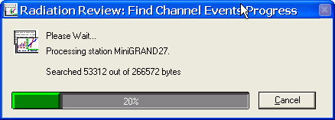
Figure 2.4-34 Event Search Progress Bar
The progress bar dialog box indicates which station is being processed, the amount of data to search and percentage of the search for the station finished so far. If you click on the Cancel button, a second dialog box appears asking if you are really sure you want to cancel the search. If you answer No, then the search is continued. If you answer Yes, the search stops when the current analysis is completed and the partial results are displayed.
While the search is being performed, the results are being written to the Channel Events Found text window, Figure 2.4-35. This window is constantly updated as the search proceeds. When the search is finished you may examine the results in this window.
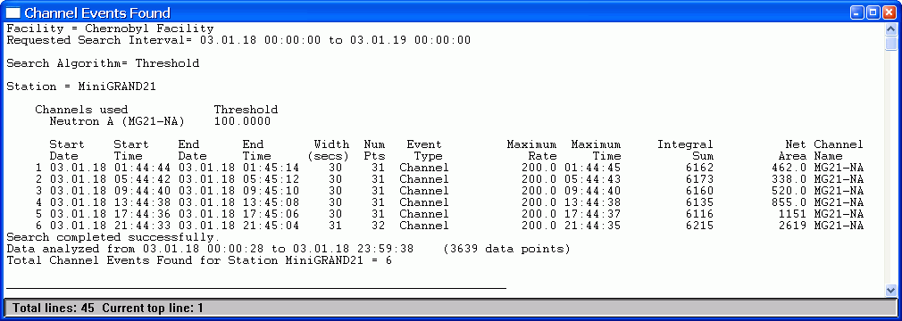
Figure 2.4-35 Tools | Find Channel Events Text Window Results
The Channel Events Found results window has the following sections:
Header Portion:
The first lines in the results text window display the facility specific header. The next section lists the search parameters including the choice of algorithm and which channels were selected to be searched.
Main Results:
Then for each station searched a list of all the events found in the interval are listed. For each event the following columns of results are displayed:
Start Date/Start Time – for this event, the date/time when the event started
End Date/End Time – for this event, the end time
Width – the duration of this event in seconds calculated by subtracting the start time from the end time. The width includes both the start and end time in the interval, so events with an identical start/end time are given a length of 1.
Num Pts – the number of data points found in the event.
Event Type – This column indicates the type of event – at present the only choice that will appear is Channel indicating the event was found with the Find Events menu option.
Maximum Rate/Maximum Time – the rate displays the highest count rate in the channel within the event and the time indicates the timestamp associated with that rate.
Integral Sum – the integral sum is the sum of the total counts (not count rates) in the event (including the start/end time points)
Net Area – the net area (counts) represents the total counts (area) above a straight line going from the start time to the end time. This is intended as a general indication of net area – for a precise net area calculation, a more accurate method should be used to do the background subtraction.
Summary Portion:
In the summary at the bottom, the status of the search, the data interval and number of data points in the interval, and the number of channel events found for the station are listed.
Log File: If you had checked the Create Log File on the original Find Events dialog box, the results without the header and summary portions are written to the text file that you selected when asked at the start of the search. That file and its format are described in Appendix A., Section A.2.4.
To get a copy of the complete results windows as shown above, you can select to copy the text window results or a portion of it to the printer or to a file or to the clipboard as described in Section 2.3.3. To access the menu that allows you to save or print results, click on the icon in the upper left corner of the text window.
IR File: In addition if Radiation Review is running as part of an IRS session, one of the options is to have a file containing some of these results produced for use by Integrated Review. That file and its format are described in Appendix A., Section A.2.5.

Direction Analysis
The Tools | Direction Analysis main menu option will search pairs of events in the database to determine the time sequence in which they occurred. If an event occurs in channel A and then 5 seconds later an event occurs in channel B, the direction of motion is said to be from A to B. Since the direction analysis is done on the events in the specified channels, events must have been found using the Tools | Find Events or Tools | Determine Measurements menu option before executing the Tools | Direction Analysis menu option. Because this option involves comparing times from events in different channels, you must carefully select to compare events on either a single station or time-synchronized stations. Typically all parameters are carefully set for each facility by an expert such as the facility officer. See Appendix D, Section D.2 for directions on how to determine the parameters for a given facility. When the Tools | Direction Analysis option is selected, Figure 2.4-36 appears:
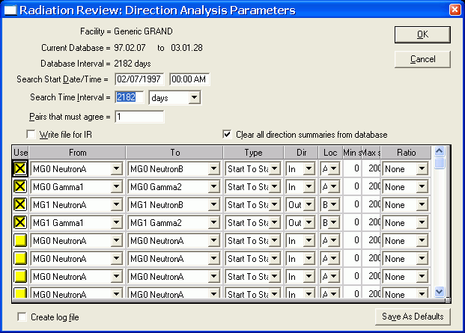
Figure 2.4-36 Tools | Direction Analysis Dialog Box
The Facility name is displayed on the top line. The Current Database and Database Interval display the first and last dates of data in the database and the total number of days covered by the database. The Database Interval is expressed as days; even if a day only contains data for an hour in the day, it is counted as an entire day. Facility, Current Database and Database Interval are information only parameters and cannot be changed by the user.
The next two lines of parameters, Search Start Date/Time and Search Time Interval, allow the user to select a subset of the entire database to be used. The Search Time Interval units can be days, hours or minutes. The default values for Search Start Date/Time and Search Time Interval vary depending on whether Radiation Review is running standalone or a part of an IRS session. In standalone mode, these parameters default to the entire database or the time interval last selected using the Tools | Review Period menu option. If Radiation Review is running as part of an IRS session, then these parameters correspond to the time interval specified on the Inspector Information Screen. If you execute this menu option more than once during a program run, then on re-entry to this menu option these interval values are set to those used the last time in this menu option.
The Pairs that must agree parameters allow you to specify how many of the specified From/To pairs must agree to establish a condition. (Currently only one pair is allowed.)
The Clear all direction summaries from database checkbox, if checked, causes all direction summaries that are currently in the database to be deleted before the new search is started.
The Write File for IR checkbox, if checked, indicates that the results of the search should be written to the file for use by Integrated Review. The format of the file is described in Appendix A. Section A 2.7.
Table Columns: The conditions for the direction search are set in the table. The table has as many entries as there are channels in the facility; if all the entries cannot be displayed a scroll bar on the right-hand side of the table appears. The following columns are in the table:
Use- check the box for each condition that you want to add to your search.
From - specifies the first channel in which the movement is detected. If you click on the arrow in the right-hand part of the column, a list of all channels in the facility appears and you can select the desired channel. If the movement is from Neutron A to Neutron B, for example, Neutron A would be in the From column.
To - specifies the second channel in which the movement is detected. If you click on the arrow in the right-hand part of the column, a list of all channels in the facility appears and you can select the needed channel. If the movement is from Neutron A to Neutron B, for example, Neutron B would be in the To column.
Type – sets the condition for which edges of the channel event to use when deciding whether the events are in the same group. The choices are Start to Start, Start to End, End to Start and End to End. These conditions have the following meaning:
Start to Start - Start time of the From event is compared to the Start time of the To event,
Start to End – Start time of the From event is compared to the End time of the To event,
End to Start – End time of the From event is compared to the Start time of the To event,
End to End – End time of the From event is compared to the End time of the To event.
Dir – sets the direction of motion that describes the movement. If moving from Neutron A to Neutron B is moving into the facility, then you would select In. The only choices for this column are In, Out, None or In/Out. There is no standard way to describe what is in or out – these are facility specific parameters that must be defined. These choices have the following meaning:
In - used to signal an inward movement,
Out – used to signal an outward movement,
None – used to describe a movement that cannot be classified as either in or out,
In/Out – used to describe a movement that was both in and out. For example if the From and To channels are the same channel then a directional movement would signal that the item moved both in and out.
Loc - defines the location where the movement has occurred; the only choices are the generic locations, A and B. These generic locations must be “mapped” to definitions that have meaning for the specific facility.
Min, Max - these two columns specify the time boundaries of the condition. The columns have this meaning:
Min - specifies the minimum number of seconds that must pass from the time that the From event edge starts until the To event edge starts. This number can be 0 or greater.
Max - specifies the maximum number of seconds that can pass from the time that the From event edge started until the To event edge begins.
For example if you set Min to 5 and Max to 60 and the Type as Start to Start then if the From event starts at 10:40:35 then the To event must begin in the range of 10:40:40 - 10:41:35.
Ratio - specifies a simple relationship between the rows of the table. Typically this column is used to calculate a rough neutron/gamma ratio that can tell something about the type of material that was moved. Your choices are Numerator, Denominator or None. If you select a row to be used in the numerator calculation, then the maximum values of both the From and To channel are included in a numerator sum and likewise for the denominator. If you select None, then this row is ignored in the ratio calculation.
Clicking on the Cancel button aborts the option and all changes you have made to the parameters are discarded.
Click on Save As Defaults to save these parameters to be the defaults the next time the program is started.
Clicking on the OK button starts the search.
The channel events for the pairs of channels for each condition are searched. In order to qualify as matching the criteria, the following analysis is performed. First all events in the database are grouped using the Type and Min/Max criteria; based on the Type the following algorithms are executed:
Start to Start – check if the beginning time of the first event in the database is within the Min/Max criteria of the next event’s beginning time. If yes, set the group time of both events to be the beginning time of the first event. If no, then use the second and third events in the database for the comparison. Continue until all database events have been compared.
Start to End – check if the beginning time of the first event in the database is within the Min/Max criteria of the next event’s ending time. If yes, set the group time of both events to be the beginning time of the first event. If no, then use the second and third events in the database for the comparison. Continue until all database events have been compared.
End to Start – check if the ending time of the first event in the database is within the Min/Max criteria of the next event’s beginning time. If yes, set the group time of both events to be the beginning time of the first event. If no, then use the second and third events in the database for the comparison. Continue until all database events have been compared.
End to End – check if the ending time of the first event in the database is within the Min/Max criteria of the next event’s ending time. If yes, set the group time of both events to be the beginning time of the first event. If no, then use the second and third events in the database for the comparison. Continue until all database events have been compared.
Note – previous versions of Radiation Review used the maximum values rather than the start/end of the events for the calculations; this version does the calculation based on the actual start/end times.
The results are displayed in a text window similar to Figure 2.4-37.
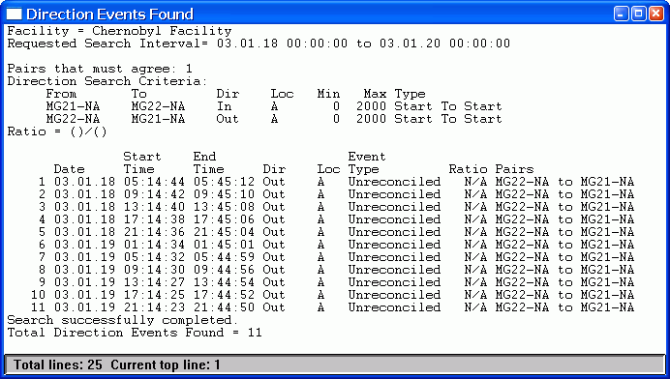
Figure 2.4-37 Tools | Direction Analysis Text Window Results
The Direction Analysis results window has the following sections:
Header Portion:
The top of the results text window shows the facility, search interval and the conditions selected for this particular search (the number of pairs, which pairs and their conditions, and the channels to use in the ratio calculation).
Main Results:
The direction events found are printed. For each event the following columns of results are displayed:
Date – for this event, the date when the event started
Start Time – for this event, the time when the event started
End Time – for this event, the end time (normally the date of the end time is the same as the start time)
Dir – the direction assigned to this movement,
Loc – where the direction occurred,
Event Type – always is Unreconciled,
Ratio – results of calculation specified in dialog box, if no calculation is specified, this entry is N/A for not applicable.
Pairs - pairs of channels containing channel events that met the specified conditions and indicate the direction of motion (x to y). The short names of the channels are used.
Summary Portion:
In the summary at the bottom, the status of the search and total direction events found is displayed.
Log File: If you had checked the Create Log File on the original Direction Analysis dialog box, the results without the header and summary portions would be written to the text file that you selected. See Appendix A, Section A.2.6.
To get a copy of the complete results windows as shown above, you can select to copy the text window results or a portion of it to the printer or to a file or to the clipboard as described in Section 2.3.3. To access the menu that allows you to save or print results, click on the icon in the upper left corner of the text window.
IR File: In addition if Radiation Review is running as part of an IRS session, one of the options is to have a file containing some of these results produced for use by Integrated Review. That file and its format are described in Appendix A, Section A.2.7.

Adjust Station Timestamp
The Tools | Adjust Station Timestamp main menu option is used to align the times of two or more stations whose data were collected when the station clocks were not synchronized. If this option is used, the data should be time-aligned immediately after the data have been imported before any analysis has been done. In order to use this option, the user must be able to identify precisely when common events occurred on two or more stations (typically done using the graph). The time of the first station checked in the list is considered to be the “correct” time and all data from selected stations below it are corrected to align with the “correct” time. When the Tools | Adjust Station Timestamp option is selected, the dialog box and graph shown in Figure 2.4-38 appears:
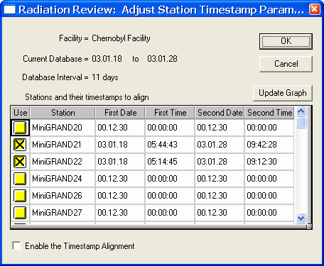
Figure 2.4-38 Tools | Adjust Station Timestamp Dialog Box
The Facility name is displayed on the top line. The Current Database and Database Interval display the first and last dates of data in the database and the total number of days covered by the database. The Database Interval is expressed as days; even if a day only contains data for an hour in the day, it is counted as an entire day. Facility, Current Database and Database Interval are information only parameters and cannot be changed by the user.
The table in the lower half of the dialog box allows the user to enter the times of two events that are known to occur at precisely the same time on two or more stations. The columns of the table are defined as:
Use – check the box for each station that you know had an event at the same time
Station – names of the stations in the facility – this column cannot be changed
First Date – the day of the first common event
First Time – the time of the first common event
Second Date – the day of the second common event
Second Time – the time of the second common event.
The checkbox Enable the Timestamp Alignment is checked for the alignment to occur. This box allows the user to look at data in the both uncorrected and corrected formats.
Clicking on the Cancel button aborts the option and all changes you have made to the parameters are discarded.
All parameters are automatically saved when the analysis is done. There is no Save As Defaults button.
Clicking on the OK button starts the calculation.
During the calculation the parameters are saved and the slope and intercept of a straight line going from time 1 to time 2 is calculated. If the timestamp alignment is active (Enable the Timestamp Alignment box is checked), then each time data are accessed either for raw data or to retrieve results the timestamp is adjusted. The database always maintains data with the original times read from the raw data files.
It is important that you conduct all analysis with a common time base – either everything is done with adjusted timestamps or all with unadjusted timestamps. If you would perform the following steps in this order: Import All, then Find Channel Events and then Adjust Station Timestamp, you will see that the “events” marked on the graph are not on the peaks. This is because you used unadjusted times for the Find Channel Events and then used adjusted timestamps for the Graph. The proper sequence would be: Import All, Adjust Station Timestamp, Find Channel Events and then Graph.

Graph
The Tools | Graph main menu option is used to graphically display the data in the database. This allows the user to quickly examine the data for trends and information of interest. Attempts have been made to optimize the most commonly used graph features. When the Tools | Graph option is selected, the dialog box and graph shown in Figure 2.4-39 appears:
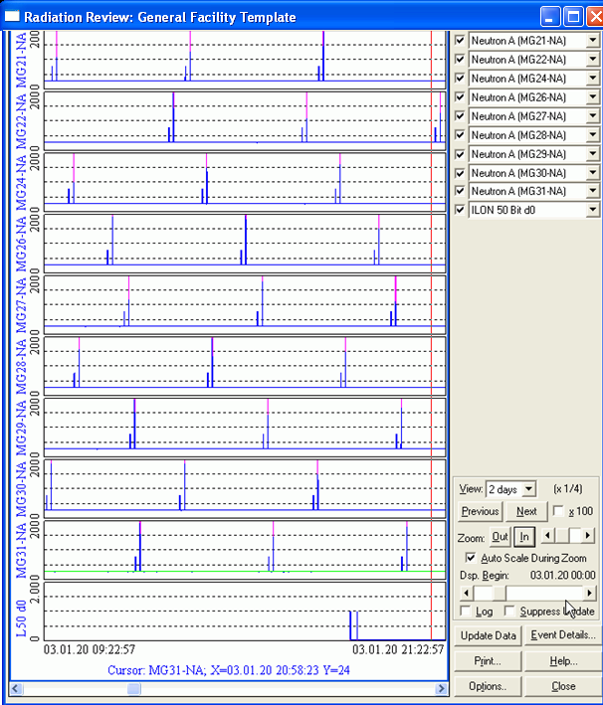
Figure 2.4-39 Tools | Graph Dialog Box and Display
The graph consists of several components:
Graph traces:
On the left side of the dialog boxes, there are from 1 to 10 traces. Each trace displays the time series data associated with one channel from a station (instrument). The channel name associated with each trace is listed on the left-hand axis of each trace – you can also determine the associated channels by looking at the boxes checked in the upper right portion of the dialog box.
The normal color for a trace is blue. A pink trace indicates channel events found using the Tools | Find Channel Event menu option. An orange trace indicates measurement events found using the Tools | Determine Measurements menu option. A gray trace indicates a manually marked background.
Graph cursor:
The timestamp and data associated with a data point can be displayed by using the cursor. The cursor is indicated by red crosshairs. The cursor extends vertically across all the traces so that timestamps on one trace can be correlated with timestamps on another trace.
The data at the cursor position are printed at the bottom of all the traces and include the trace (channel) name, the x value (date/time) and the y value. The color of the cursor readout information corresponds to the type of data point on which it resides. The following colors indicate the different kinds of information: pink - channel event, orange – measurement event, gray - background, red - mark.
Cursor movement left and right:
To move the cursor left or right on a trace, either:
click on a location to the left or right of the present cursor position or
use the left/right arrow keys on the keyboard to move one point left or right.
Cursor movement from trace to trace:
To move the cursor from one trace to the same time on another trace, click anywhere in the trace area of the new trace. The cursor will move to the new trace at the same time as on the previous trace (if the exact time is not present on the new data trace, you are informed on the bottom line of cursor information that this data is interpolated).
To move the cursor from one trace to a new time on another trace, click twice at the new trace and time desired. The first click moves to the new trace, the second click to the new timestamp.
Selecting how many channels to display:
The upper right corner of the display allows you to select up to 10 traces (channels) to be displayed. The channels containing a checked box by their label will be displayed. The top trace is associated with the first box checked. The number of traces available is decreased to 9 if you are using a low-resolution (800 X 600 or less) monitor. A minimum recommended monitor resolution is 1024x768; more is better.
Selecting which channels to display:
Once a trace (channel) in the upper right corner of the dialog box has a checked box, click on the right hand arrow to display a list of all channels possible. You can change which channel is displayed by selecting another channel from the list.
Selecting view period:
The View box allows you to select the interval to be displayed on the graph x-axis. You can select time intervals from 5 minutes up to 110 days.
Selecting next/previous view period:
The Previous and Next buttons allow you to select the Previous view period or the Next view period. For example, if the View box is set to 8 hours and you select Previous then the previous 8 hours are displayed in graph x-axis.
Zoom:
There are several methods for zooming in and out on the plots.
1) The checkbox x100 zooms in by a factor of 100 around the current location of the cursor. 2) Each time you click on the Out or In box you zoom in/out by an additional factor of two.
3) Alternately you can use the scroll bar next to the In/Out buttons to zoom by a variable amount; the amount of the zoom is displayed on the line with the View amount.
The maximum zoom amount is 100x99 or 9900.
When the graph is zoomed in, a scroll bar appears along the x-axis of the bottom graph trace. You can use this to scroll through the expanded data by clicking on the endpoints of the scrollbar.
Auto scale during zoom:
If the checkbox Auto Scale During Zoom is checked then the graphical display will automatically scale vertically to the data being displayed. If the check box is not checked, then the graphical display will retain the same scale as was present before the zoom was performed.
Selecting time to display using scroll bar:
There is a scroll bar in the middle of the lower right corner area of the dialog box labeled Dsp. Begin (Display Begin). This scroll bar represents the entire time interval covered by the database. The thumb (scroll box) can be dragged along the scroll bar to select a different starting time. As the thumb is moved, the date/time above the scroll bar are updated; this date/time is where the graph will be started. When the thumb is released, the graph is updated using the scroll bar time as the beginning time.
Log/linear display:
To change between log and linear scale, simply check the Log checkbox. This will toggle between log and linear scale. In log scale, negative numbers and 0 are plotted as the lowest value in the data array although their actual value is displayed with the cursor readout. All traces is set to log or linear – it is not possible to have some log traces and some linear traces.
Suppress Update:
If the suppress update box is checked, then no data are present on the graph traces. This is helpful when configuring which graph traces to display. After the graph layout is complete, uncheck the suppress update box and the data are displayed.
Mark/Unmarking time on graph:
There are 6 buttons in the lower right of the dialog box. The upper left button can be labeled either Mark/Unmark or Update depending on a checkbox in the Graph Options button. If the button is labeled Mark, then the time associated with the cursor position can be labeled on the graph. To label a specific time on a graph trace, position the cursor at the position to be labeled. Select the Mark key and the time will be labeled on the graph trace. In addition to the time being labeled on the graph trace, the information is entered into the database. The next time the cursor is on this point the cursor readout information at the bottom of the screen will be red to indicate this is a marked point and the button label changes to Unmark when the cursor is residing on the marked point.
Update:
There are 6 buttons in the lower right of the dialog box. The upper left button can be labeled either Mark/Unmark or Update depending on a checkbox in the Graph Options button. If the button is Update, then the action normally taken with the Import|Import Most Recent File(s) is performed when the button is clicked. This is useful when you are viewing data in near-real-time.
Event Details
Capabilities exist for adding, editing or deleting events on a graph trace. To access these capabilities, click the Event Details button. Either Figure 2.4-40 or Figure 2.4-41 dialog box appears depending on whether the cursor on the graph is located in an event or not.
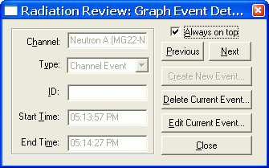
Figure 2.4-40 Graph Event Details Dialog Box of Existing Event

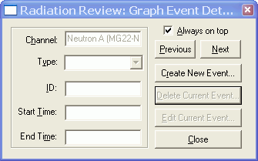
Figure 2.4-41 Graph Event Details Dialog Box of New Event
The left-hand column of the dialog box shows this information about the event (if any) in which the cursor currently resides: the channel name, the type of event, the associated ID if this event is a measurement, and the start/end time of the event. Which buttons are enabled in the right-hand column of the dialog box depends on whether the cursor is currently in an event or not. If the cursor is positioned in an event, the Delete Current Event and Edit Current Event are enabled.
If you are in an event and select Delete Current Event, another dialog box Figure 2.4-42 appears asking if you are sure you want to delete the event. If you answer yes, the event is deleted and the graph redrawn and the event will no longer be highlighted in a different color. If you answer No, no changes are made in the graph.
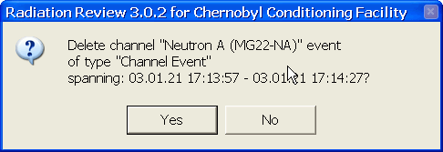
Figure 2.4-42 Graph Delete Event Question
If you select Edit Current Event, the same dialog box is displayed as before except this time the left-hand columns are available for editing as indicated by Figure 2.4-43.
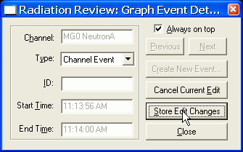
Figure 2.4-43 Graph Edit Event Dialog Box
In addition the selected event is marked on the graph trace with a heavy pink trace and a bounding box indicated by dotted lines appears around the event (see Figure 2.4-44). Several actions are possible at this point: in the left hand column of the dialog box you can select an event type and enter an ID, on the graph trace you can use the cursor to adjust the left/right sides of the bounding box to change the event start/end times
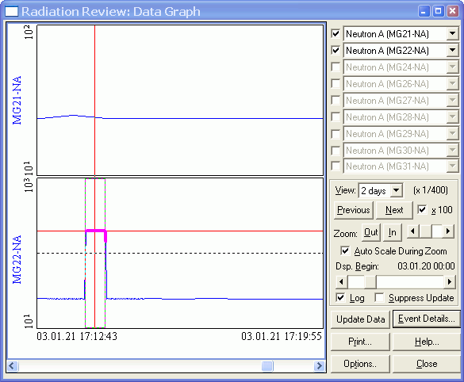
Figure 2.4-44 Graph Showing Event Being Edited
When you have completed the edit process for the event, select the Store Edit Changes button to delete the original event and store the new event in the database. The graph is then redrawn with the new event colored appropriate to its type.
Printing graph:
To print the graph, select the Print key. The normal Windows default printer selected will be used.
Help:
To display a simple graph help menu shown in Figure 2.4-45, select the Help button.
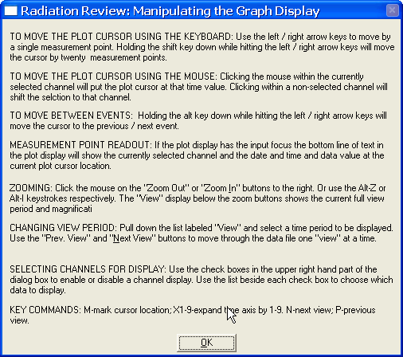
Figure 2.4-45 Graph Help Information
Options:
If the Options button is clicked, the dialog box in Figure 2.4-46 appears. There are three actions that can be taken – setting the time of the graph or reading/writing all the graph parameters from the database or changing the label of a button on the graph to be either Mark or Update.
The top half of the dialog box deals with setting the graph time span. At the top of the dialog box you can select either Start Time or Center Time. If Start Time is selected, then the graph beginning time will be the time set in the scroll boxes or the Date/Time fields in the dialog box. If Center Time is selected, then the graph center time will be the time set.
The middle part of the dialog box, Graph Configurations, provides the capability to manipulate graph trace configurations. There are four possible actions:
Read Configuration – the selected configuration is read from the database and all the graph parameters are set to those values (including the time in the upper half of the dialog box).
Write New Configuration – the current graph parameters are stored in the database identified by the name in the entry at the bottom. This is particularly helpful in facilities where there are so many instruments that not all the data can be displayed at one time.
Update Configuration – the current graph parameters are written over the existing graph parameters of the name specified
Delete Configuration – deletes the current set of graph parameters from the data base.
The configuration name “default” is reserved to save the graph parameters any time the graph exits. The next time the graph is plotted the same graph will be displayed with the exception that no zoom is shown.
The Update or Mark portion of the graph allows the user to change the label of the upper left button in the lower portion of the main graph dialog box. If the box is checked the label on that button is “Update”, if the box is not checked the label on the button is “Mark”.
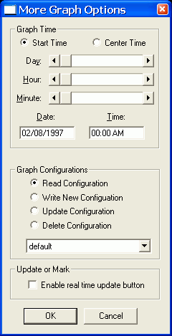
Figure 2.4-46 Graph Options Dialog Box
Close:
To exit the graph option, select the Close button or double click on the icon in the upper left corner of the graph. The parameters selected when you close the graph are the defaults for the next time the graph is displayed whether it is during this run of the program or another run of it.

Determine Measurements
The Tools | Determine Measurements option is typically used with shift register data to perform the same measurement analysis as was previously performed in the DOS SR Collect program. This menu option is enabled when shift register data are being used. Each data point is analyzed to determine the run type (normal, high or low background, moving, assay/verification, empty, and Cf normalization or check source). Consecutive runs of the same type are grouped into measurements. The data can be analyzed in one of two ways: (Reals-Doubles or Totals-Singles).
When the Tools | Determine Measurements option is accessed from the main menu, the Figure 2.4-47 dialog box appears:
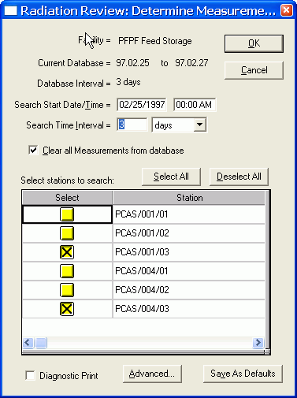
Figure 2.4-47 Tools | Determine Measurements Dialog Box
The Facility name is displayed on the top line. The Current Database and Database Interval display the first and last dates of data in the database and the total number of days covered by the database. The Database Interval is expressed as days; even if a day only contains data for an hour in the day, it is counted as an entire day. Facility, Current Database and Database Interval are information only parameters and cannot be changed by the user.
The next two lines of parameters, Search Start Date/Time and Search Time Interval, allow the user to select a subset of the entire database to be used. The Search Time Interval units can be days, hours or minutes. The default values for Search Start Date/Time and Search Time Interval vary depending on whether Radiation Review is running standalone or a part of an IRS session. In standalone mode, these parameters default to the entire database or the time interval last selected using the Tools | Review Period menu option. If Radiation Review is running as part of an IRS session, then these parameters correspond to the time interval specified on the Inspector Information Screen. If you execute this menu option more than once during a program run, then on re-entry to this menu option these interval values are set to those used the last time in this menu option.
The Clear all Measurements from database button can be used to delete all measurements in the database before a new search is started.
Table Columns: The stations to be searched for measurements are set in the table. The following columns are in the table:
Select- check the box for each station to be analyzed.
Station - all the stations at the facility. You cannot edit this column.
Clicking on the Cancel button aborts the option and all changes you have made to the parameters are discarded.
Clicking on the OK button starts the search.
Clicking on the Select All button puts a checkmark in the Select column for each station in the table.
Clicking on the Deselect All button removes the checkmark from each Select column for each station in the table.
Click on Save As Defaults to save these parameters to be the defaults the next time the program is started.
The Diagnostic Print box is used only by an expert during the parameter determination. In order to verify the analysis is being performed as expected, this option gives the user a list of the raw data and its analysis state data for the specified time period. By examining the values around an event, the user determines which advanced parameter values should be used. In normal operation this is never checked!
Click on Advanced to display the parameters that are used during the analysis. When this button is clicked, the Figure 2.4-48 dialog box appears:
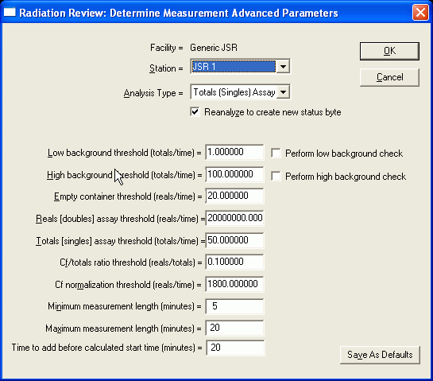
Figure 2.4-48 Advanced Measurement Parameters Dialog Box
The user can change any of the listed parameters. A separate set of parameters is maintained in the database for each station. The data are analyzed according to the flow charts contained in Appendix E.
The Facility name is displayed on the top line. This is an information only parameter; it cannot be changed by the user.
The Station field allows the user to select a specific station from a dropdown list of all stations at the facility.
The Analysis type can be either Reals (Doubles) Assay or Totals (Singles) Assay. See Appendix E for the algorithms that are executed for each analysis.
The Reanalyze to create new status byte checkbox allows you to selectively choose to use whether the data collected by DOS SR Collect will be reanalyzed. This box must always be checked for data collected by MIC from the AMSR/ISR as no on-line analysis is performed in the ISR.
Low background threshold: runs on which the totals rate falls below this value are said to be low background. The values for this field can range from 0 - 10,000.
Perform low background check: if this box is checked, the runs are checked for low background.
High background threshold: runs on which the totals rate falls below this value and above the low background threshold are said to be high background. The values for this field can range from 0 - 10,000.
Perform high background check: if this box is checked, the runs are checked for high background.
Empty container threshold: runs on which the reals rate falls below this value and above the reals/doubles assay threshold are of type empty. The values for this field can range from 0 - 10,000.
Reals/doubles assay threshold: runs on which the reals rate falls above this value are not background runs. Further analysis is done to determine the type of assay/verification type. The values for this field can range from 0 - 100,000.
Totals/singles assay threshold: runs on which the totals rate falls above this value are of type totals assay. The values for this field can range from 0 - 100,000. This parameter only has effect when the Analysis type is Totals (Singles) Assay.
Cf/totals ratio threshold: runs on which the reals value is above the reals/doubles assay threshold and the reals rate/totals rate falls above this value are of type Cf. A further test is done to decide whether it is a normalization or check Cf source. The values for this field can range from 0 - 10,000.
Cf normalization threshold (reals/time): for runs on which it has been determined the Cf is present, the runs that fall above this threshold are of type normalization; those below the threshold are of type check. The values for this field can range from 0 - 10,000.
Minimum Measurement Length: Measurements whose elapsed time is less than this value are classified as short. The values for this field can range from 0 - 100 minutes. Measurements marked as less than the minimum length are not filtered. The short classification is retained with the measurement. The short status is displayed by both the Diagnostics | Raw Data (§ 2.6.1) and the Tools | Data Integrity Checks features (§ 2.4.3).
Maximum Measurement Length: Measurements whose elapsed time is more than this value are classified as long. The values for this field can range from 0 – 100 minutes. Measurements marked as longer than the maximum length are not filtered. The long classification is retained with the measurement. The long status is displayed by both the Diagnostics | Raw Data (§ 2.6.1) and the Tools | Data Integrity Checks features (§ 2.4.3).
Time to add before calculated start time (minutes): Special parameter added primarily to support WCASA system. For measurements determine with Totals (Singles) Assay analysis, subtract the specified number of minutes from the start of the measurement. Note, to get the Totals analysis to run, set the Reals (doubles) assay threshold (reals/time) to be high enough so that the Totals analysis is performed. See Appendix E for a flowchart of the algorithm. The values for this field can range from 0 - 999.
Clicking on the Cancel button aborts the option and all changes you have made to the parameters are discarded.
Click on Save As Defaults to save these parameters to be the defaults the next time the program is started.
Clicking on the OK button saves the parameters and closes this dialog box and returns you to the dialog box in Figure 2.4-47 Tools | Determine Measurements Dialog Box.
After all the parameters are correctly set, the user clicks on the OK button in the Figure 2.4-47 Tools | Determine Measurements Dialog Box. The data runs are sequentially analyzed according the algorithm described by the flow charts in Appendix E. Status bits are set as appropriate as the analysis proceeds.
During the analysis a progress box is displayed showing the amount of data analyzed for each station. There is a Cancel button as the bottom of the progress box. If you select to Cancel another dialog box appears asking if you are really sure you want to cancel the search. If you answer Yes, the search aborts when the current data are analyzed and the partial results are displayed. If you answer No, the search will resume and the total results are displayed.
The results of the measurement search are displayed in a text window similar to Figure 2.4-49.
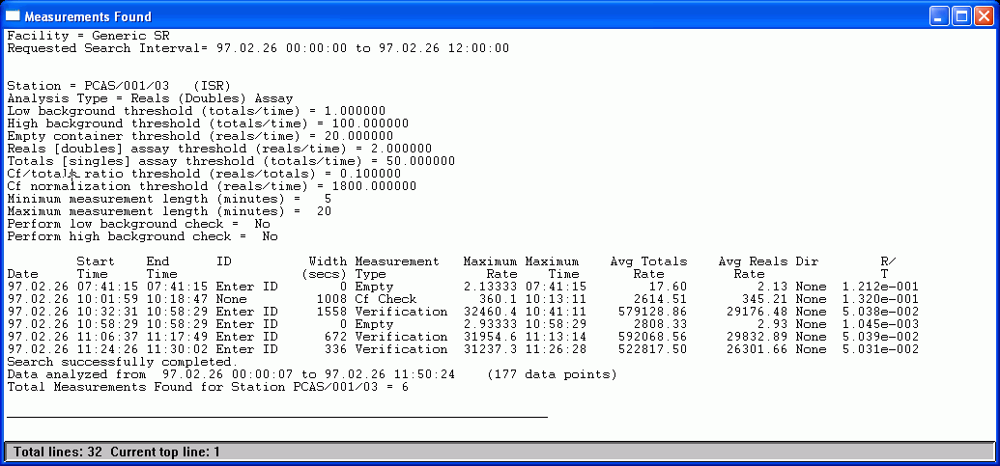
Figure 2.4-49 Determine Measurements Text Windows Results
The Measurements Found results window has the following sections:
Header Portion:
The top of the results text window shows the facility, search interval and the conditions selected for this particular analysis.
Main Results:
The measurement events found are printed. For each measurement event the following columns of results are displayed:
Date – for this event, the date,
Start Time – for this event, the time when the event started,
End Time – for this event, the end time (normally the date of the end time is the same as the start time),
ID – the ID associated with the sample,
Width – number of seconds between the Start Time and End Time, ,
Measurement Type – can be Low Bkg, High Bkg, Empty, Verif., Cf Check, Cf Norm, Totals, GRAND MII or Undefined,
Avg Totals Rate – average totals (singles) counting rate for the measurement event,
Avg Reals Rate – average reals (doubles) counting rate for the measurement event,
Dir – direction associated with this measurement event, if any,
Maximum Time – the time associated with the highest totals or reals rate in the event (totals are used if Totals (Singles) Assay is selected, reals used if Reals (Doubles) Assay is selected,
Maximum Rate – the highest rate of either reals or totals depending on the Analysis Type (Reals or Totals).
Summary Portion:
In the summary at the bottom, the status of the search, the interval analyzed and the number of measurement events found is displayed.
To get a copy of the complete results windows as shown above, you can select to copy the text window results or a portion of it to the printer or to a file or to the clipboard as described in Section 2.3.3. To access the menu that allows you to save or print results, click on the icon in the upper left corner of the text window.
IR File: If Radiation Review is running as part of an IRS session, one of the options is to have a file containing some of these results produced for use by Integrated Review. That file and its format are described in Appendix A, Section A.2.7.

Export Data
The Tools | Export Data menu option is used with shift register and MiniGRAND/GRAND data to select data contained in measurement or channel events to export to other analysis tools such as INCC or FDMS for further analysis. Events for export must have been found prior to using this menu option. Events can be found either through the Tools | Find Channel Events or Tools | Determine Measurements menu options. They can also be created manually on the graph using the Create Event option. Selected subsets of these events can be sent to other review tools for further analysis.
When the Tools | Export Data option is accessed from the main menu, the Figure 2.4-50 dialog box appears:
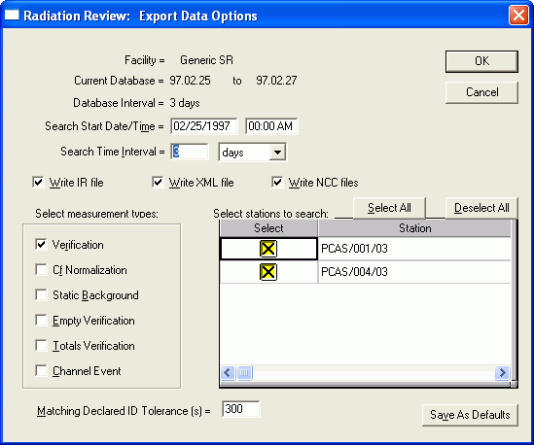
Figure 2.4-50 Tools | Export Data Dialog Box
The Facility name is displayed on the top line. This is an information only parameter; it cannot be changed by the user.
The Current Database and Database Interval display the first and last dates in the database and the total number of days covered by the database. The units for these parameters are whole days; even if a day only contains data for an hour in the day, it is counted as an entire day. These are information only parameters and cannot be changed by the user.
The next two lines of parameters, Search Start Date/Time and Search Time Interval, allow the user to select a subset of the entire database to be used. The Search Time Interval units can be days, hours or minutes. The default values for Search Start Date/Time and Search Time Interval vary depending on whether Radiation Review is running standalone or a part of an IRS session. In standalone mode, these parameters default to the entire database or the time interval last selected using the Tools | Review Period menu option. If Radiation Review is running as part of an IRS session, then these parameters correspond to the time interval specified on the Inspector Information Screen. If you execute this menu option more than once during a program run, then on re-entry to this menu option these interval values are set to those used the last time in this menu option.
The Write File for IR checkbox, if checked, indicates that the information about the selected measurements should be written to the file for use by Integrated Review. The format of the file is described in Appendix A. Section A 2.7.
The Write XML File IR checkbox, if checked, indicates that the information about the selected measurements should be written to the file for use by FDMS. The format of the file is described in Appendix A. Section A 2.3.
The Write NCC files checkbox, if checked, indicates that the data from each selected measurement should be written to *.NCC files for use by INCC. The format of the file is described in Appendix A. Section A 2.2.
Table Columns: The conditions for the export are set in the table. The table has as many entries as there are channels in the facility; if all the entries cannot be displayed a scroll bar on the right-hand side of the table appears. The following columns are in the table:
Select - check the box for each station that you want to export data from.
Station - all the stations at the facility. You cannot edit this column.
In the Select Measurement Types, the following types of measurements can be selected for export by checking the appropriate checkboxes:
Verification - measurements that were determined to be verification/assay either by DOS SR Collect or during the Tools | Determine Measurements option of Radiation Review are presented for export to INCC.
Cf Normalization - measurements that were determined to be Cf normalization either by DOS SR Collect or during the Tools | Determine Measurements option of Radiation Review are presented for export to INCC.
Background - groups of runs that were marked to be Background from the Tools | Graph | Event Details button are presented for export.
Empty Verification - measurements that were determined to be empty verification/assay either by DOS SR Collect or during the Tools | Determine Measurements option of Radiation Review are presented for export to INCC.
Totals Verification - measurements that were determined to be totals verification/assay either by DOS SR Collect or during the Tools | Determine Measurements option of Radiation Review are presented for export to INCC. These types of measurements are only possible when Totals (Singles) Assay is selected in the Advanced Parameters for the Tools | Determine Measurements option.
Channel Event - measurements that were determined to be channel events either by using the Tools | Find Channel Events option of Radiation Review or manually marking events on the Tools | Graph | Event Details button are presented for export to another review tool.
In the Matching Declared ID Tolerance field, you can enter a tolerance (in seconds) for matching an ID to the measurement. If a file (produced by Operator Review) containing information about the IDs associated with certain stations and timestamps has been imported into the database, then those IDs will be searched to try to find the ID that is within the specified tolerance from the start of the measurement. If no ID file has been imported, then this field is ignored.
Clicking on the Cancel button aborts the option and all changes you have made to the parameters are discarded.
Clicking on the Select All button puts a checkmark in the Select column for each station in the table.
Clicking on the Deselect All button removes the checkmark from each Select column for each station in the table.
Click on Save As Defaults to save these parameters to be the defaults the next time the program is started.
Clicking on the OK button starts the search for measurements/runs meeting the conditions specified.
The database is searched for measurement events which meet the qualifying conditions. When all measurement events have been searched, a table containing the matching measurement events is displayed as shown in Figure 2.4-51.
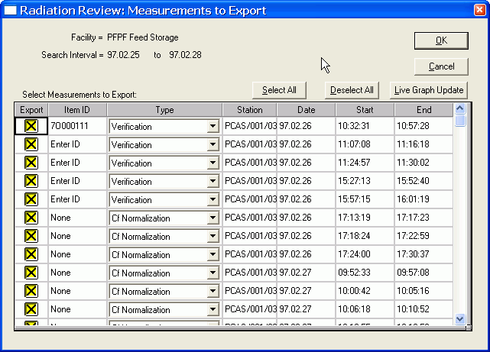
Figure 2.4-51 Tools | Export Data – Measurements to Export Dialog Box
The Facility name is displayed on the top line. This is an information only parameter that cannot be changed by the user.
The Search Time Interval displays the interval selected in the previous dialog box, Figure 2.4-50 Tools | Export Data Dialog Box.
The Select All button puts an X in every row in the Export column.
The Deselect All button removes the X’s from every row in the Export column.
The Live Graph Update button opens the graph. You can then switch back and forth between the table and the graph to edit IDs, change start/end times, etc. When the events are stored to the database, the corresponding events on either the graph or the table are updated.
Table Columns: The table contains 7 columns of information of which the first 3 can be edited.
Export: an X in this column selects the measurement in the row for export to INCC.
Item ID: At any time the user can manually enter the ID for the item that is specified by the row. Normally only verification and empty verification measurements are associated with specific item IDs. This ID is used by INCC to identify the item and the associated parameters such as isotopics to use to calculate the mass, etc. The ID can be up to 12 characters long. If an ID file has been imported into the database, the IDs are searched to try to find an ID within the specified time tolerance of the measurement. If an ID is found that meets the conditions, then the ID field is filled in with this as a “best guess”. IDs are typically found in the operator declarations and if possible, the inspector should independently verify the ID through another means, such as am image.
Type: The type of the measurement to be exported to another review tool, such as INCC or FDMS, can be selected here. Normally the user would accept the type determined by the automated analysis in Tools | Determine Measurements or Tools | Find Channel Events.
Station: The name of the station where the measurement occurred is listed. This field cannot be edited.
Date: The date of the measurement start. This field cannot be edited (measurement date can only be changed using Tools | Graph | Event Details.
Start: The time of the measurement start. This field cannot be edited (measurement start times can only be changed using Tools | Graph | Event Details.
End: The time of the measurement end. This field cannot be edited (measurement end times can only be changed using Tools | Graph | Event Details.
Clicking on the Cancel button aborts the option and all changes you have made to the parameters are discarded.
Clicking on the OK button initiates the export.
For each measurement event selected for export a file is written that can be imported into by other review tools. If SR data are being exported, it is assumed the data will be used by INCC and a separate file for each measurement event is written in the format described in Appendix A, Section A.2.2. If MiniGRAND/GRAND data are being exported, event summaries are written to an XML file described in Appendix A, Section A.2.3 – it is assumed that the review tool receiving the data will read the XML file and retrieve the needed raw data from the CoGrandImport COM. After all files have been written a text window of results is displayed similar to Figure 2.4-52.
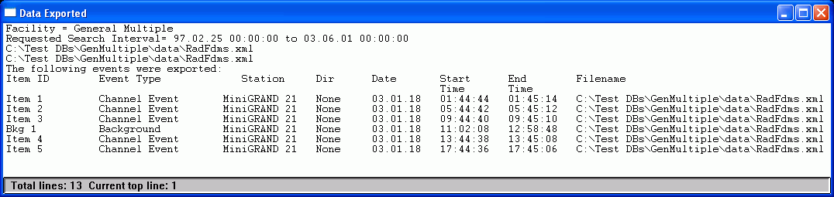
Figure 2.4-52 Tools | Export Data Text Window Results
The Data Exported results window has the following sections:
Header Portion:
The top of the results text window shows the facility and search interval.
Main Results:
The measurement files that were created are listed. For each file the following columns of results are displayed:
Item ID – Item ID contained in the file,
Event Type – whether Verification, Cf Normalization, Background, Empty Verification, Totals Verification, or Channel
Station – Name of station associated with measurement event,
Dir – direction associated with this measurement event, if any,
Date – for this measurement event, the date,
Start Time – for this event, the time when the event started,
End Time – for this event, the end time (normally the date of the end time is the same as the start time),
Filename – file written for either INCC (contains drive, path and name) or the XML file
To get a copy of the complete results windows as shown above, you can select to copy the text window results or a portion of it to the printer or to a file or to the clipboard as described in Section 2.3.3. To access the menu that allows you to save or print results, click on the icon in the upper left corner of the text window.
IR File: In addition if Radiation Review is running as part of an IRS session, one of the options is to have a file containing some of these results produced for use by Integrated Review. That file and its format are described in Appendix A Section A.2.7.

Facility Manager
The Tools | Facility Manager menu option uses the common Facility Manager Component present in all Integrated Review software tools. This option allows the user (with proper privileges) to add/delete/change the facility configuration. No detailed instructions are provided in this manual since the Facility Manager contains online help accessed via the Help button on the dialog box. When the Tools | Facility Manager option is selected, the following dialog box appears.
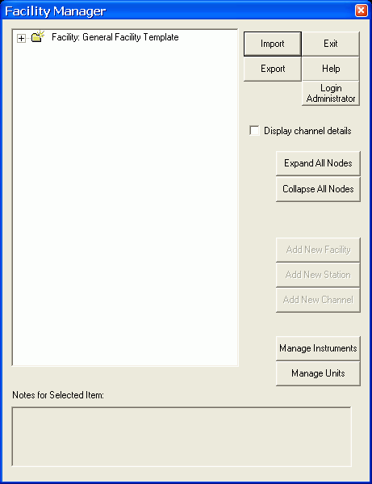
Figure 2.4-53 Tools | Facility Configuration Dialog Box
When you exit Facility Manager the following dialog box appears warning that you should re-import data if you have changed or added or deleted any stations for the facility you are currently using.
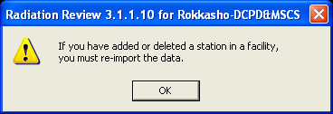
Figure 2.4-54 Tools | Facility Manager Exit Warning Message
If you click on the Manage Instruments button in Figure 2.4-53, the dialog in Figure 2.4-55 appears. This option allows the user (with proper privileges) to add/delete/change the instrument definitions configuration. No detailed instructions are provided in this manual since the Instrument Manager contains online help accessed via the Help button on the dialog box.
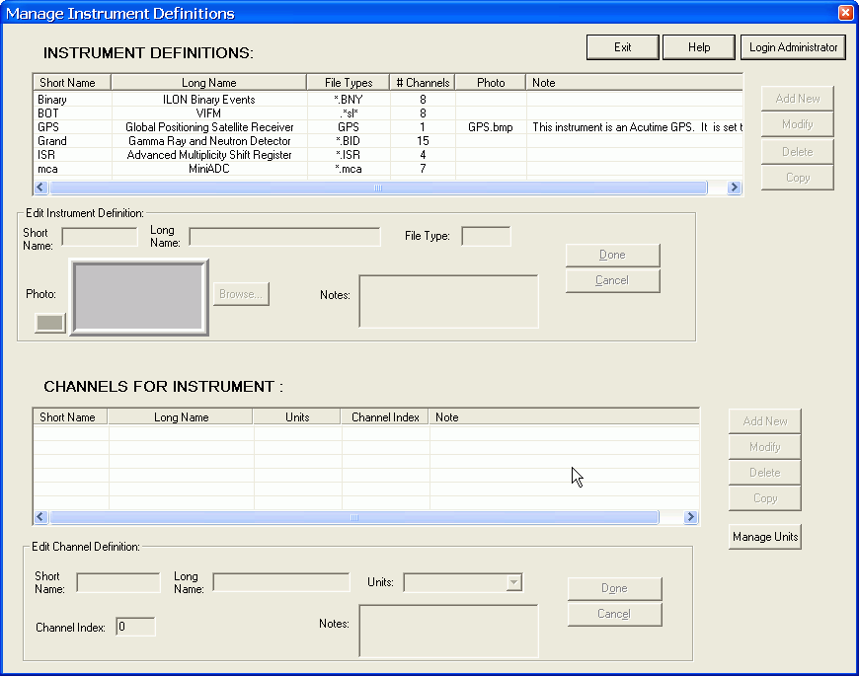
Figure 2.4-55 Tools | Instrument Manager Dialog Box
If you click on the Manage Units button in Figure 2.4-53, the dialog in Error: Reference source not found appears. This option allows the user (with proper privileges) to add/delete/change the instrument units. No detailed instructions are provided in this manual since the Units Manager contains online help accessed via the Help button on the dialog box.
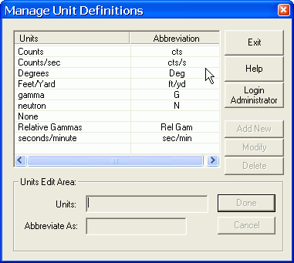
Figure 2.4-56 Tools | Units Manager Box

Caution: if the current Facility is deleted prior to changing to a new Facility by using Select Facility in the Radiation Review tools menu, Radiation Review will fail to open properly. Manually edit the irs.ini file in C:\irs folder to reflect the new Facility ID number. Restarting Radiation Review now should use the existing facility.

Summaries Menu
The Summaries options allow you to summarize the data in the database in various ways. If you are not using shift registers, then the option for Measurements has no meaning and could be grayed out to indicate it is not available. In a similar manner, Direction Events could be grayed out if you are not using Direction Analysis. If you select Summaries from the Main Menu Bar, the menu in Figure 2.5-57 is displayed.
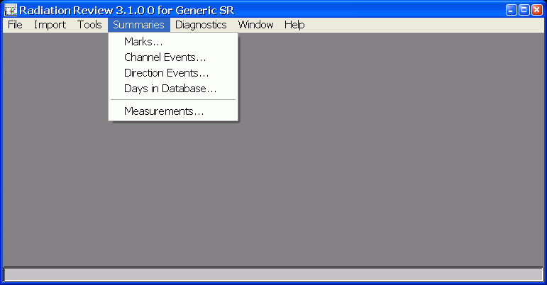
Figure 2.5-57 Summaries Pull-down Menu Examples

Marks
The Summaries | Marks option allows you to list the data points that were marked during the Tools | Graph option. When Summaries | Marks is selected the Figure 2.5-58 dialog box appears:
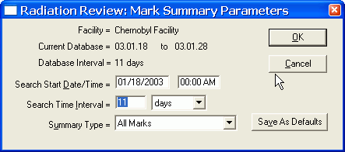
Figure 2.5-58 Summaries | Marks Dialog Box
The Facility name is displayed on the top line. The Current Database and Database Interval display the first and last dates of data in the database and the total number of days covered by the database. The Database Interval is expressed as days; even if a day only contains data for an hour in the day, it is counted as an entire day. Facility, Current Database and Database Interval are information only parameters and cannot be changed by the user.
The next two lines of parameters, Search Start Date/Time and Search Time Interval, allow the user to select a subset of the entire database to be used. The Search Time Interval units can be days, hours or minutes. The default values for Search Start Date/Time and Search Time Interval vary depending on whether Radiation Review is running standalone or a part of an IRS session. In standalone mode, these parameters default to the entire database or the time interval last selected using the Tools | Review Period menu option. If Radiation Review is running as part of an IRS session, then these parameters correspond to the time interval specified on the Inspector Information Screen. If you execute this menu option more than once during a program run, then on re-entry to this menu option these interval values are set to those used the last time in this menu option.
You can select which type of summary you would like displayed. You have the choice to select All Marks or Daily Mark Summaries.
Clicking on the Cancel button aborts the option and all changes you have made to the parameters are discarded.
Click on Save As Defaults to save these parameters to be the defaults the next time the program is started. The Search Start Date/Time and Search Time Interval are not saved. Their defaults are set as described above.
Clicking on the OK button starts the search.
After the search is finished the results are shown in a text window like Figure 2.5-59 if you selected All Marks as your search condition or Figure 2.5-60 if you selected Daily Summaries.
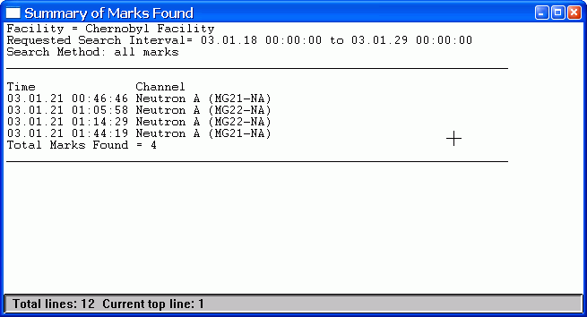
Figure 2.5-59 All Marks Summaries Text Window Results
The Summary of Marks Found for All Marks results window has the following sections:
Header Portion:
The top of the results text window shows the facility, search interval and the conditions selected for this particular search (all marks).
Main Results:
The marks information is displayed. For each mark the following columns of results are displayed:
Time – for this mark, the date/time of the mark
Channel – which channel this mark is associated with
Summary Portion:
In the summary at the bottom, the status of the search and total number of marks found is displayed.
If you selected Daily Mark Summaries as the search condition, results similar to those in Figure 2.5-60 are generated.
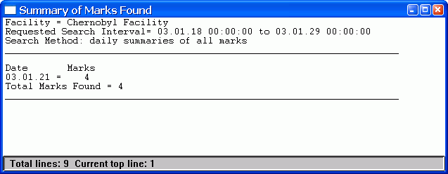
Figure 2.5-60 Daily Mark Summaries Text Window Results
The Summary of Marks Found for Daily Summaries results window has the following sections:
Header Portion:
The top of the results text window shows the facility, search interval and the conditions selected for this particular search (all marks).
Main Results:
The marks information is displayed. For each mark the following columns of results are displayed:
Date – which day the summary is for
Marks – how many marks (for all channels) for the day
Summary Portion:
In the summary at the bottom, the status of the search and total number of marks found for all days is displayed.
To get a copy of any results windows, you can select to copy the text window results or a portion of it to the printer or to a file or to the clipboard as described in Section 2.3.3. To access the menu that allows you to save or print results, click on the icon in the upper left corner of the text window.

Channel Events
The Summaries | Channel Events option allows you to list the channel events that were found using the Tools | Channel Events option. When Summaries | Channel Events is selected the Figure 2.5-61 dialog box appears:
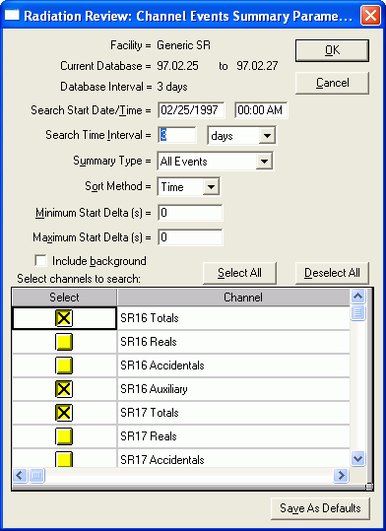
Figure 2.5-61 Summaries | Channel Events Dialog Box
The Facility name is displayed on the top line. The Current Database and Database Interval display the first and last dates of data in the database and the total number of days covered by the database. The Database Interval is expressed as days; even if a day only contains data for an hour in the day, it is counted as an entire day. Facility, Current Database and Database Interval are information only parameters and cannot be changed by the user.
The next two lines of parameters, Search Start Date/Time and Search Time Interval, allow the user to select a subset of the entire database to be used. The Search Time Interval units can be days, hours or minutes. The default values for Search Start Date/Time and Search Time Interval vary depending on whether Radiation Review is running standalone or a part of an IRS session. In standalone mode, these parameters default to the entire database or the time interval last selected using the Tools | Review Period menu option. If Radiation Review is running as part of an IRS session, then these parameters correspond to the time interval specified on the Inspector Information Screen. If you execute this menu option more than once during a program run, then on re-entry to this menu option these interval values are set to those used the last time in this menu option.
The Summary Type (All Events or Daily Summaries) allows you to choose whether you want to list the individual events (All Events) or to provide only a numerical total of the events for each day (Daily Summaries).
The Sort Method (Time or Channel) allows you to choose the grouping method. If you select Time all selected channels from an instrument are examined and the results are listed in order of the times the channels events occurred. Subsequent GRANDs at the facility are handled the same way. If you select Channel then all events for the first selected channel are listed, then all events for the second selected channel are listed, and the other selected channels are also listed separately.
The Minimum Event Start Delta and Maximum Event Start Delta allow you to format your output by grouping events together whose starting times fall within the Minimum to Maximum range (in seconds) of each other.
The Include background checkbox, if checked, indicates that the background events that were manually marked using the graph will be included in the results for the specified channels. If it is not checked, then only Channel events found using Tools | Find Channel Events or manually marked on the graph will be displayed.
Table Columns: The table at the bottom of the dialog box allows you to select on which channels you would like to perform the search.
Select: An X in this column selects the channel to be searched for channel events.
Channel : All channels in the facility are listed. If all channels cannot be displayed, a scroll bar appears at the right of the table and the user can scroll through all the channels. You cannot edit this column.
The Select All and Deselect All buttons allow you to select all or none of the channels for searching. Individual channels can be selected/de-selected by clicking on the X in the Select column for that channel.
Clicking on the Cancel button aborts the option and all changes you have made to the parameters are discarded.
Click on Save As Defaults to save these parameters to be the defaults the next time the program is started. The Search Start Date/Time and Search Time Interval are not saved. Their defaults are set as described above.
Clicking on the OK button starts the search.
The specified interval is searched for channel events and the results are displayed.
If you selected Summary Type of All Events and Sort Method of Channel then Figure 2.5-62 is shown.
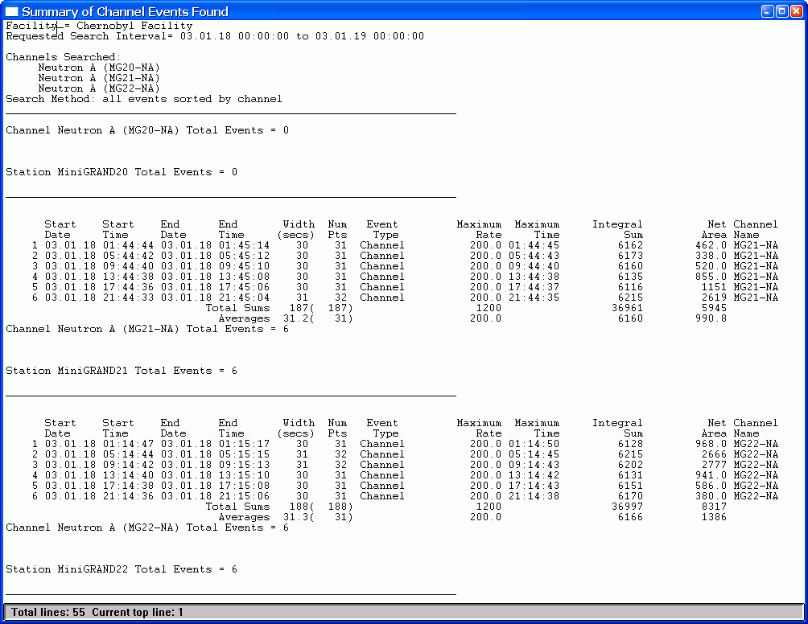
Figure 2.5-62 Summaries | Channel Events - All Events Sorted by Channel
If you selected Summary Type of All Events and Sort Method of Time then the results similar to Figure 2.5-63 are shown.
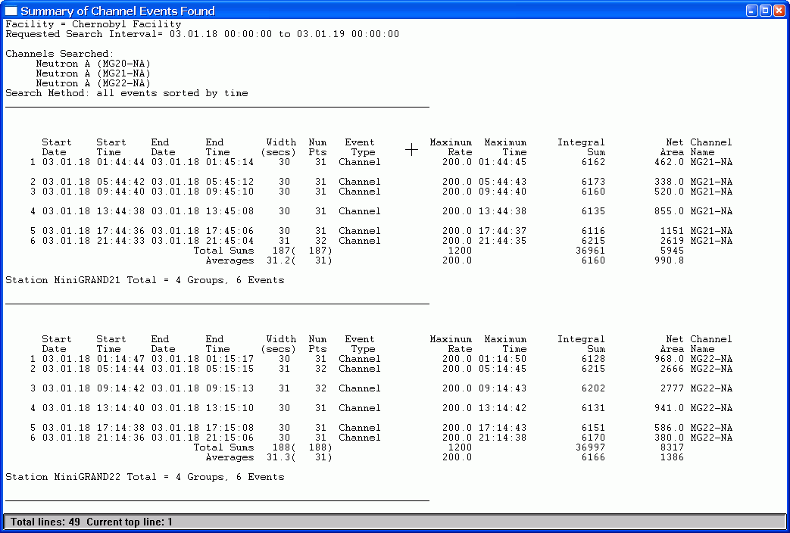
Figure 2.5-63 Summaries | Channel Events - All Events Sorted by Time
The Summary of Channel Events Found for All Events (whether sorted by Channel or Time) has the following sections:
Header Portion:
The first lines in the results text window display the facility specific header. The next section lists the search parameters including the choice of algorithm and which channels were selected to be searched.
Main Results:
Then for each station searched a list of all the events found in the interval are listed. For each event the following columns of results are displayed:
Start Date/Start Time – for this event, the date/time when the event started
End Date/End Time – for this event, the end time (normally the date of the end time is the same as the start time, you can use the parameter Width to verify this.)
Width – the duration of this event in seconds calculated by subtracting the start time from the end time. The width includes both the start and end time in the interval. Events with an identical start/end time are given a length of 1.
Num Pts – the number of data points found in the event.
Event Type – This column indicates the type of event – at present the only choice that will appear is Channel indicating the event was found with the Find Events menu option.
Maximum Rate/Maximum Time – the rate displays the highest count rate in the channel within the event and the time indicates the timestamp associated with that rate.
Integral Sum – the integral sum is the sum of all the count rates in the event (including the start/end time points)
Net Area – the net area (counts) represents the total counts (area) above a straight line going from the start time to the end time. This is intended as a general indication of net area – for a precise net area calculation, a more accurate method should be used to do the background subtraction.
To give gross information about the data, two calculations are done on the columns of numbers.
Total Sums – The numbers in each column above are summed.
Averages –The average of the numbers in each column above are calculated.
Summary Portion:
In the summary at the bottom, the status of the search, the data interval and number of data points in the interval, and the number of channel events found for the station are listed.
If you selected Summary Type of Daily Summaries and Sort Method of Channel then results similar to Figure 2.5-64 are shown.
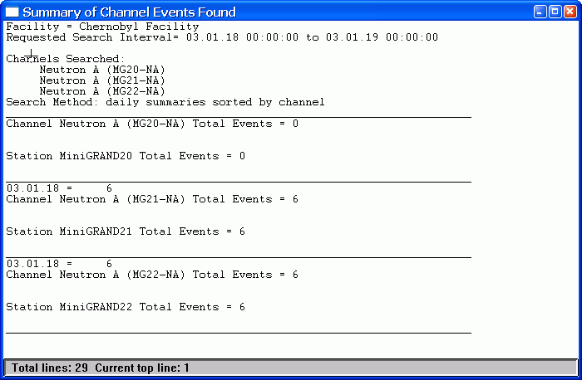
Figure 2.5-64 Summaries | Channel Events – Daily Summaries Sorted by Channel
The Summary of Channel Events Found for All Events sorted by Channel has the following sections:
Header Portion:
The first lines in the results text window display the facility specific header. The next section lists the channels to be searched and the sort method.
Main Results:
For each channel searched, the total number of events for each day in the interval is displayed.
Summary Portion:
In the summary for each instrument, the total number of events found for all channels on the instrument is displayed.
If you selected Summary Type of Daily Summaries and Sort Method of Time then results similar to Figure 2.5-65 are shown.
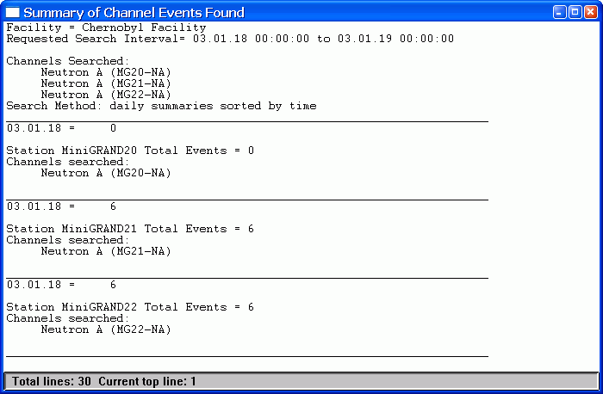
Figure 2.5-65 Summaries | Channel Events – Daily Summaries Sorted by Time
The Summary of Channel Events Found for Daily Summaries sorted by Time has the following sections:
Header Portion:
The first lines in the results text window display the facility specific header. The next section lists the channels searched and the sort method.
Main Results:
For each day, the total number of events for each instrument is listed.
Summary Portion:
For each instrument, the total number of events for all the days is listed.
To get a copy of any results window, you can select to copy the text window results or a portion of it to the printer or to a file or to the clipboard as described in Section 2.3.3. To access the menu that allows you to save or print results, click on the icon in the upper left corner of the text window.

Direction Events
The Summaries | Direction Events option allows you to list the direction events that were determined in the Tools | Direction Analysis option. When Summaries | Direction Events is chosen the Figure 2.5-66 dialog box is displayed:
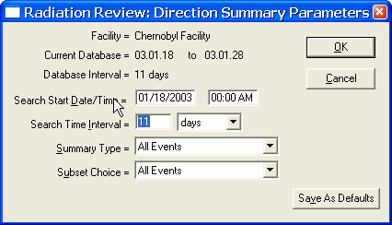
Figure 2.5-66 Summaries | Direction Events Dialog Box
The Facility name is displayed on the top line. The Current Database and Database Interval display the first and last dates of data in the database and the total number of days covered by the database. The Database Interval is expressed as days; even if a day only contains data for an hour in the day, it is counted as an entire day. Facility, Current Database and Database Interval are information only parameters and cannot be changed by the user.
The next two lines of parameters, Search Start Date/Time and Search Time Interval, allow the user to select a subset of the entire database to be used. The Search Time Interval units can be days, hours or minutes. The default values for Search Start Date/Time and Search Time Interval vary depending on whether Radiation Review is running standalone or a part of an IRS session. In standalone mode, these parameters default to the entire database or the time interval last selected using the Tools | Review Period menu option. If Radiation Review is running as part of an IRS session, then these parameters correspond to the time interval specified on the Inspector Information Screen. If you execute this menu option more than once during a program run, then on re-entry to this menu option these interval values are set to those used the last time in this menu option.
The Summary Type (All Direction Events or Daily Direction Summaries) allows you to choose whether you want to list the individual direction events (All Direction Events) or to provide only a numerical total of the direction movements for each day (Daily Direction Summaries).
The Sort Method (All Events; Direction In, Location A; Direction Out, Location A; Direction In, Location B; Direction Out, Location B; All Location A Events; All Location B Events; All Direction In Events or All Direction Out Events) allows you to choose which of the direction events to display.
Clicking on the Cancel button aborts the option and all changes you have made to the parameters are discarded.
Click on Save As Defaults to save these parameters to be the defaults the next time the program is started. The Search Start Date/Time and Search Time Interval are not saved. Their defaults are set as described above.
Clicking on the OK button starts the search.
The specified interval is searched for the specified kind of direction events and the results are displayed.
If you selected to search for all events in the interval, a text window of results similar to Figure 2.5-67 will appear:
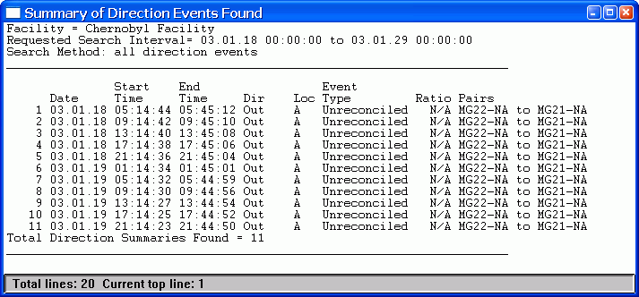
Figure 2.5-67 Summaries | Direction Events - All Events Text Window Results
The Summary of Direction Events Found results text window has the following sections:
Header Portion:
The top of the results text window shows the facility, search interval and the conditions selected for this particular search.
Main Results:
The direction events found are printed. For each event the following columns of results are displayed:
Date – for this event, the date when the event started
Start Time – for this event, the time when the event started
End Time – for this event, the end time (normally the date of the end time is the same as the start time)
Dir – the direction assigned to this movement,
Loc – where the direction occurred,
Event Type – always is unreconciled,
Ratio – results of calculation specified in Tools | Direction Analysis dialog box, if no calculation is specified, this entry is N/A for not applicable.
Pairs - pairs of channels containing channel events that met the specified conditions and indicate the direction of motion (x to y). The short names of the channels are used.
Summary Portion:
In the summary at the bottom, the total number of direction events found is displayed.
To get a copy of the complete results windows as shown above, you can select to copy the text window results or a portion of it to the printer or to a file or to the clipboard as described in Section 2.3.3. To access the menu that allows you to save or print results, click on the icon in the upper left corner of the text window.
If you selected to list only daily summaries of all events in the interval, a text window of results similar to Figure 2.5-68 will appear:
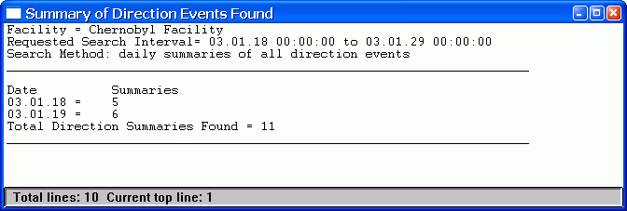
Figure 2.5-68 Summaries | Direction Events - Daily Summaries Text Window Results
The Summary of Direction Events Found for daily summaries has the following sections:
Header Portion:
The top of the results text window shows the facility header, search interval and the conditions selected for this particular search.
Main Results:
The direction events found are printed. For each event the following columns of results are displayed:
Date – day being summarized
Summaries – number of direction events for all instruments for the day.
Summary Portion:
In the summary at the bottom, the total direction events found is displayed.
To get a copy of the complete results windows as shown above, you can select to copy the text window results or a portion of it to the printer or to a file or to the clipboard as described in Section 2.3.3. To access the menu that allows you to save or print results, click on the icon in the upper left corner of the text window.

Days in Database
The Summaries | Days in Database provides a list of which days for which instruments are in the database. When the Summaries | Days in Database option is selected the Figure 2.5-69 dialog box appears:
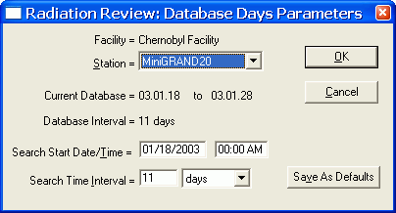
Figure 2.5-69 Summaries | Days in Database Dialog Box
The Facility name is displayed on the top line. The Station field provides a dropdown list of all stations in the facility and allows the user to indicate whether to perform the search for a single station or all stations. The Current Database and Database Interval display the first and last dates of data in the database and the total number of days covered by the database. The Database Interval is expressed as days; even if a day only contains data for an hour in the day, it is counted as an entire day. Facility, Current Database and Database Interval are information only parameters and cannot be changed by the user.
The next two lines of parameters, Search Start Date/Time and Search Time Interval, allow the user to select a subset of the entire database to be used. The Search Time Interval units can be days, hours or minutes. The default values for Search Start Date/Time and Search Time Interval vary depending on whether Radiation Review is running standalone or a part of an IRS session. In standalone mode, these parameters default to the entire database or the time interval last selected using the Tools | Review Period menu option. If Radiation Review is running as part of an IRS session, then these parameters correspond to the time interval specified on the Inspector Information Screen. If you execute this menu option more than once during a program run, then on re-entry to this menu option these interval values are set to those used the last time in this menu option.
Clicking on the Cancel button aborts the option and all changes you have made to the parameters are discarded.
Click on Save As Defaults to save these parameters to be the defaults the next time the program is started. The Search Start Date/Time and Search Time Interval are not saved. Their defaults are set as described above.
Clicking on the OK button starts the search. When the search completes, a text window similar to Figure 2.5-70 shows the results:
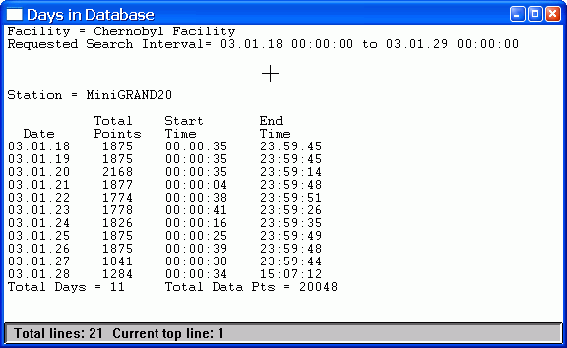
Figure 2.5-70 Summaries | Days in Database Text Window Results
The Days in Database results text window has the following sections:
Header Portion:
The top of the results text window shows the facility and search interval.
Main Results:
For each day in the database for the specified station, the total number of data points and the time for the first and last point in the day are listed.
Date – day being summarized
Total Points – number of data points for the specified station in the day
Start Time – time of first data point in the day for the station
End Time – time of last data point in the day for the station.
Summary Portion:
In the summary at the bottom, the total number of days and data points is calculated and displayed.
To get a copy of the complete results windows as shown above, you can select to copy the text window results or a portion of it to the printer or to a file or to the clipboard as described in Section 2.3.3. To access the menu that allows you to save or print results, click on the icon in the upper left corner of the text window.

Measurements in Database
The Summaries | Measurements options allows you to list the measurement events that were determined in the Tools | Determine Measurements option. When the Summaries | Measurements option is selected the dialog box in Figure 2.5-71 appears:
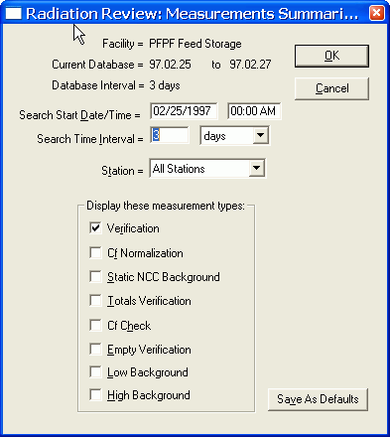
Figure 2.5-71 Summaries | Measurements Dialog Box
The Facility name is displayed on the top line. The Current Database and Database Interval display the first and last dates of data in the database and the total number of days covered by the database. The Database Interval is expressed as days; even if a day only contains data for an hour in the day, it is counted as an entire day. Facility, Current Database and Database Interval are information only parameters and cannot be changed by the user.
The next two lines of parameters, Search Start Date/Time and Search Time Interval, allow the user to select a subset of the entire database to be used. The Search Time Interval units can be days, hours or minutes. The default values for Search Start Date/Time and Search Time Interval vary depending on whether Radiation Review is running standalone or a part of an IRS session. In standalone mode, these parameters default to the entire database or the time interval last selected using the Tools | Review Period menu option. If Radiation Review is running as part of an IRS session, then these parameters correspond to the time interval specified on the Inspector Information Screen. If you execute this menu option more than once during a program run, then on re-entry to this menu option these interval values are set to those used the last time in this menu option.
The Station field provides a dropdown list of all stations in the facility and allows the user to indicate whether to perform the search for a single station or all stations.
Select which measurement types to display by checking the appropriate boxes in the Display these measurement types check boxes.
Clicking on the Cancel button aborts the option and all changes you have made to the parameters are discarded.
Click on Save As Defaults to save these parameters to be the defaults the next time the program is started. The Search Start Date/Time and Search Time Interval are not saved. Their defaults are set as described above.
Clicking on the OK button starts the search. When the search completes, a text window similar to Figure 2.5-72 shows the results:
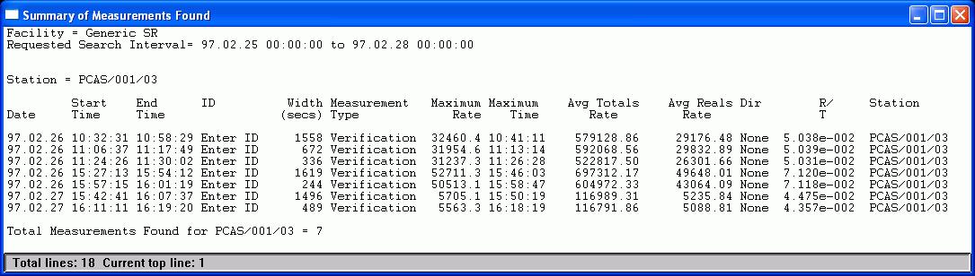
Figure 2.5-72 Summaries | Measurements Text Window Results
The Summary of Measurements Found text window has the following sections:
Header Portion:
The top of the results text window shows the facility, search interval and the conditions selected for this particular analysis.
Main Results:
The measurement events found are printed. For each measurement event the following columns of results are displayed:
Date – for this event, the date,
Start Time – for this event, the time when the event started,
End Time – for this event, the end time (normally the date of the end time is the same as the start time),
ID – the ID associated with the sample,
Width – number of seconds between the Start Time and End Time, ,
Measurement Type – can be Low Bkg, High Bkg, Empty, Verif., Cf Check, Cf Norm, Totals, GRAND MII or Undefined,
Avg Totals Rate – average totals (singles) counting rate for the measurement event,
Avg Reals Rate – average reals (doubles) counting rate for the measurement event,
Dir – direction associated with this measurement event, if any,
Maximum Time – the time associated with the highest totals or reals rate in the event (totals are used if Totals (Singles) Assay is selected, reals used if Reals (Doubles) Assay is selected,
Maximum Rate – the highest rate of either reals or totals depending on the Analysis Type (Reals or Totals).
Summary Portion:
In the summary at the bottom, the status of the search, the interval analyzed and the number of measurement events found is displayed.
To get a copy of the complete results windows as shown above, you can select to copy the text window results or a portion of it to the printer or to a file or to the clipboard as described in Section 2.3.3. To access the menu that allows you to save or print results, click on the icon in the upper left corner of the text window.

Diagnostics Menu
The diagnostics are intended only for use by experienced users. If you select Diagnostics from the Main Menu Bar, the menu in Figure 2.6-73 is displayed.
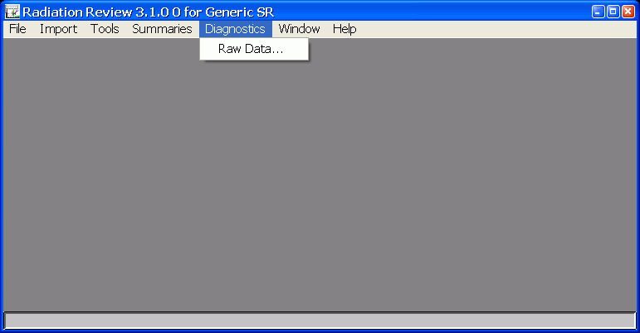
Figure 2.6-73 Diagnostics Pull-down Menu

Raw Data
The Diagnostics | Raw Data option allows you to select a portion of the data in the database for display. This option is more basic than Tools | Data Integrity because it searches based on any combination of status bits for the search criteria. The dialog box is displayed when this option is chosen.

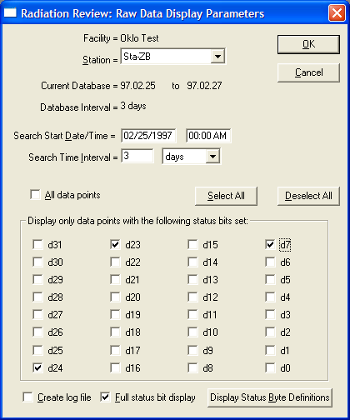
Figure 2.6-74 Diagnostics | Raw Data Dialog Box
The Facility name is displayed on the top line. The Station field provides a dropdown list of all stations in the facility and allows the user to indicate whether to perform the search for a single station or all stations. The Current Database and Database Interval display the first and last dates of data in the database and the total number of days covered by the database. The Database Interval is expressed as days; even if a day only contains data for an hour in the day, it is counted as an entire day. Facility, Current Database and Database Interval are information only parameters and cannot be changed by the user.
The next two lines of parameters, Search Start Date/Time and Search Time Interval, allow the user to select a subset of the entire database to be used. The Search Time Interval units can be days, hours or minutes. The default values for Search Start Date/Time and Search Time Interval vary depending on whether Radiation Review is running standalone or a part of an IRS session. In standalone mode, these parameters default to the entire database or the time interval last selected using the Tools | Review Period menu option. If Radiation Review is running as part of an IRS session, then these parameters correspond to the time interval specified on the Inspector Information Screen. If you execute this menu option more than once during a program run, then on re-entry to this menu option these interval values are set to those used the last time in this menu option.
You can select which data points you would like displayed by checking the appropriate check boxes. The following conditions can be checked for:
All Data Points: all data points in the interval are listed.
d31-d0: individual status bits can be specified for the search. Only data points having the indicated status bits set will match the search.

Clicking on the Display Status Byte Definitions button will cause a help box to be displayed that defines the status bits for the instrument type of the currently selected station in the Station field. Based on the instrument type of the station selected one of the following dialog boxes appears. Click OK to return back to the Raw Data Display Parameters dialog box.
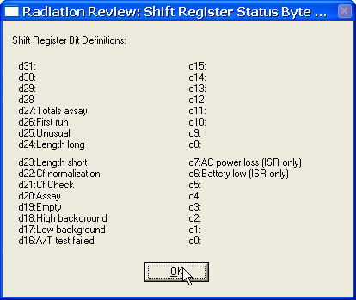
Figure 2.6-75 Shift Register Status Bit Definitions
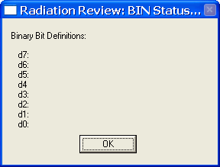
Figure 2.6-76 Binary Status Bit Definitions

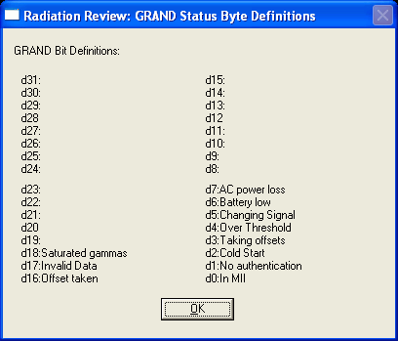
Figure 2.6-77 GRAND Status Bit Definitions

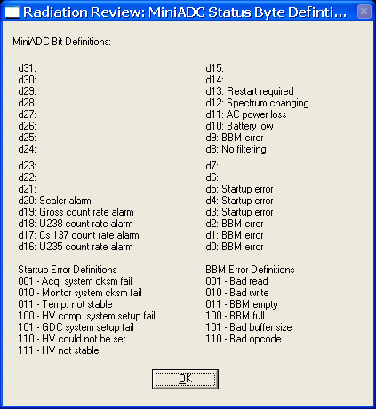
Figure 2.6-78 MiniADC Status Bit Definitions
Referring to the Raw Data Display Parameters dialog box, clicking on the Cancel button aborts the option and all changes you have made to the parameters are discarded.
The Create log file box can be checked if the user wants the results written to a file. If this box is checked, when the analysis begins, the user will be prompted for the filename in which to store the results.
The Full status bit display box is checked automatically. This checkbox enables a full description of each bit set in the “Stat Word” column to be displayed under each line. An example of this expanded display feature is shown in Figure 2.6-79 for SR data (below). Uncheck this box to obtain the standard single line display format.
Click on Save As Defaults to save these parameters to be the defaults the next time the program is started.
Clicking on the OK button starts the search.
The specified station is searched for data in the interval that match the criteria. Depending on the amount of data in the interval, this search may take several minutes. As the station is being searched, a progress bar appears indicating the current status of the search.
After the search is completed a text window displays the results similar to that shown below depending on the type of instrument. Any record that matched one of the specified conditions is displayed. If more than 16K records match the criteria, only the first 16K are printed in the results text window and you are informed that the results are truncated.
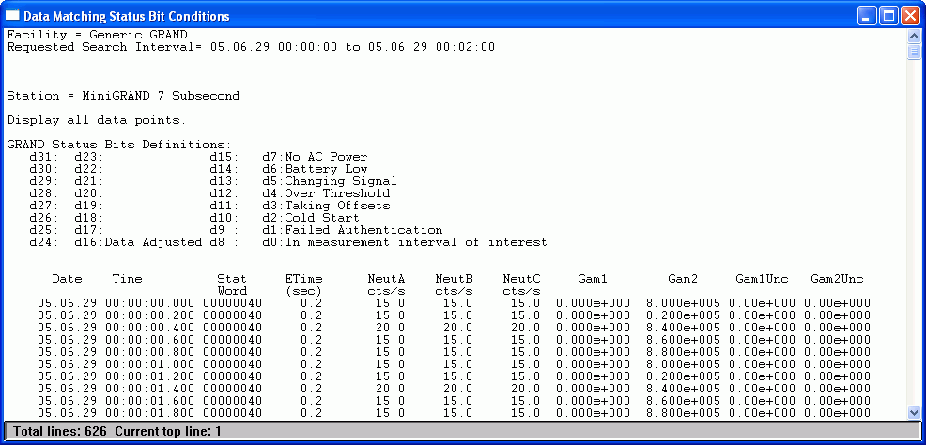
Figure 2.6-80 Diagnostics | Raw Data Results Text Window for GRAND data
The Data Matching Status Bit Conditions text window has the following sections for GRAND data:
Header Portion:
The header specifies the facility name and the time interval searched. For each station, a list of the conditions searched and a definition of the status bytes is displayed.
Main Results:
For each data point matching the condition the following information is given:
Date – date of matching data point
Time – time (with milliseconds) of matching data point
Stat Word – the status byte represented in hexadecimal – the status bit definitions are given in the header of the results text window.
ETime – the elapsed time that this data point represents
NeutA – the count rate in the GRAND/MiniGRAND A pulse channel
NeutB – the count rate in the GRAND/MiniGRAND B pulse channel
NeutC – the count rate in the GRAND/MiniGRAND C pulse channel
Gam1 – the relative gammas for the GRAND/MiniGRAND G1 ion chamber input
Gam2 – the relative gammas for the GRAND/MiniGRAND G2 ion chamber input
Gam1Unc – the G1 uncertainty as calculated by the GRAND/MiniGRAND or on-board temperature
Gam2Unc – the G2 uncertainty as calculated by the GRAND/MiniGRAND or off-board temperature
Summary Portion:
In the summary at the bottom, the status of the search, the number of matching data points and the search interval are displayed.
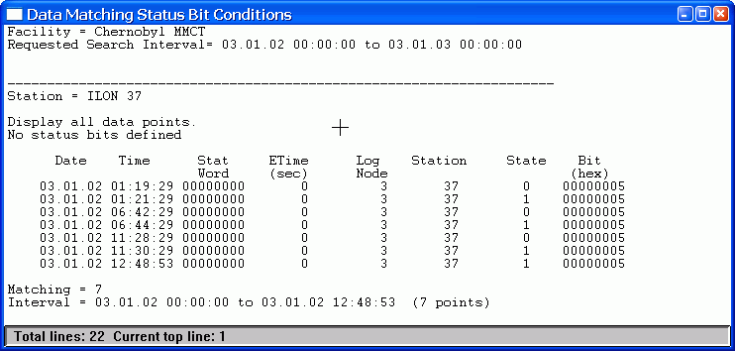
Figure 2.6-81 Diagnostics | Raw Data Results Text Window for Binary data
The Data Matching Status Bit Conditions text window has the following sections for Binary data:
Header Portion:
The header specifies the facility name and the time interval searched. For each station, a list of the conditions searched and a definition of the status bytes is displayed.
Main Results:
For each data point matching the condition the following information is given: Date – day being summarized
Date – date of matching data point
Time – time of matching data point
Stat Word – the status byte represented in hexadecimal – the status bit definitions are given in the header of the results text window.
ETime – the elapsed time that this data point represents
Log Node – the number of the ILON to which the information was logged
Station –the number of the ILON with which the data are associated
State – state that was logged (0 or 1)
Bit – which bit changed state
Summary Portion:
In the summary at the bottom, the status of the search, the number of matching data points and the search interval are displayed.
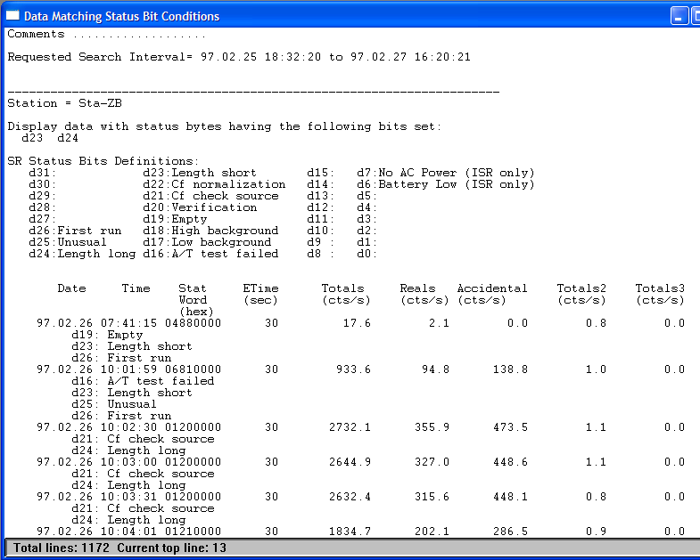
Figure 2.6-82 Diagnostics | Raw Data Results Text Window for SR data
The Data Matching Status Bit Conditions text window has the following sections for SR data:
Header Portion:
The first lines in the results text window display the facility specific header. The next section lists the search parameters.
Main Results:
For each station searched a list of all the data points matching the specified conditions are listed. For each data point the following columns of results are displayed:
First Column: Which condition the data point matches
Date/Time – the date/time,
Stat Word – the status byte represented in hexadecimal – the status bit definitions are given in the header of the results text window.
Etime – the elapsed time,
Totals – the count rate for the totals channel,
Reals – the count rate for the reals,
Accidentals – the count rate for the accidentals,
Totals 2 – the count rate in the auxiliary 1 channel.
Totals 3 – the count rate in the auxiliary 2 channel.
Summary Portion:
In the summary at the bottom, the status of the search, the number of matching data points and the search interval are displayed.
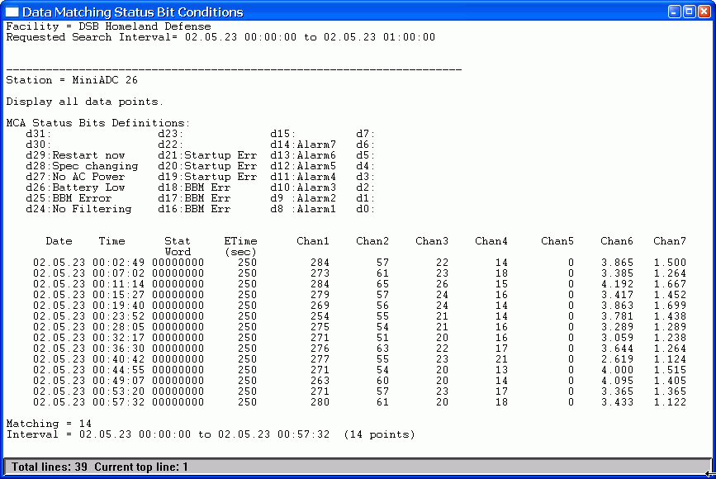
Figure 2.6-83 Diagnostics | Raw Data Results Text Window for MiniADC data
The Data Matching Status Bit Conditions text window has the following sections for MiniADC data:
Header Portion:
The first lines in the results text window display the facility specific header. The next section lists the search parameters.
Main Results:
For each station searched a list of all the data points matching the specified conditions are listed. For each data point the following columns of results are displayed:
First Column: Which condition the data point matches
Date/Time – the date/time,
Stat Word – the status byte represented in hexadecimal – the status bit definitions are given in the header of the results text window.
Etime – the elapsed time,
Chan 1, Chan2, Chan3, Chan4, Chan5, Chan6, Chan7 – the counts in the first channel defined in the MiniADC
Summary Portion:
In the summary at the bottom, the status of the search, the number of matching data points and the search interval are displayed.
To get a copy of the complete results windows as shown above, you can select to copy the text window results or a portion of it to the printer or to a file or to the clipboard as described in Section 2.3.3. To access the menu that allows you to save or print results, click on the icon in the upper left corner of the text window. Again, note that only 16,000 lines are printed to the results window – if you want to get all the data points check the Create Log File box on the initial dialog box and the results are written to a file.

Window Menu
If you select Window from the Main Menu Bar, the menu in Figure 2.7-84 is displayed.

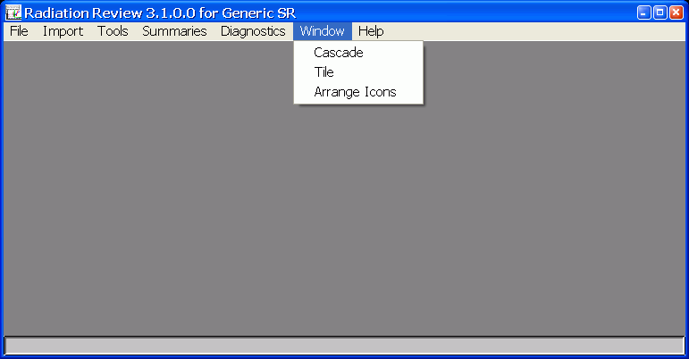
Figure 2.7-84 Windows Pull-down Menu
The typical Windows actions of Cascade, Tile, and Arrange Icons are available.

Help Menu
If you select Help from the Main Menu Bar, the menu in Figure 2.8-85 is displayed. A complete help is not implemented.

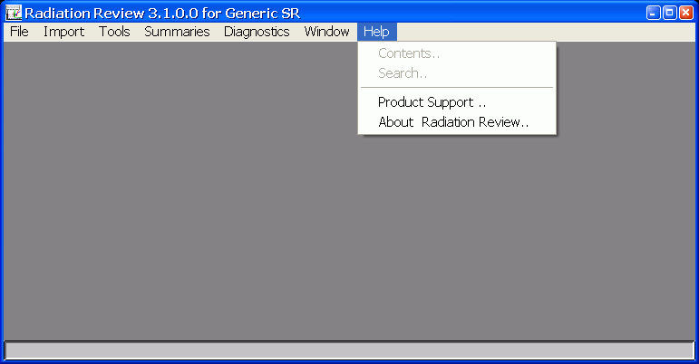
Figure 2.8-85 Help Pull-down Menu

Contents
This option is not yet implemented.

Search
This option is not yet implemented.

Product Support
Help | Product Support displays the Figure 2.8-86 information box.
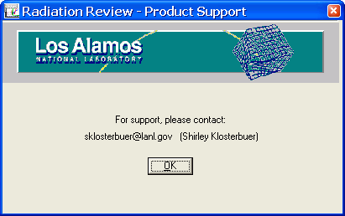
Figure 2.8-86 Help | Product Support Screen

About Radiation Review
Help | About Radiation Review displays the Figure 2.8-87 information box.
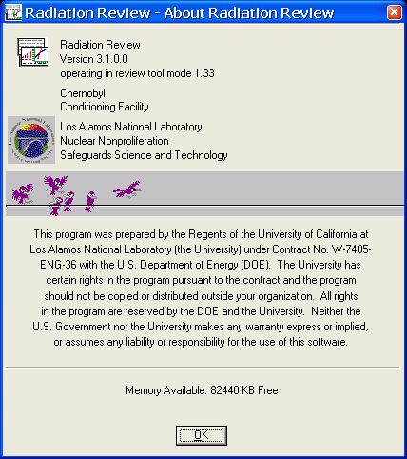
Figure 2.8-87 Help | About Screen

Alternate Startup
Radiation Review contains the IRS Upper Layer software consisting consists of a defined messaging protocol between Integrated Review Software (IRS) tools as well as each tool supporting various startup modes. The startup mode for any IRS tool is indicated as a command line parameter when an IRS tool is started (or if no command line parameter is present, then the IRS tool starts in the mode indicated by a configuration parameter in its IRS Upper Layer .INI file). Typically different startup modes are only used when Radiation Review is running as part of an IRS session. The user is never required to select a startup mode; the other IRS tools call Radiation Review in the different startup modes. The following startup modes are possible: REVIEW, IMPORT, REANALYZE, SETUP, TITLE, INSPECTION and SKIP_RUNNING_MSG. This section details the Radiation Review actions for each of these startup modes.

REVIEW Startup Mode
The REVIEW startup mode is the same as the standalone startup mode for the Radiation Review. Typically the main menu is displayed and the user can execute any of the menu options. Radiation Review is exited only by user request. When the IRS tools are running together, the REVIEW mode is the startup mode used when Radiation Review is started to do a time match of data. In addition to starting in REVIEW mode when a time match message is received, the graph is displayed and the cursor positioned at the timestamp contained in the time match message. The menu options that are enabled are indicated by parameters in the RAD.INI file (see Appendix A, Section 1.4).

IMPORT Startup Mode
Radiation Review performs actions to import/organize/analyze all data for the time range specified in the INSPEC.INI file. Radiation Review runs in automated mode as much as possible (with minimal, if any, interactions required from the user) stringing together several menu options. Radiation Review automatically exits when all import actions are completed. The actions that are performed are indicated by parameters in the RAD.INI file (see Appendix A, Section 1.4).

REANALYZE Startup Mode
REANALYZE is requested by an IRS tool when the user has taken an action that changes the data that are supplied to other IRS tools further down the line. Since Radiation Review has no IRS review tools that it depends on that can change their data, Radiation Review has no defined action for REANALYZE MODE.

SETUP Startup Mode
in this startup mode, Radiation Review displays dialog boxes that could be used to set the default parameters to be used with the menu options that are automatically executed during the IMPORT startup mode. Radiation Review exits automatically when all dialog boxes have been displayed and parameters set. The actions that are performed are indicated by parameters in the RAD.INI file (see Appendix A, Section 1.4).

TITLE, INSPECTION or SKIP_RUNNING_MSG Startup Mode
TITLE, INSPECTION or SKIP_RUNNING_MSG all have the same actions in Radiation Review. When you start Radiation Review in one of these modes, Figure 2.9-88 information screen is displayed.
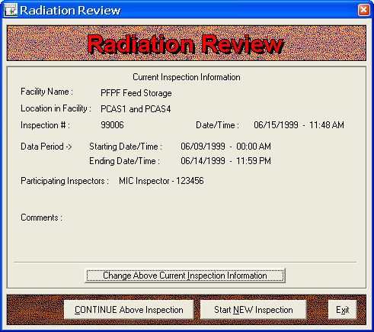
Figure 2.9-88 Inspection Startup Dialog Box
This screen shows the inspection specific information such as the facility name, the dates of the inspection, the inspectors and a comment. There are several actions that can be taken on this screen as indicated by the buttons on the bottom of the dialog box:
Continue Above Inspection: Clicking on Continue Above Inspection causes Radiation Review to be run in REVIEW mode and you can execute any of the program options as described in Section 2.1 Main Menu Bar.
Start NEW inspection: Clicking on the Start NEW Inspection Button causes these actions to be taken:
1) The Inspection Information Dialog box is displayed and the user updates fields as needed (described in Section 2.9.6)
2) Radiation Review is run in IMPORT mode and all actions that are specified in the RAD.INI file to be performed in IMPORT mode are executed (For IMPORT mode to work correctly, the facility specific default parameters for each menu option must have been established and saved – this would be done by the facility expert. See Appendix D for details on setting the facility specific default parameters), and
3) Radiation Review is started in REVIEW mode to allow the user to use all capabilities of Radiation Review as described in Section 2.1 Main Menu Bar.
Change Above Current Inspection Information: Clicking on the Change Above Current Inspection Information displays the Inspection Information Dialog box and the user updates fields as needed (described in Section 2.9.6). When you click OK on the Inspection Information Dialog box you return to the original screen displayed in Figure 2.9-88 and can take any of the actions.
Exit: Clicking on the Exit button exits the program.

Inspection Information Dialog Box
Figure 2.9-89 appears.
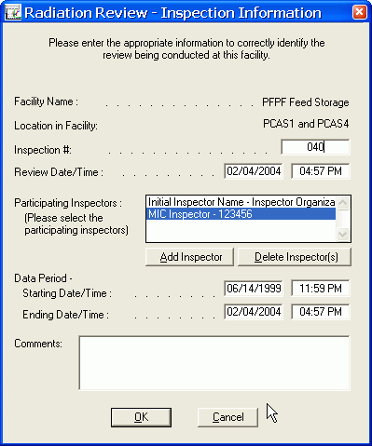
Figure 2.9-89 Inspector Information Dialog Box
The following actions can be taken to change the inspection information:
Facility Name: The current facility name is listed, you cannot edit this field.
Location in facility: The current location being reviewed in the facility is listed, you cannot edit this field.
Inspection #: You can set the Inspection Number; the format is YY0MM where YY is the last two digits of the year and MM is the current month.
Review Date/Time: The current date and time is displayed.
Participating Inspectors: The scroll box displays the names of the possible inspectors who are conducting this review. Select your name in the list.
Add Inspector: Clicking on the Add Inspector dialog box brings up a second dialog box where you are prompted to enter the name and organization of the inspector you wish to all to the Participating Inspectors list. Click OK and the name is added to the Participating Inspectors list.
Delete inspector(s): Highlight the inspector(s) that you wish to delete from the Participating Inspectors list. Click on the Delete Inspector(s) button. You are asked if you want to delete the specified inspectors. Answering Yes removes the name(s) from the Participating Inspectors list.
Data Period - Starting Date/Time: this should be set to the date of the first data to be examined.
Data Period - Ending Date/Time: this should be set to the date of the last data to be examined.
Comments: A text string describing this inspection can be entered.
Cancel: Clicking on Cancel discards the changes and returns you to the first screen.
OK: Clicking on OK accepts the changes and returns you to the Information screen (Figure 2.9-88 Inspection Startup Dialog Box).

Installation Information
See the most recent version of Radiation Review Release Notes.
Appendix A. Files
Radiation Review 3.x and higher is composed of a general program and several supporting Component Object Module (COM) library modules. This Appendix describes the input/output files associated with the main Radiation Review program as well as all of its COM libraries.
A.1. Input Files
There are several inputs to Radiation Review. The raw data files contain the data produced by MIC or other IRS tools that can be imported into Radiation Review for analysis. For all databases, at a minimum, empty database files need to be present.
A.1.1. Binary Raw Data Files (*.BID, *.ISR, *.BSR, *.MCA, *.JSR,*.ESS)
The Radiation Review program can import data files from several instrument types. The following table summarizes data collection programs and file formats produced. For details on the file formats, see the references for the associated data collection program.
Instrument | Data Collection Program | Files produced
GRAND-3 | DOS Grand Collect (Ref. 2) or MIC (Ref.3 ) | *.bid, *.cev, *.pfm
MiniGRAND | MIC (Ref. 3) | *.bid, *.cev, *.pfm
AMSR/ISR | MIC (Ref. 3) | *.isr, *.cev, *.pfm
JSR | DOS SR Collect (Ref. 1) or MIC (Ref. 3) | *.bsr or *.jsr, *.cev, *.pfm
Binary Logger ILON | MIC (Ref. 3) | *.bny, *.cev, *.pfm
MiniADC | MIC (Ref. 3) | *.mca, *.cev, *.pfm
VIFM Instruments | Standard Bot Collection software | *.*sl* or *.vbf
Neumann Electronic Seals | MIC (Ref. 3) | *.ess
Note: When reading *.bid files, Radiation Review does special interpretations of the gamma data. If the MiniGRAND has put in special numbers to indicate gammas out of range or taking offsets, then Radiation Review replaces those values with the last known valid value for a gamma reading and sets the Data Adjusted bit in the status word to warn the user that data has been replaced.
A.1.2. Database Files
There are three dbVista databases associated with Radiation Review as described in the table below.
Database | Description | Files | Location
Primary RAD database | Contains information imported from SR, MiniADCs, and all event information. | db_MAIN.dbd, DB_MAIN_.DBF, DB_MAIN_.KEY, DB_MAIN_DATA.DBF, db_MAIN_data.key, db_MAIN_datad.dbf, db_MAIN_datad.key, db_MAIN_day.dbf, db_MAIN_day.key, db_MAIN_fac.dbf, db_MAIN_fac.key, db_MAIN_summ.dbf | Located in the DATA\RAD subdirectory under the Facility Root Directory specified in Facility Manager
Operator Declaration database | Contains information imported from *.ID files produced by Operator Review | db_oper.dbd, db_oper.dbf, db_oper.key | Located in the DATA\RAD subdirectory under the Facility Root Directory specified in Facility Manager
Default Values database | Contains the default parameters for most Radiation Review menu options | db_dflt.dbd, db_defs.key, db_defs.dbf | Located in the CONFIG\RAD subdirectory under the Facility Root Directory specified in Facility Manager

Independent databases or *.INI files are used by the COM libraries:
COM Library | Description | Files | Location
EOSS Import Com | Access database containing binary events imported from *.ESS files | Eossbinarydata.mdb | Located in the Data\Import\EOSS subdirectory under the Facility Root Directory specified in Facility Manager
Grand Import COM | Db_Vista database containing information imported from GRAND or MiniGRAND *.BID files. | db_data.dbf, db_data.key, db_day.dbf, db_day.key, db_rmon.dbd | Located in the DATA\IMPORT\MG subdirectory under the Facility Root Directory specified in Facility Manager
VIFM Import COM | Db_Vista database containing information imported from *sl.* files. | db_VIFM.DBD, DB_VIFMDATA.DBF, DB_VIFMDATA.KEY, DB_VIFMDAY.DBF, DB_VIFMDAY.KEY | Located in the DATA\IMPORT\VIFM subdirectory under the Facility Root Directory specified in Facility Manager
Binary Import COM | Access database containing information imported from *.BNY files. | BINARY.MDB | Located in the DATA\IMPORT\Binary subdirectory under the Facility Root Directory specified in Facility Manager
Time Align COM | INI file containing parameters for timestamp adjust | TIMEALIGN.INI | Located in the CONFIG\RAD subdirectory under the Facility Root Directory specified in Facility Manager
Facility Manager COM | Access database containing facility configuration information entered using Tools | Facility Configuration menu option | FACILITYCONFIG.MDB | Located in the \IRS\COMLIBS directory

A.1.3. Text Raw Data Files
*.ID Files
ID files are text data files containing information about the item ID associated with a particular sample being measured. Each item is defined in a single line in the file. The various entries are separated by a comma. The format is:
Each Record:
up to 12 character item id
up to 11 character detector id (AAAA/BBB/CC)
timestamp for start of event in the timestamp format described below.
timestamp for end of event in the timestamp format described below.
TimeStamp Format:
5 ASCII Chars – not used, set to 00000
8 ASCII Characters – YYYYMMDD (year, month day)
6 ASCII Characters – HHMMSS (hour, minute, seconds)
3 ASCII Characters – MMM (milliseconds)

Examples of two entries would be:
NO000111,PCAS/001/03,0000019990614095900000,0000019990614100500000
NO000112,PCAS/001/03,0000019990614105800000,0000019990614111000000
(Note: eventually this documentation should be moved to the Operator Review User Manual since the file is produced there.)
A.1.4. Configuration Files
In addition to the Default Values database described above, Radiation Review gets configuration information from these files. The configuration information for Radiation Review is kept in several different files. A brief description of each file follows.
Configuration File | Description | Lines: | Location
RAD.INI | Contains information for interacting with other review tools and some general default parameters. | This file should only be edited by LANL personnel. | Located in the CONFIG\RAD subdirectory under the Facility Root Directory specified in Facility Manager
INSPEC.INI | Contains inspection period information such as last inspection ID, date/time of the start/end of the inspection period, inspector ID, etc. | This file should never be edited. | Located in the DATA subdirectory under the Facility Root Directory specified in Facility Manager
RADRUNNING.INI | Used to determine whether Radiation Review is already running | This file is empty | Located in the CONFIG\RAD subdirectory under the Facility Root Directory specified in Facility Manager
IRS.INI | Contains the Facility ID number for the current selected facility in Radiation Review. The facility number is RAD’s index into the Facility Manager. FDMS and INCC use irs.ini for the same purpose | Caution: if the default facility is deleted prior to changing facilities in Radiation Review, this file must be hand edited to reflect the current facility number. | Located in IRS Root Directory, normally C:\irs
Some RAD.INI parameters may need to be changed by technical experts to provide desired functioning of Radiation Review for a particular facility. The following sections detail parameters these experts may need to change to configure performance of Radiation Review.

RAD.INI Parameter Name | Values
RT_***** | All parameters named with the RT_ prefix deal with the LANL Upper Layer parameters. These parameters should be changed only by LANL personnel.
RAD_NCC_PATH | Indicates where RAD stores intermediate INCC files. This subdirectory is appended to the Facility Root Directory for the facility in Facility Manager.
RAD_INSPECTION_FILE_VALID | If TRUE, then RAD will use the inspection limits from INSPEC.INI as the default time interval rather than the start and end of the database for all options.
RAD_IMPORT_ALL | Applies only to IMPORT or SETUP startup modes. Set to TRUE if want the appropriate part of the Import | Import All menu option to be executed in either IMPORT or SETUP modes.
RAD_IMPORT_TODAY | Applies only to IMPORT or SETUP startup modes. Set to TRUE if want the appropriate part of the Import | Import Most Recent Files menu option to be executed in either IMPORT or SETUP modes
RAD_INTEGRITY | Applies only to IMPORT or SETUP startup modes. Set to TRUE if want the appropriate part of the Tools | Data Integrity Checks menu option to be executed in either IMPORT or SETUP modes
RAD_FIND_EVENTS | Applies only to IMPORT or SETUP startup modes. Tools | Find Channel Events menu option to be executed in either IMPORT or SETUP modes
RAD_DIRECTION | Applies only to IMPORT or SETUP startup modes. Set to TRUE if want the appropriate part of the Tools | Direction Analysis menu option to be executed in either IMPORT or SETUP modes
RAD_MEASUREMENT | Applies only to IMPORT or SETUP startup modes. Set to TRUE if want the appropriate part of the Tools | Determine Measurements menu option to be executed in either IMPORT or SETUP modes
RAD_EXPORT | Applies only to IMPORT or SETUP startup modes. Set to TRUE if want the appropriate part of the Tools | Export to INCC menu option to be executed in either IMPORT or SETUP modes
RAD_GRAPH | Applies only to IMPORT or SETUP startup modes. Set to TRUE if want the appropriate part of theTools | Graph menu option to be executed in either IMPORT or SETUP modes.
RAD_MENU_IMPORT_TODAY | Applies only to REVIEW startup mode. Set to TRUE if you want the Import | Import Most Recent Files main menu option to be active for the user. (FALSE grays out the menu option)
RAD_MENU_IMPORT_SELECTED | Applies only to REVIEW startup mode. Set to TRUE if you want the Import | Import Selected Files main menu option to be active for the user. (FALSE grays out the menu option)
RAD_MENU_DETERMINE_MEASUREMENTS | Applies only to REVIEW startup mode. Set to TRUE if you want the Tools | Determine Measurements main menu option to be active for the user. (FALSE grays out the menu option)
RAD_MENU_DIRECTION_ANALYSIS | Applies only to REVIEW startup mode. Set to TRUE if you want the Tools | Direction Analysis main menu option to be active for the user. (FALSE grays out the menu option)
RAD_MENU_EXPORT_TO_INCC | Applies only to REVIEW startup mode. Set to TRUE if you want the Tools | Export to INCC main menu option to be active for the user. (FALSE grays out the menu option)
RAD_MENU_MEASUREMENTS_SUMMARY | Applies only to REVIEW startup mode. Set to TRUE if you want the Summaries | Measurements main menu option to be active for the user. (FALSE grays out the menu option)
RAD_MENU_DIRECTION_SUMMARY | Applies only to REVIEW startup mode. Set to TRUE if you want the Summaries | Direction Events main menu option to be active for the user. (FALSE grays out the menu option)
RAD_MENU_INTEGRITY_CHECK | Applies only to REVIEW startup mode. Set to TRUE if you want the Tools | Data Integrity Checks main menu option to be active for the user. (FALSE grays out the menu option)
RAD_WRITE_CHAN_EVENT_RESULTS_FILE | TRUE - Write RAD.DB file described in Section A.2 after executing the Tools | Find Channel Events  FALSE – do not write the RAD.DB file. Also controlled by checkbox in Find Channel Events dialog box.
RAD_WRITE_DIR_EVENT_RESULTS_FILE | TRUE - Write RAD.DB file described in Section A.2 after executing the Tools | Direction Analysis  FALSE – do not write the RAD.DB file. Also controlled by checkbox in Direction Analysis dialog box.
RAD_WRITE_MEASUREMENT_RESULTS_FILE | Redefined in RAD 3.2.0.0 to be a number with the following bit definitions: bit 0 = 1, write *.ncc file  bit 1 = 1, write file for IR  bit 2 = 1, write XML file. These parameters are set through the Tools | Export Data dialog box by checking the appropriate boxes.
RAD_REAL _TIME_UPDATE | TRUE (“Update” button on Graph dialog box) or FALSE (“Mark” button on Graph dialog box). Also controlled by a checkbox on the Options button of the graph.
RAD_REANALYZE_ENABLED | Used when running RAD as part of IRS.  TRUE – RAD prompts as to whether to request a REANALYZE from IR after the Tools | Export to INCC menu option is executed.  FALSE – REANALYZE not supported.
RAD_MEAS_AT_THRES | Used in Determine Measurement SR analysis. Accidentals/Totals test threshold level, default is 100.0
RAD_MEAS_AT_BIAS | Used in Determine Measurement SR analysis. Accidentals/Totals test bias limit, default is 0.1
RAD_MEAS_AT_SIGMA | Used in Determine Measurement SR analysis. Accidentals/Totals test sigma allowed, default is 3.0
RAD_MEAS_GATE_WIDTH | Used in Determine Measurement SR analysis. Gate width for Accidentals/Totals test, default is 64.0
RAD_MEAS_TERM_ON_MOVING | Used in Determine Measurement SR analysis. If TRUE, then a run that fails A/T will terminate a measurement, default is FALSE
RAD_MEAS_INCLUDE_AT_FAIL | Used in Determine Measurement SR analysis. If TRUE, then include runs that fail A/T in those sent to INCC, default is TRUE
RAD_LOCATION_MATCH_TYPE | Should always be 1
RAD_LOCATION_MATCH_ITEM | Should always be 1
RAD_LOCATION_NO_MATCH_MSG | Should always be TRUE
RAD_IMPORT_AUTOMATE_QUESTION | Normally is FALSE. If TRUE then when running in IMPORT mode, ask a question about whether they really want to delete the database before importing the new data
RAD_IMPORT_DISK_PROMPT | Normally is FALSE. If TRUE then when running in IMPORT mode, display a prompt telling user to put disk containing RAD data in the proper drive.
RAD_IMPORT_MULTIPLE_DISKS | Normally is FALSE. If TRUE then when running in IMPORT mode, display a prompt telling user to put multiple disks containing RAD data in the proper drive.
RAD_R_T_UPPER_LIMIT | In doing Tools | Determine Measurements, add a check on the upper limit for the R/T ratio if Cf. Default is 0.5.
RAD_ENABLE_RATIOS | When displaying results for Tools | Find Channel Events, either display Integral Sum and Net Area or 3 Rokkasho specific ratios. TRUE = use Rokkasho specific ratios.
Other RAD_ parameters | Values are settable through RAD dialog boxes and do not need to be hand edited.

A.2. Output Files
Several files can be produced by Radiation Review if the user specifies them. They fall into 2 general categories: ASCII files containing all or a portion of text window results and log files generated by checking the appropriate boxes. The names for the files can be specified by the user so they are not listed here.
A.2.1. Files from text window results
Anytime results are displayed in a text window the user has the option to save all or a portion of the text window in a filename specified by the user. The format of the file is an exact copy of what appears on the screen.
A.2.2. Files for import to INCC
During the Tools | Export Data option, if using shift register data, files can be generated for input to INCC at the location specified in the RAD.INI file with the RAD_NCC_PATH parameter. Each file includes all the cycles for one verification, background or normalization measurement event.
The Radiation Review measurement event data file is in binary format, and the file extension is always .NCC. The filename encodes the date and time of the first run in the event into the standard LANL 8-character naming convention described in Ref. 3. The format of the file is:
Header
“IREV”, 4 characters specifying the file type
1 character, B = background, N = normalization, V = verification
11 character detector id (AAAA/BBB/CC)
where:
AAAA = detector type, e.g. PCAS
BBB = detector identifier, e.g. 004
CC = configuration id, usually 01
12 character item id (filled with trailing blanks if less than 12 characters)
yy.mm.dd, 8 characters, date of first cycle
hh:mm:ss, 8 characters, time of first cycle
unsigned short, number of cycles
Repeated for each cycle in the measurement
yy.mm.dd, 8 characters, date of cycle i
hh:mm:ss, 8 characters, time of cycle i
unsigned short, count time in seconds for cycle i
double, totals for cycle i
double, R+A for cycle i
double, accidentals for cycle i
double, scalar 1 for cycle i
double, scalar 2 for cycle i
unsigned short, number of multiplicity values for cycle i (n = 0 to 128)
n unsigned longs, non-zero R+A multiplicity distributions for cycle i
n unsigned longs, non-zero accidentals multiplicity distributions for cycle i
Note: All cycles in a verification or normalization measurement must have the same count time. Background measurements may have cycles with different count times because all the cycles will be summed into one cycle.
A.2.3. Events XML File for Reading by FDMS or other review tools
When Radiation Review exports MiniGRAND/GRAND data using the Tools | Export Data option an XML file is written. The XML file is always named RADFDMS.XML and is located in the Data subdirectory under the Facility Directory set by Facility Manager. It is assumed that the analysis program using the data reads the XML file and then makes calls to the CoGrandImport COM library to retrieve the raw data for events of interest. A sample XML file containing summaries of events is shown in the figure below.

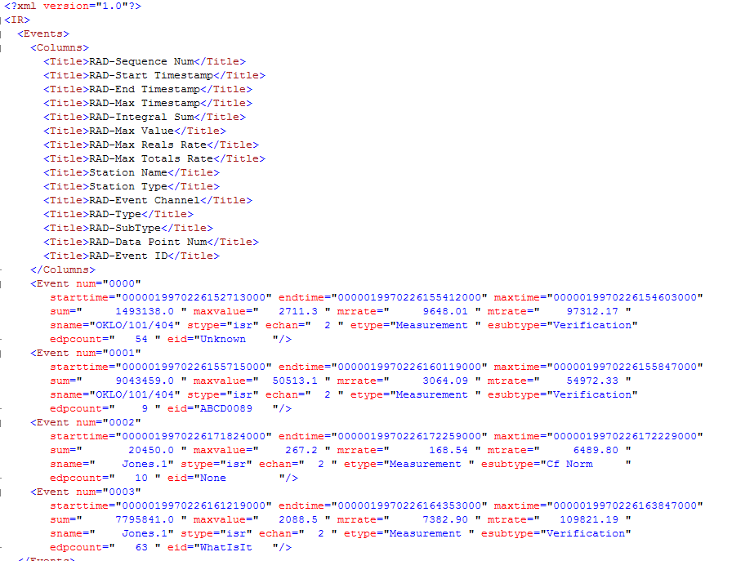

The attributes in each Event map have constraints and map to the column names like so:
1 RAD-Sequence Num (Event num): must be 4 digits, indicates line number, example 0001
2 RAD-Start Timestamp (starttime): IR format timestamp
3 RAD-End Timestamp (endtime): IR format timestamp
4 RAD-Max Timestamp (maxtime): IR format timestamp
5 RAD-Integral Sum (sum): sum of counts for channel from start to end timestamp
6 RAD-Max Value (maxvalue): highest count rate from start to end timestamp
7 RAD-Max Reals Rate (mrrate): maximum reals rate if SR data, otherwise is 0.0
8 RAD-Max Totals Rate (mtrate): maximum totals rate if SR data, otherwise is 0.0
9 Station Name (sname): Name of the station the data is associated with (from Facility Manager).
10 Station Type (stype): Type of the station the data is associated with (from Facility Manager).
11 RAD-Event Channel (echan): Which channel at the station the data is associated with (from Facility Manager).
12 RAD-Type (etype): Type of event (unknown, channel, measurement or background)
13 RAD-Subtype (esubtype): If Event Type is Measurement, then subtype is Unknown, Empty, Assay, Cf Check, Cf Normalization or Totals. If Event Type is Background, then subtype is Normal Background, Low Background or High Background.
14 RAD-Data Point Num (edpcount): Number of data points in the events
15 RAD-Event ID (eid): ID associated with the event.
A.2.4. Find Events Log File
Typically if you want a file version of the Channel Events Found results text window, you would click on the icon in the upper left-hand corner and select “Save As” from the drop down menu. However, the results window has a limit of 16,000 lines that can be written to it. If your output exceeds 16,000 and you want get a file version of the results, check the Create Log File box on the Tools | Find Events dialog box. You are prompted for a name and location for the log file when the analysis starts. As the results are processed, most of what would normally be displayed in the Channel Events Found text window is also written to the specified log file. The figure below shows a portion of a log file:
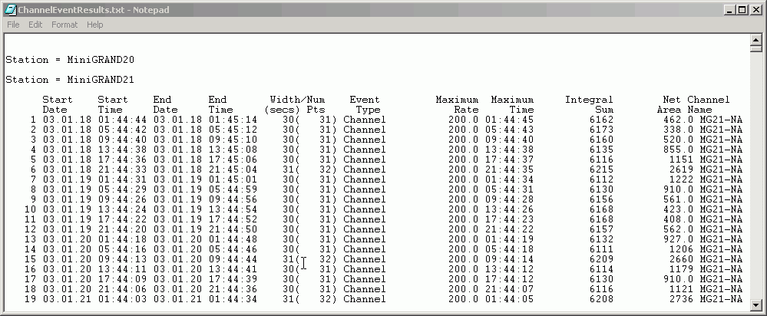

A.2.5. Find Events Data File for Reading by Integrated Review
When Radiation Review runs as a member of the IRS, through configuration parameters in the RAD.INI file, you can select to have the results written to a file to be read by Integrated Review. The name (plus path) of the file is specified in the RAD.INI parameter RT_SUMMARY_DATA_FILENAME (typically rad.db or rad.txt). This file is written only if the checkbox in the Find Events dialog box is checked. The figure below shows a portion of this specially formatted file:
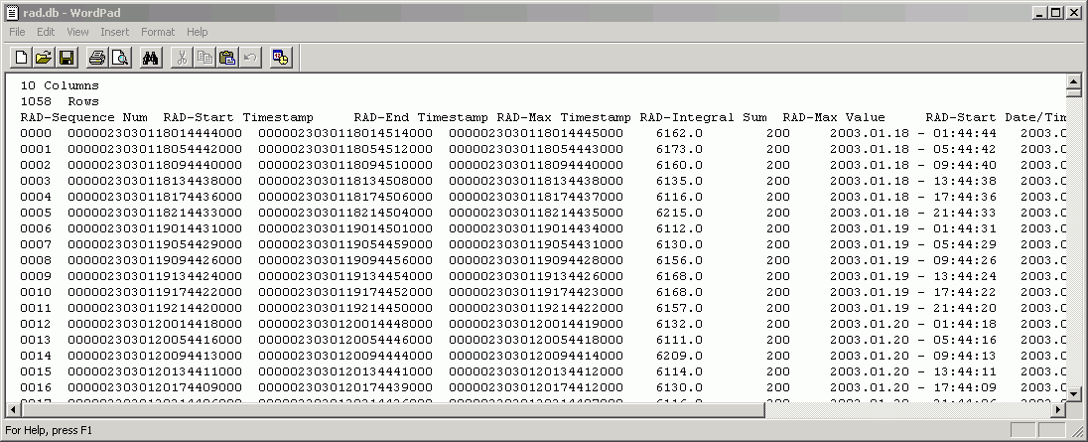

The file has this format:
Line 1 – number of columns in the “table”
Line 2 – number of rows in the “table”
Line 3 – Heading labels for “columns” in the “table”
Line 4 – n Data values written into the columns in the “table”
The 10 columns in the table (referred to by Lines 3 and 4 are:
1 RAD-Sequence Num: must be 4 digits, indicates line number, example 0001
2 RAD-Start Timestamp: IR format timestamp, example 000023030118014444000
3 RAD-End Timestamp: IR format timestamp
4 RAD-Max Timestamp:IR format timestamps
5 RAD-Integral Sum: sum of counts for channel from start to end timestamp
6 RAD-Max Value: highest count rate from start to end timestamp
7 RAD-Start Date/Time: timestamp format displayed to user
8 RAD-End Date/Time: timestamp format displayed to user
9 RAD-Max Date/Time: timestamp format displayed to use)
10 RAD-Type: always is Channel
A.2.6. Direction Analysis Log File
Typically if you want a file version of the Direction Analysis results text window, you would click on the icon in the upper left-hand corner and select “Save As” from the drop down menu. However, the results window has a limit of 16,000 lines that can be written to it. If your output exceeds 16,000 and you want get a file version of the results, check the Create Log File box on the Tools|Direction Analysis dialog box. You are prompted for a name and location for the log file when the analysis starts. As the results are processed, most of what would normally be displayed in the Direction Events Found text window is also written to the specified log file. The figure below shows a log file:
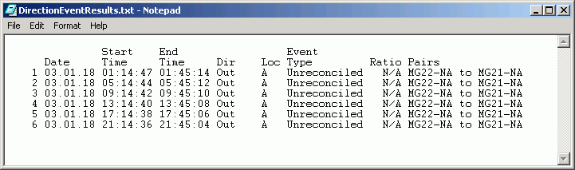

A.2.7. Direction Analysis Data File for Reading by Integrated Review
When Radiation Review runs as a member of the IRS, through configuration parameters in the RAD.INI file, you can select to have the results written to a file to be read by Integrated Review. The name (plus path) of the file is specified in the RAD.INI parameter RT_SUMMARY_DATA_FILENAME (typically rad.db or rad.txt). This file is written only if the checkbox in the Direction Analysis or Export to INCC dialog box is checked. The figure below shows a portion of this specially formatted file:
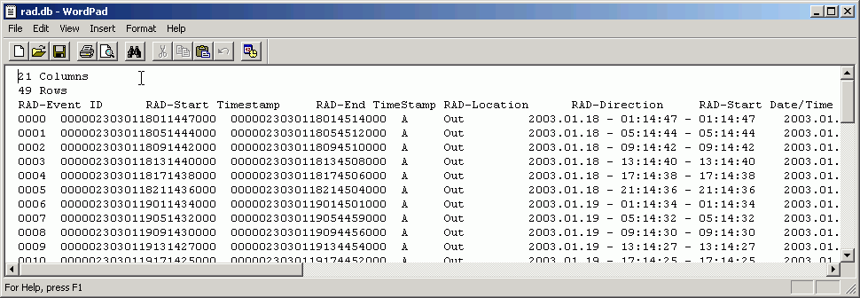

The file has this format:
Line 1 – number of columns in the “table”
Line 2 – number of rows in the “table”
Line 3 – Heading labels for “columns” in the “table”
Line 4 – n Data values written into the columns in the “table”
The 21 columns in the table (referred to by Lines 3 and 4 are:
1 RAD-Event ID: must be 4 digits, indicates line number, example 0001
2 RAD-Start Timestamp: IR format timestamp, example 000023030118014444000
3 RAD-End Timestamp: IR format timestamp
4 RAD-Location: either A or B (or Station in case of MiniGRAND data)
5 RAD-Direction: either In, Out, None or In/Out
6 RAD-Start Date/Time: timestamp format displayed in table, i.e., 1998.06.05 - 17:33:37
7 RAD-End Date/Time: timestamp format display in table
8 RAD-Start Date: date only, i.e. 1998.06.05
9 RAD-Start Time: time only, i.e. 17:33:37
10 RAD-End Date: date only, i.e. 1998.06.05
11 RAD-End Time: time only, i.e. 17:33:37
12 RAD-n/g ratio: the neutron gamma ratio
13 RAD-Status: always is Unreconciled
14 RAD-1a: Name of From channel in first pair meeting the condition
15 RAD-1b : Name of To channel in first pair meeting the condition
16 RAD-2a: Name of From channel in second pair meeting the condition
17 RAD-2b: Name of To channel in second pair meeting the condition
18 RAD-3a: Name of From channel in third pair meeting the condition
19 RAD-3b : Name of To channel in third pair meeting the condition
20 RAD-4a: Name of From channel in fourth pair meeting the condition
21 RAD-4b: Name of To channel in fourth pair meeting the condition
A.2.8. Export Analysis Data File for Reading by Integrated Review
When Radiation Review runs as a member of the IRS, through configuration parameters in the RAD.INI file, you can select to have the results written to a file to be read by Integrated Review when the Tools | Export Data option is run. The name (plus path) of the file is specified in the RAD.INI parameter RT_SUMMARY_DATA_FILENAME (typically rad.db or rad.txt). This file is written only if the checkbox in the Export Data dialog box is checked. The figure below shows a portion of this specially formatted file:
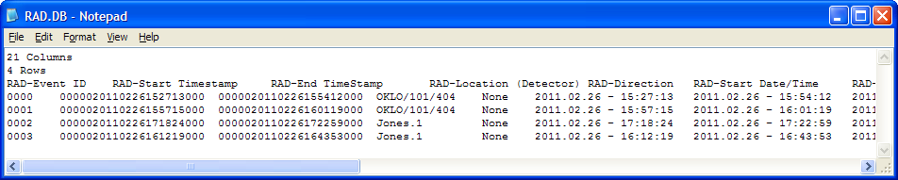

The file has this format:
Line 1 – number of columns in the “table”
Line 2 – number of rows in the “table”
Line 3 – Heading labels for “columns” in the “table”
Line 4 – n Data values written into the columns in the “table”
The 21 columns in the table (referred to by Lines 3 and 4) are:
1 RAD-Event ID: must be 4 digits, indicates line number, example 0001
2 RAD-Start Timestamp: IR format timestamp, example 000023030118014444000
3 RAD-End Timestamp: IR format timestamp
4 RAD-Location (Detector): Station name
5 RAD-Direction: either In, Out, None or In/Out
6 RAD-Start Date/Time: timestamp format displayed in table, i.e., 1998.06.05 - 17:33:37
7 RAD-End Date/Time: timestamp format display in table
8 RAD-Start Date: date only, i.e. 1998.06.05
9 RAD-Start Time: time only, i.e. 17:33:37
10 RAD-End Date: date only, i.e. 1998.06.05
11 RAD-End Time: time only, i.e. 17:33:37
12 RAD-Inspector Entered Item ID: the ID as entered in the previous dialog box
13 RAD-Status: type of event
14 RAD-1a: Name of From channel in first pair meeting a direction condition
15 RAD-1b : Name of To channel in first pair meeting a direction condition
16 RAD-2a: Name of From channel in second pair meeting a direction condition
17 RAD-2b: Name of To channel in second pair meeting a direction condition
18 RAD-3a: Name of From channel in third pair meeting a direction condition
19 RAD-3b : Name of To channel in third pair meeting a direction condition
20 RAD-4a: Name of From channel in fourth pair meeting a direction condition
21 RAD-4b: Name of To channel in fourth pair meeting a direction condition

Appendix B. Troubleshooting
B.1. Warning/Error Messages
Error Num | Warning Message | Recommended Action
1100 | BLANK_STRING_ERR: A blank string is not a valid entry. Please further specify the xxx field. | Fill in the xxx field.
1101 | BROWSE_INFO_WARN: Subfolder search is only valid for a single root path. The import will continue using only paths xxx. | No action needed. Only the first path defined is used for browse, all others are ignored.
1102 | CANNOT_OPEN_ANY_DATABASE_ERR: No database at xxx could be opened. Program cannot proceed. | Reinstall Radiation Review.
1103 | CHAN_NOT_DEFINED_ERR: Channel xx is not defined (Function yyy). | Add the channel using Tools | Facility Configuration menu option
1104 | COPY_DB_ERR: An error occurred while trying to copy the database from xxx to yyy. The copy is aborted. | Verify the selected destination drive can be written to.
1105 | DB_DOES_NOT_EXIST_ERR: A database does not exist at yyy | Reinstall Radiation Review.
1106 | DATABASE_OPENED_INFO: Database at xxx is open. | No action needed.
1107 | DB_BAD_ERR: Unexpected database error. Try clearing database and reimporting the data.  Or Unexpected database error in function xxx. Try clearing database and reimporting the data.  Or Unexpected database error number xxx in function yyy. Try clearing database and reimporting the data." | Use Import | Import All menu option to clear the database and import the data again.
1108 | DB_EMPTY_STATUS: The database has no data. Please import data | Use Import | Import All menu option to import the data.
1109 | DB_INIT_ERR: An error occurred during the initialization of xxx. Option will abort. | Reinstall Radiation Review.
1110 | DEFAULT_CFG_PATH_TOO_LONG_ERR: Pathname of xxx specified in yyy is too long. Please fix and start Rad again. Maximum length is %d characters. | One of the paths in the DEFAULT.CFG file is greater than 256 characters. Change RAD data storage to make path length less than 256 characters.
1111 | DEFAULT_CFG_FILE_ERR: Fatal error reading the default.cfg file. Please fix it. | Reinstall Radiation Review.
1112 | DFLT_DB_READ_ERR: Requested an invalid field from the default database. The option will abort.  Or Unexpected error while reading the default parameters for %s | Reinstall Radiation Review.
1113 | DISPLAY_AT_LEAST_ONE_CHANNEL_ERR: At least one channel must be enabled | Select at least one channel in the previous dialog box.
1114 | DRIVE_DOES_NOT_EXIST_ERR: The specified path does not exist. | Select a drive that exists on your computer.
1115 | EVENT_NOT_FOUND_WARN: Couldn't find event to update. Nothing will be changed in database. | Database is probably corrupt. Reimport data.
1116 | FAC_NOT_IN_DB_ERR : Facility xxx is not defined (Function xxx) | Change the default facility with the Diagnostics | Select Facility menu option.
1117 | FACILITY_NOT_DEFINED_ERR: Facility xxx is not defined. Please select a valid facility from Diagnostics | SelectFacility menu option. | Change the default facility with the Diagnostics | Select Facility menu option.
1118 | FILE_OPEN_ERR: The specified file xxx could not be opened. | File may be corrupt.
1119 | FILE_READ_ERR: Error reading file xxx. | File may be corrupt.
1120 | FILE_WRITE_ERR: Unexpected error when writing to xxx | File may be corrupt or read protected.
1121 | FILE_STA_NOT_IN_DB_WARN: File: xxx Station number yy is unknown to Radiation Review. Add with Facility Manager. | Add the station using Tools | Facility Configuration menu option
1122 | INTERNAL_ERR: Internal Error:xxx This should not occur, please report it to LANL. | Report error and circumstances that produce the error to LANL.
1123 | INVALID_DFLT_DB_FIELD_ERR: Requested an invalid field from the default database. The option will abort. | Reinstall Radiation Review.
1124 | MAKE_DIR_ERR: The specified directory xxx could not be created. | Verify drive exists and can be written to.
1125 | MEMORY_ALLOCATION_ERR: Memory allocation error: Option will abort. If possible, select a smaller interval. Or Memory allocation error for xxx: Option will abort. | Try restarting your computer to free up memory.
1126 | NAME_TOO_LONG_ERR: The specified name xxx too long. Maximum length is 256 characters. | Use a filename shorter than 256 characters.
1127 | NAMES_CFG_READ_ERR: Database cleared okay, but could not read .cfg file. | Not in V 3.0.x
1128 | NO_ASSOCIATED_GRAPH_TRACE_ERR: No traces on the graph match the specified location: xxx. Please manually select appropriate traces now. | Select graph traces to go with the specified location.
1129 | NO_CHANS_SELECTED_WARN: No channels were selected. The option will abort | In the previous dialog box, select at least one channel.
1130 | NO_DATA_IN_INTERVAL_WARN: No data for xxx found in interval: yyy to zzz. | Information only.
1131 | NO_DEFAULT_CFG_FILE_ERR: File xxx is not present, current working directory is yyy. Please fix this problem. The program will exit now. | No default.cfg file exists in the specified directory.
1132 | NO_DIR_SELECTED_WARN: No direction analysis conditions were selected. The option will abort. | In the previous dialog box, select at least one condition for the direction analysis.
1133 | NO_FACILITIES_ERR: There are no facilities defined. | Add at least one facility using Tools | Facility Configuration menu option
1134 | NO_FILES_EXIST_WARN: No xxx files exist at yyy. | Information only.
1135 | NO_LOCATION_NUM_MATCH_SUPPORTED_ERR: Matching to a location number is not support. The option will abort | Information only.
1136 | NO_MATCHING_CHAN_EVENTS_WARN: No channel events found for any station in specified time interval. The option will abort.  Or No channel events found in interval: xxx to yyy. | Information only.
1137 | NO_MATCHING_DATA_WARN: No data for xxx found in interval: yyy to zzz. | Information only.
1138 | NO_MATCHING_RAW_DATA_WARN: No conditions selected for raw data display. The option will abort. | Select at least one condition in the previous dialog box.
1139 | NO_MATCHING_DIR_EVENTS_WARN: No direction events found in interval xxx to yyy. | Information only.
1140
1141 | NO_MEAS_SELECTED_WARN: No measurements were selected. No measurements will be sent to INCC. | Information only.
1142 | NO_MEAS_TYPE_IN_INTERVAL_WARN: No measurements of specified types\n found in interval: xxx to yyy. | Information only.
1143 | NO_MEAS_TYPES_SELECTED_WARN: No measurement types were selected. The option will abort. | Select at least one measurement type in the previous dialog box.
1144 | NO_MEMORY_FOR_APP_ERR: Not enough memory available to begin the application. Please try to free more memory and begin again. | Try restarting your computer to free up memory
1145 | NO_NCC_FILE_REQUESTED_ERR: Requested not to write NCC file. To write files, change parameter RAD_WRITE_MEASUREMENT_RESULTS_FILE in RAD.INI file to TRUE. | Have expert set correct values in RAD.INI file.
1146 | NO_STAS_SELECTED_WARN: No stations were selected. The option will abort. | Select at least one station in the previous dialog box.
1147 | NO_STATIONS_FOR_FACILITY_ERR: There are no stations in the database for the default facility | Add at least one station for facility using Tools | Facility Configuration menu option
1148 | NOT_ENOUGH_DATA_TO_ANALYZE_WARN: Not enough data in interval to analyze. Please select larger time interval. Event search will abort now. | Information only.
1149 | ONLY_ONE_GRAPH_WARN: Only one graph may be displayed. | Information only.
1150 | OPEN_COM_DB_WARN: Could not open xxx database at yyy, check path is correct. | Verify path or reinstall Radiation Review.
1151 | PATH_DOES_NOT_EXIST_ERR: The specified path does not exist. | Information only.
1152 | PATH_TOO_LONG_ERR: The specified paths xxx are too long. Maximum length is 256 characters. | Move data to a shorter path length name.
1153 | PATHS_TOO_LONG_ERR: The specified paths xxx are too long. Maximum length is 256 characters. | Move data to a shorter path length name.
1154 | PEAK_WIDTH_TOO_LARGE_WARN: Not enough data in interval to analyze. Please select larger time interval or reduce the peak width. Event search will abort now. | Information only.
1155 | RAD_INVALID_DATABASE_PATH_ERR: There is not a Radiation Review database at xxx. Program will abort now. | Verify path or reinstall Radiation Review.
1156 | RAD_START_FATAL_ERR: A fatal error was encountered when xxx during the Rad startup. Rad will abort now. | Try restarting your computer.
1157 | RT_IMPORT_ERR: The Radiation Review Import process did not successfully complete. This could be due to an error during the import or the user selecting to cancel the process. Press okay to continue the Import process for the other tools. | Information only.
1158 | SUMMARY_NOT_FOUND_STATUS: No summaries were found. | Information only.
1159 | UNKNOWN_EVENT_TYPE_ERR The event type is unknown. | Database may be corrupt. Try reimporting data and repeating analysis.
1160 | WILDCARDS_TOO_LONG_ERR: Too many wildcards are specified, reduce the length to < 40. | Shorten wildcards string.
1161 | WILDCARD_DOES_NOT_EXIST: The specified wildcard xxx is not recognized. | Enter a valid wildcard.
1162 | INVALID_FACILITY: The FacilityID xx in \\IRS\\IRS.INI is not known to Facility Manager. Please change IRS.INI | Change the facility number in the IRS.INI file.
1163 | NO_CHANNEL_STRING_MATCH_SUPPORTED_ERR: Matching to a channel string xxx is not supported. Change RAD_LOCATION_MATCH_ITEM in RAD.INI. | Set the indicated parameter in RAD.INI to FALSE.
1164 | REQUESTED_FACILTY_NOT_CURRENT_FACILTY: xxx is not the current default facility. | Use Tools | Select Facility to chose the indicated facility.
1165 | INSPEC_INI_ERR: Hint: Check RT_INSPEC_INFO_COMMON_FILENAME in RAD.INI for valid path. | INSPEC.INI file could not be found. Change the path and name in RAD.INI to point to the INSPEC.INI file desired.
1166 | No error defined
1167 | DEFAULT_CANNOT_BE_DELETED: Graph configuration “default" cannot be deleted. | No action needed – warning message if try to delete graph configuration named default..
B.2. Database becomes corrupt
If the database becomes corrupt and clearing and reimporting the data do not solve the problem, reinstall the Radiation Review program.
B.3. Program locks up
Unexpected problems may arise where the program locks up. If this happens, display the task list for the specific operating system and choose to End Task for Radiation Review.
B.4. Undefined facility on startup
Radiation Review uses the file irs.ini to select and access the current facility. The value in irs.ini is the Facility ID defined in the Facility Manager database. If the ID in irs.ini is not in the Facility Manager database, two dialogs are displayed (see below), and Radiation Review will not start. To repair this problem, manually edit irs.ini with a valid Facility ID and restart Radiation Review.

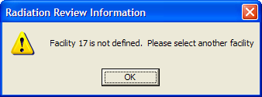

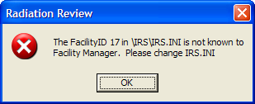

Appendix C. Technical Support, Change Summary
Questions, comments, and trouble reports for this program should be directed to Joe Longo, phone number (505) 667-2452, email longo@lanl.gov. You may also email general UNARM software and hardware questions to the UNARM software control board at uscb@lanl.gov.
C.1. Radiation Review 3.2.0.7 Resolved Issues and Change Summary

Issue # | Item | Summary
BMEND-1 | RAD | RAD graph loses data on import under some conditions: Displaying data for two MGs, (MG21/MG20), importing MG20 data, the data display blanks, this is seen often in the 1 week view window.
BMEND-6 | RAD | RAD graph left-button navigating to DVR connects eventually, but the long delay connecting to DVR (or some other unknown interaction) causes RAD to crash.
BMEND-7 | RAD | RAD graph marking activities often create [“Internal error: create mark failed.”] pop-up errors, with of course no contextual information as to why it might fail.
BMEND-8 | RAD | When doing database size stress-testing using MG data, internal errors are logged, but the user is not notified. Then RAD must be restarted to get import errors cleared; even when the database is cleared first. The graph is unusable at the DB full poin...
BMEND-9 | RAD UG | 'Determine Measurements' doesn't appear to function correctly, or else the manual needs to be made clearer, or the feature should be implemented to be a filter for short duration's measurements.
 |  | Placed note in § 2.4.8 describing the use and limits of these flags
BMEND-10 | RAD | RAD XML export crashes with IR/OP config. The config used was experimental and not functioning, so a proper arrangement (per #5) might already work fine.
BMEND-15 | RAD | Blank screen on graph update needs an hourglass or some sort of visual indication to user that work is being performed.
BMEND-16 | RAD UG | RAD and MIC manuals have no EOSS description in them. Also see #56.
 |  | Added minor EOSS description improvements in UG
BMEND-19 | RAD UG | Irs.ini not documented anywhere. This all-important file is the root definition of the 'current facility' for RAD, FDMS and INCC. The file's existence and use should be documented.
 |  | Added content to §§ 2.4.10, A.1.4 and B.4
BMEND-23 | RAD | The RAD ‘integrity check’ verbose text changes, requested in 2008, are not included in this weeks’ test, but the fix is ready in the latest internal RAD release.
BMEND-29 | RAD UG | RAD created events for AMSR and JSR, but 'Find Events' does not find them, nor are they in the summary report.
 |  | Added info about UNKNOWN events not being used by Find Events.
BMEND-30 | RAD | EOSS events can be created only in some locations on the graph (where there are two points available, not at end points). Also see #BMEND-57.
BMEND-56 | RAD UG | EOSS should be in the MIC UG and in the RAD manual too. Also see #BMEND-16.
 |  | Added minor EOSS description improvements in UG
BMEND-57 | RAD | EOSS graph marking hard to handle. See #30.
BMEND-66 | RAD UG | Note in RAD UG: Shift Register data "sign and forward" is not implemented.
 |  | Added note in § 2.3.1
BMEND-84 | RAD | Verify all crashes in IRS (especially RAD) don’t happen when the Install/Configuration is fixed
BMEND-85 | RAD | Data Integrity Checks for VIFM data must be fixed
BMEND-114 | RAD | RAD EOSS GetDataByStation can be inconsistent

C.2. Radiation Review 3.2.0.8 Resolved Issues and Change Summary

Issue # | Item | Summary
BMEND-124 | RAD | Some EOSS and VIFM data files fail to import into RAD
BMEND-125 | RAD | RAD graph missing MG data when multiple data sources displayed

C.3. Radiation Review 3.2.0.9 Resolved Issues and Change Summary

Issue # | Item | Summary
BMEND-144 | RAD | RAD Timealign ini file overrun
BMEND-148 | RAD | On RAD graph, signify when a channel is actively adjusted with a "Adjust Station Timestamp"
BEE-159 | RAD | EOSS Import has memory leaks

Appendix D. Setting Facility Specific Parameters
D.1. Channel Event Parameters
The following steps should be taken to determine the facility parameters for the Tools | Find Channel Events menu option:
Use the Graph option to find a data segment containing typical data for all channels in your facility. Record the starting and ending time of this data segment. Try to choose a small segment, no more than approximately 100 data points if possible. From the graph evaluate the type of data you have to determine which channel search algorithm is most appropriate for your data - if the background is constant select either the threshold or sliding window with background algorithm; if the background varies greatly select the sliding window with local background.
If you selected Threshold follow these steps:
- Select the Tools|Find Channel Events menu option.
- Adjust the Search Start Date/Time and Search Time Interval to specify the data segment containing the typical peaks.
- Select the Algorithm to be Threshold.
- The Smooth Data and Peak Width have no effect on the threshold.
- Select a single channel to be evaluated.
- Check the Diagnostic Print Points box and the click on OK. Data in the specified interval are analyzed and results with the following columns are displayed:
Chan Pt Sub
Date Time Num Num Num Data
97.01.06 00:45:00 0 2 0 16.000
97.01.06 00:45:02 0 3 1 16.000
97.01.06 00:45:04 0 4 2 16.000
97.01.06 00:45:06 0 5 3 16.000
97.01.06 00:45:08 0 6 4 16.000
97.01.06 00:45:10 0 7 5 916.500 Peak Start
97.01.06 00:45:12 0 8 6 5635.500 Above V
97.01.06 00:45:14 0 9 7 10730.000 Above V
97.01.06 00:45:16 0 10 8 15767.000 Above V
97.01.06 00:45:18 0 11 9 18358.500 Above V
97.01.06 00:45:20 0 12 10 13304.500 Above V
97.01.06 00:45:22 0 13 11 8235.000 Above V
97.01.06 00:45:24 0 14 12 3152.000 Above V
97.01.06 00:45:26 0 15 13 16.000 Peak End + 1
97.01.06 00:45:28 0 16 14 16.000
97.01.06 00:45:30 0 17 15 16.000
- Look at the Data column. Select a number for the threshold that represents when the event starts according to the graph. For the example above, 25 might be a good choice for threshold.
- Repeat the preceding 2 steps for all channels that indicate the peak.
- When you have determined the values for all channels that you need to use, put the values in the Threshold column in the Find Events dialog box. Set all the values in the Background column to 0.
- Run the analysis and use the graphics option to determine if these parameters are good. If not adjust the Threshold values.
- When you have determined that you have the correct numbers in the dialog box for the Tools | Find Channel Events, click on the Save As Defaults button. This writes the parameters to the default database and they will be the defaults the next time the program starts.
If you selected Sliding Window with Background follow these steps:
- Select the Tools | Find Channel Events menu option.
- Adjust the Search Start Date/Time and Search Time Interval to specify the data segment containing the typical peaks.
- Select the Algorithm to be Sliding Window with Background.
- If you want to use data smoothed with a 3 point smooth, check the Smooth Data box.
- Select a single channel to be evaluated.
- Check the diagnostic print points box and the click on OK. Data in the specified interval are scanned and results showing the following columns are printed:
Chan Pt Sub Smoothed V Event
Date Time Num Num Num Data Data Data Status
97.01.06 00:45:00 0 1 40 16.000 16.000 -72867
97.01.06 00:45:02 0 2 41 16.000 16.000 -76003
|97.01.06 00:45:04 0 3 42 16.000 16.000 -73302
97.01.06 00:45:06 0 4 43 16.000 16.000 -56443
97.01.06 00:45:08 0 5 44 16.000 16.000 -24301
97.01.06 00:45:10 0 6 45 916.500 916.500 22952 Peak Start+0
97.01.06 00:45:12 0 7 46 5635.500 5635.500 77980 Above V
97.01.06 00:45:14 0 8 47 10730.000 10730.000 117845 Above V
97.01.06 00:45:16 0 9 48 15767.000 15767.000 142502 Above V
97.01.06 00:45:18 0 10 49 18358.500 18358.500 149209 Above V
97.01.06 00:45:20 0 11 50 13304.500 13304.500 132350 Above V
97.01.06 00:45:22 0 12 51 8235.000 8235.000 100208 Above V
97.01.06 00:45:24 0 13 52 3152.000 3152.000 52955 Above V
97.01.06 00:45:26 0 14 53 16.000 16.000 -2073 End + 1
97.01.06 00:45:28 0 15 54 16.000 16.000 -41938
97.01.06 00:45:30 0 16 55 16.000 16.000 -66595
97.01.06 00:45:32 0 17 56 16.000 16.000 -76003
97.01.06 00:45:34 0 18 57 16.000 16.000 -75103
97.01.06 00:45:36 0 19 58 16.000 16.000 -69483
97.01.06 00:45:38 0 20 59 16.000 16.000 -58769
97.01.06 00:45:40 0 21 60 16.000 16.000 -43018
97.01.06 00:45:42 0 22 61 16.000 16.000 -24676
97.01.06 00:45:44 0 23 62 16.000 16.000 -11387
97.01.06 00:45:46 0 24 63 16.000 16.000 -3168
97.01.06 00:45:48 0 25 64 16.000 16.000 -32
97.01.06 00:45:50 0 26 65 16.000 16.000 -32
97.01.06 00:45:52 0 27 66 16.000 16.000 -32
97.01.06 00:45:54 0 28 67 16.000 16.000 -32
97.01.06 00:45:56 0 29 68 16.000 16.000 -32
- Look at the V Data column. Select a number for the threshold that represents when the event starts according to the graph. For the example above, any number 0-20000 might be a good choice for threshold.
- Look at the Data column. Select a number that represents a good value for the constant background. For the example above, 20 would be a good choice for background.
- Look at the Data column. Select a number that represents the number of points in the peak that will be used as the Peak Width. For the example above, 8 might be a good choice for the number of points in the peak.
- Repeat the preceding 5 steps for all channels that indicate the peak.
- When you have determined the values for all channels that you need to use, put the values in the Threshold and Background columns in the Find Events dialog box. Set the Peak Width to the most common number of points in the peak.
- Run the analysis and use the graphics option to determine if these parameters are good and all peaks are properly detected. If not, adjust the Threshold and Background values.
- When you have determined that you have the correct numbers in the dialog box for the Tools | Find Channel Events, click on the Save As Defaults button. This writes the parameters to the default database and they will be the defaults the next time the program starts.
If you selected Sliding Window with Local Background follow these steps:
- Select the Tools | Find Channel Events menu option.
- Adjust the Search Start Date/Time and Search Time Interval to specify the data segment containing the typical peaks.
- Select the Algorithm to be Sliding Window with Local Background.
- If you want to use data smoothed with a 3 point smooth, check the Smooth Data box.
- Select a single channel to be evaluated.
- Check the diagnostic print points box and the click on OK. The specified interval is scanned and results showing the following columns is printed:
Chan Pt Sub Smoothed V Event
Date Time Num Num Num Data Data Data Status
97.01.06 00:45:00 0 1 40 16.000 16.000 -72867
97.01.06 00:45:02 0 2 41 16.000 16.000 -76003
|97.01.06 00:45:04 0 3 42 16.000 16.000 -73302
97.01.06 00:45:06 0 4 43 16.000 16.000 -56443
97.01.06 00:45:08 0 5 44 16.000 16.000 -24301
97.01.06 00:45:10 0 6 45 916.500 916.500 22952 Peak Start+0
97.01.06 00:45:12 0 7 46 5635.500 5635.500 77980 Above V
97.01.06 00:45:14 0 8 47 10730.000 10730.000 117845 Above V
97.01.06 00:45:16 0 9 48 15767.000 15767.000 142502 Above V
97.01.06 00:45:18 0 10 49 18358.500 18358.500 149209 Above V
97.01.06 00:45:20 0 11 50 13304.500 13304.500 132350 Above V
97.01.06 00:45:22 0 12 51 8235.000 8235.000 100208 Above V
97.01.06 00:45:24 0 13 52 3152.000 3152.000 52955 Above V
97.01.06 00:45:26 0 14 53 16.000 16.000 -2073 End + 1
97.01.06 00:45:28 0 15 54 16.000 16.000 -41938
97.01.06 00:45:30 0 16 55 16.000 16.000 -66595
97.01.06 00:45:32 0 17 56 16.000 16.000 -76003
97.01.06 00:45:34 0 18 57 16.000 16.000 -75103
97.01.06 00:45:36 0 19 58 16.000 16.000 -69483
97.01.06 00:45:38 0 20 59 16.000 16.000 -58769
97.01.06 00:45:40 0 21 60 16.000 16.000 -43018
97.01.06 00:45:42 0 22 61 16.000 16.000 -24676
97.01.06 00:45:44 0 23 62 16.000 16.000 -11387
97.01.06 00:45:46 0 24 63 16.000 16.000 -3168
97.01.06 00:45:48 0 25 64 16.000 16.000 -32
97.01.06 00:45:50 0 26 65 16.000 16.000 -32
97.01.06 00:45:52 0 27 66 16.000 16.000 -32
97.01.06 00:45:54 0 28 67 16.000 16.000 -32
97.01.06 00:45:56 0 29 68 16.000 16.000 -32
- Look at the V Data column. Select a number for the threshold that represents when the event starts according to the graph. For the example above, any number 0-20000 might be a good choice for threshold.
- Look at the Data column. Select a number that represents the number of points in the peak that will be used as the Peak Width. For the example above, 8 might be a good choice for the number of points in the peak.
- Repeat the preceding 4 steps for all channels that indicate the peak.
- When you have determined the values for all channels that you need to use, put the values in the Threshold columns in the Find Events dialog box. Set the Background column to 0s. Set the Peak Width to the most common number of points in the peak.
- Run the analysis and use the graphics option to determine if these parameters are good and all peaks are properly detected. If not, adjust the Threshold values.
- When you have determined that you have the correct numbers in the dialog box for the Tools | Find Channel Events, click on the Save As Defaults button. This writes the parameters to the default database and they will be the defaults the next time the program starts.
D.2. Direction Analysis Parameters
The following steps should be taken to determine the facility specific parameters for the Tools | Direction Analysis menu option: This option is used for facilities that have special combinations of detectors that can be used to determine direction of motion.
- Use the Tools | Find Events or Tools | Determine Measurements to determine channel or measurement events for the facility.
- Use the Tools | Graph option to find a data segment containing typical data for all channels in your facility. Expand around the peaks indicating a direction of motion. Use the cursor to manually determine the number of seconds between the start of the event on one channel to the start of the event on another channel. If the times differ on the various channels record the times for each pair of channels. Also record approximately how long the time is in-between channel events.
- In the dialog box for Tools | Direction Analysis, setup the conditions for the various direction events as described in Section 2.4.5. For the Min column fill in the number of seconds that must pass after the first channel in your pair detects the event until the second channel in your pair detects the event; normally this is 0. For the Max column fill in the most seconds choose the largest number of seconds that must pass after the first channel in your pair detects the event until the second channel in your pair detects the event; normally this is 200-500s. It must be less than the number of seconds in-between two events on the same channel. If you want to calculate a ratio of the neutron/gammas for all the pairs for a given direction/location, fill in the appropriate choice for each channel pair.
- Run the analysis and to determine if these parameters are good and all direction events are properly detected. If not, adjust the values.
- When you have determined that you have the correct numbers in the dialog box for the Tools | Direction Analysis, click on the Save As Defaults button. This writes the parameters to the default database and they will be the defaults the next time the program starts.
Appendix E. Shift Register Specific Information
E.1. Shift Register Analysis
E.1.1 SR Measurement Analysis
Data from each run are analyzed to determine the run type. The eight run types include the following:
Run Type | Meaning
BACKGROUND | Normal background run
LOW BKG | Low-background run
HIGH BKG | High-background run
MOVING | Moving source (failed A/T test) run
ASSAY | Plutonium container run
EMPTY | Empty container (low-level Plutonium source) run
CF NORM | Cf normalization run
CF CHECK | Cf check source run
TOTALS | Totals (singles) assay run

Run-type determination is described in the flow chart in Appendix E.1.2 for facilities using Reals (Doubles) analysis and Appendix E.1.3 for facilities using Totals (Singles) analysis. The run type MOVING indicates that a source may be moving past the detector. A moving source causes an anomaly in the counting statistics and fails the A/T test. The A/T test procedure is described in Appendix E.1.4.
Consecutive runs are grouped into measurements. There are eight measurement types:
Measurement Type | Meaning
BACKGROUND | Normal background measurement
LOW BKG | Low-background measurement
HIGH BKG | High-background measurement
UNKNOWN | Unknown measurement
ASSAY | Plutonium container measurement
TOTALS | Singles assay measurement
EMPTY | Empty container (low-level Plutonium source) measurement
CF NORM | Cf normalization source measurement
CF CHECK | Cf check source measurement

Six of these measurement types (ASSAY, EMPTY, TOTALS, CF NORM, CF CHECK, and UNKNOWN) are known as event measurements. Three (BACKGROUND, LOW BKG, and HIGH BKG) are known as background measurements.
Consecutive measurement runs with the same run types are grouped into their corresponding measurement types:
Run Type | Measurement Type
BACKGROUND | BACKGROUND
LOW BKG | LOW BKG
HIGH BKG | HIGH BKG
ASSAY | ASSAY
TOTALS | TOTALS
EMPTY | EMPTY
CF NORM | CF NORM
CF CHECK | CF CHECK

A measurement type begins with the first run of the corresponding run type and ends with the last run of the same corresponding run type. The average of the totals and reals rates of the runs is maintained for the duration of a measurement type. The duration covers the time from the start of the first run to the end of the last run (i.e., start of last run plus the duration of last run). The average rates are calculated from the sums of the rates of runs included in the measurement type divided by the number of runs included in the measurement type.
The moving (MOVING) run type is special. A moving run following a background measurement cannot be characterized until a subsequent run. It is designated an unknown (UNKNOWN) measurement type. Subsequent moving runs are grouped into one unknown measurement type. The duration of the unknown measurement type is maintained, but the average rates are defined as zero. If a subsequent run starts an event measurement, then the preceding unknown measurement is reclassified as part of the new event measurement type (i.e., the start of the new event is the start of the previously classified unknown event).
If a moving run follows an event measurement, it is included as part of the duration of the event measurement. If it is between two of the same measurement events, it is included as part of the duration of the event measurement as a whole. If it is at the end of one event measurement but before the beginning of a different event measurement, it is included as part of the duration of the first event measurement. In no case are the statistics of a moving run type included in the statistics of the event measurement.
If a subsequent run starts a background measurement, then the preceding unknown measurement is not reclassified. A moving run type is never included in a background measurement.
Analysis of each run results in flags being written to the status byte associated with the data. There are twelve flags:

Flag | Meaning
A/T Test Failed | Run is MOVING run type
Low Background | Run is part of a LOW BKG measurement
High Background | Run is part of a HIGH BKG measurement
Empty | Run is part of an EMPTY measurement
Assay | Run is part of an ASSAY measurement
Cf Check | Run is part of a CF CHECK measurement
Cf Norm | Run is part of a CF NORM measurement
Length short | Event measurement duration is less than minimum event limit
Length long | Event measurement duration is greater than maximum event limit
Unusual measurement | Run is part of UNKNOWN measurement
First run | First run of a measurement (does not apply to BACKGROUND measurements)
Totals | Run is part of a TOTALS measurement

E.1.2 Run Type Determination (Doubles Assay)

Start
Failed A/T Test
Low Back-ground
High Back-ground

Moving
Empty
Verifi-cation
Assay Verifi-cation
Cf Check
Cf Normal-ization

Normal Back-ground
R/t < Reals (Doubles) Assay Threshold
T/t <= Low Background Threshold
T/t >= High Background Threshold
R/t < Cf Normalization Threshold
R/t <= Empty Container Threshold
R/T > Cf/Totals ratio Threshold and < Cf/Totals upper limit
FALSE
TRUE
FALSE
FALSE
TRUE
FALSE
TRUE
TRUE
FALSE
TRUE
FALSE
TRUE
TRUE
FALSE
DEFINITIONS:
R/t = reals rate
T/t = totals rate
R/T = reals-to-totals ratio
- E.1.3 Run Type Determination (Singles Assay)

Start
Low Back-ground
Normal Back-ground

Totals Assay
High Back-ground
R/t < Reals (Doubles) Assay Threshold
T/t <= High Background Threshold
T/t <= Low Background Threshold
T/t <= Totals (Singles) Assay Threshold
FALSE
FALSE
TRUE
FALSE
FALSE
TRUE
TRUE
TRUE
To Doubles
(Reals) Analysis
DEFINITIONS:
R/t = reals rate
T/t = totals rate
- E.1.4 A/T Test

Start
T/t <
A/T threshold
Bias <
A/T bias limit
Sigmas < A/T sigma limit

Fail
Not Appli-cable

Pass
TRUE
TRUE
TRUE
FALSE
FALSE
FALSE
DEFINITIONS:
T/t = totals rate
A/t = accidentals rate
R = A/t/((T/t)**2 * gate width)
Bias = ABS(1-r)
Sigmas = Bias * SQRT(A)/r

